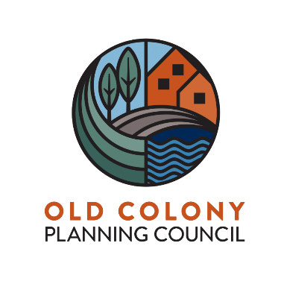

Old Colony Bicycle and Pedestrian Advisory Committee Meeting
Thursday, September 22, 2022 at 1:00 PM held via Zoom
https://us02web.zoom.us/webinar/register/WN_anjeWIpLSBO5zfLReGMQ7g

Agenda

- Welcome and Introductions
- Guest Speaker(s): Peter Sutton, Bicycle and Pedestrian Program Coordinator, MassDOT
- Shared Streets & Spaces Grant Program & Mass Trails Awards
- Bicycle and Pedestrian Projects in the Old Colony Region - Local Examples
- Brockton – Corridor Improvements on Route 123 (Belmont Street) Phase 3
- Easton – Corridor Improvements on Depot Street
- MassDOT Transportation Data Management System (MS2) – Non Motorized Database System
- Discussion on Bicycle and Pedestrian Issues
- Next Steps
- Adjourn

