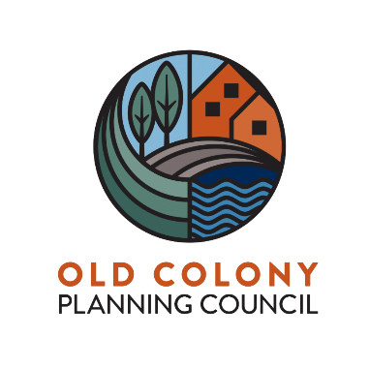

Old Colony Bicycle and Pedestrian Advisory Committee Meeting
Friday, December 16, 2022 at 1:00 PM held via Zoom
https://us02web.zoom.us/webinar/register/WN_7h5DREtUTPadK7fQWx_eMQ
Agenda

- Welcome and Introductions
- Guest Speaker(s): Rachel Calderara Bruce, Wildlands Trust – D.W. Field Park Initiative Overview
- Rail Trails – Local Examples and Funding Opportunities
- Choosing The Correct Bicycle Seat
- Bicycle and Pedestrian Projects in the Old Colony Region - Local Examples
- Discussion on Bicycle and Pedestrian Issues
- Next Steps
- Adjourn

