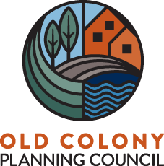

Valerie Massard, President | Mary Waldron, Executive Director

Phone: (508) 583-1833 | 70 School Street | mwaldron@ocpcrpa.org
Fax: (508) 559-8768 | Brockton, MA 02301 | www.oldcolonyplanning.org

Job Description: GIS Intern
Department: Community Planning Economic Development

Old Colony Planning is seeking a GIS Intern to assist in the mapping and data management tasks of the GIS Department. This is a paid internship.

Typical Duties and Responsibilities
- Data creation and development using ESRI’s ArcGIS software
- Preparing and uploading data and maps for web portal
- Assists in staff training on GIS Software
- Attends and participates in meetings with planning staff and regional organizations

Typical Knowledge
- Competency in various computer software programs, such as Office 365, Excel.

Typical Skills
- Strong written and oral communication skills
- Strong research and analytical skills
- Motivated self-starter able to work independently.
- Ability to work effectively in a Team environment.
- Flexibility and desire to work on varying projects.

Qualifications
This position is open to a currently enrolled undergraduate student with:
- Coursework experience using ArcGIS
- Interest in planning and local government
- Experience with Microsoft Windows and Office
- Preference for a Junior or Senior level student

Learn more at www.oldcolonyplanning.org

Old Colony Planning Council provides equal employment opportunities to all employees and applicants for employment and prohibits discrimination and harassment of any type without regard to race, color, religion, age, sex, national origin, disability status, genetics, protected veteran status, sexual orientation, gender identity or expression, or any other characteristic protected by federal, state or local laws.

