Housing Production Plan

Halifax, Massachusetts

September 2019 -Technical Assistance provided by

Old Colony Planning Council

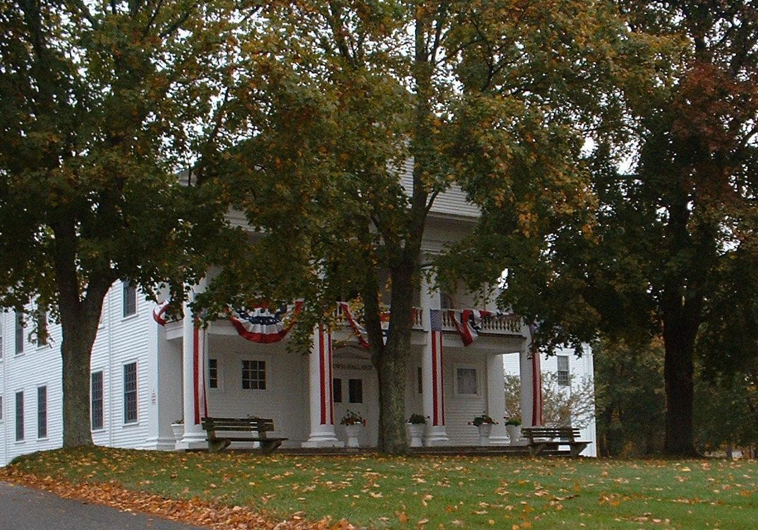

=

# Table of Contents

Glossary of Terms 5

List of Tables 9

List of Figures 10

1. Notices & Acknowledgements 11
2. Executive Summary 12

Comprehensive Housing Needs Assessment 12

Affordable Housing Goals & Strategies 15

* 1. Housing Goals 15
  2. Implementation Strategies 15

1. Introduction 17
2. Profile of Halifax 17
3. Overview of a Housing Production Plan 18
4. Defining Affordable Housing 19
5. Comprehensive Housing Needs Assessment 20
6. Demographics 20
   1. Population 21
   2. Households 22
7. Household Size 24
8. Age Distribution 25
9. Race & Ethnicity 26
10. School Enrollment 27
11. Educational Attainment 27
12. Disability Status 28
13. Income 29
14. Employment 31
15. Housing Stock Analysis
    1. Housing Units 33
    2. Housing Unit Types 33
    3. Age and Condition of Housing 34
    4. Household Tenure 34
    5. Vacancy 36
16. Value of Owner Occupied Housing Units 37
17. Median Sales Price 37
18. Number of Residential Sales 38
19. Median Gross Rent 40
20. Housing Units Permitted 40
21. Recent & Future Development 41
22. Projected Housing Demand 41
23. Housing Affordability 42
    1. Poverty Rate 42
    2. Households Eligible for Housing Assistance 43
    3. Fair Market Rents 44
    4. Current M.G.L. Chapter 40B Subsidized Housing Inventory 45
    5. Housing Cost Burden 46
    6. Rental Affordability for Current Households 48
    7. Homeownership Affordability for Current Households 49
    8. Housing Affordability Gap 49
    9. Waiting list for Affordable Housing 50
24. Challenges to Producing Affordable Housing 51
25. Land Availability 52
26. Watershed Areas 52
27. Protected Open Space, Wetlands & Floodplains 52
28. Water & Sewer 53
29. Transportation 53
30. Schools 53
31. Residential Zoning 53
32. Affordable Housing Goals and Strategies 55
33. Housing Goals 55
34. Implementation Strategies 57

Appendix A: Halifax Zoning Map 74

Appendix B: Halifax Developmental Constraints Map 75

Appendix C: Halifax – Potential Affordable Housing Sites 76

Appendix D: Available Housing Resources & Programs 77

Appendix E: DHCD, MHP, CEDAC, MassHousing and MassDevelopment Bedroom Mix Policy 81

Appendix F: Draft Inclusionary Zoning Bylaw 83

Appendix G: Community Housing Survey 90

Appendix H: Community Housing Survey Results 97

Appendix I: Subsidized Housing Inventory - Halifax 116

Appendix J: Subsidized Housing Inventory- Facts, Questions, Answers 117

Appendix K: Important Affordable Housing Resources 118

Appendix L: Important Affordable Housing Resources 120

Appendix M: Model Bylaw for Accessory Dwelling Units 122

Appendix N: Local Initiative Program(LIP) / Local Action Units 130

Appendix O: Comprehensive Permit Process 133

# Glossary of Terms

Affordable: The U.S. Department of Housing and Urban Development (HUD) considers housing affordable if housing costs (including utilities) do not exceed 30% of a household’s income.

Affordable Housing: Affordable housing is also defined according to percentages of median income for an area.

According to HUD “extremely low income” housing is reserved for households earning at or below 30% of the Area Median Income (AMI); “very low income” households are households earning between 31% and 50% of the AMI; and “low income” households are households earning between 51% and 80% of the Area Median Income (AMI).

Area Median Income (AMI) – means area median household income as defined by HUD pursuant to section 3 of the 42 U.S.C. 1437 (the Housing Act of 1937), as amended, adjusted for household size.

Community Preservation Act**:** The Community Preservation Act (CPA) is a Massachusetts law that allows participating cities and towns to adopt a real estate tax surcharge of up to 3% in order to fund the four community preservation purposes of open space, historic preservation, affordable housing, and recreation. In addition to the community tax surcharge, the state provides matching funds that are not less than 5% and not more than 100% of the funds raised by the community. The actual percentage varies from year to year dependent on the health of the Commonwealth’s community preservation trust fund, which is funded by a surcharge on Registry of Deeds transactions. Communities with Community Preservation funding find this resource invaluable in paying for upfront predevelopment costs and feasibility analysis, staff and consultants, as well as leveraging additional subsidies. CPA in Halifax**:** The town of Halifax has not adopted the Community Preservation Act as of the writing of this Plan. A ballot initiative failed more than ten years ago.

The Community Preservation Committee (CPC): In towns that adopt CPCA, the CPC annually solicits proposals for the use of the funds, ranks the submissions, and makes a recommendation to Town Meeting for the best use of program funds. By law, a minimum of 10% of the CPA money must be spent on affordable housing. The CPC has been a strong advocate of affordable housing and will continue to offer financial assistance to worthwhile projects.

Comprehensive Permit: The Comprehensive Permit Act is a Massachusetts law which allows developers of affordable housing to override certain aspects of municipal zoning bylaws and requirements. A permit for the development of low and moderate income housing issued by a Board or the Committee pursuant to the M.G.L. Chapter 40B Section 20 through 23 and 760 CMR 56.00.

Cost Burdened: When a household pays more than 30% of its income on housing (including utilities), it is considered to be cost burdened.

Detached Unit: A detached home is almost always considered a single-family home, meaning all internal areas are shared and in common, also called a single detached dwelling.

Disability: Difficulty with any of the six types of disability collected in the American Community Survey: vision, hearing, ambulatory, cognitive, self-care, and independent living. It overs functional limitations in the three

domains of disability (communication, mental and physical), activities of daily living (ADLs), and instrumental activities of daily living (IADLs). Vision difficulty: Blindness or serious difficulty seeing, even when wearing glasses or contacts. Hearing difficulty: Deafness or serious difficulty hearing. Cognitive difficulty: Serious difficulty remembering, concentrating, or making decisions. Ambulatory difficulty: Serious difficulty walking or climbing stairs. Self-care difficulty: Difficulty dressing or bathing. This type relates to ADLs. Independent living difficulty: Difficulty doing errands alone such as visiting a doctor’s office or shopping. This relates to IADLs.

Eligible for Assistance: A family’s eligibility for assistance is based on the income limit applicable to the type of housing assistance the family is to receive. A family may be income-eligible for one program but have too high an income for another program.

Employment to population ratio: The ratio of people who are currently employed to the total population, in terms of percentage.

Exclusionary zoning: is the utilization of zoning ordinances to exclude certain types of people from a given community.

Household: A household consists of all the people who occupy a housing unit. A house, an apartment or other group of rooms, or a single room, is regarded as a housing unit when it is occupied or intended for occupancy as separate living quarters; that is, when the occupants do not live with any other persons in the structure and there is direct access from the outside or through a common hall. A household includes the related family members and all the unrelated people, if any, such as lodgers, foster children, wards, or employees who share the housing unit. A person living alone in a housing unit, or a group of unrelated people sharing a housing unit such as partners or roomers, is also counted as a household. The count of households excludes group quarters. There are two major categories of households, "family" and "nonfamily".

Housing Unit: A house, an apartment, a group of rooms, or a single room occupies or intended for occupancy as separate living quarters.

Housing Production Plan (HPP) – means an affordable housing plan adopted by a municipality and approved by the Department, defining certain annual increases in its number of SHI Eligible Housing units as described in 760 CMR §56.03(4).

Housing Production Plan Community Survey: a brief survey created and available through Survey Monkey, to help the committee determine community need and solicit input on affordable housing for inclusion in development of this plan. Pages 90-115 in the back of this plan are the questions and the community responses from the 138 individuals who participated.

Housing Resources: The affordability of most housing development projects typically involves multiple sources of financing including both private and public loans and grants. Even Chapter 40B Comprehensive Permit projects rely on what is referred to as “internal” subsidies where the market rate units support the costs of the affordable ones in tandem with increased density. It will be important for the Town to encourage the establishment of partnerships with other interested parties including non-profit organizations, lenders, public agencies, and developers to secure the necessary financial and technical resources to create affordable units.

Inclusionary zoning: refers to municipal planning ordinances that require a given share of new construction to be affordable by people with low to moderate incomes.

Local Initiative Program (LIP): a state program that encourages the creation of affordable housing by providing technical assistance to communities and developers who are working together to create affordable rental opportunities for low and moderate-income households.

Low Income Persons – means all persons who, according to the latest available United States Census, reside in households whose net income does not exceed the maximum income limits for admission to public housing, as established by the Department. The Department's calculation shall be presumed conclusive on the Committee unless a party introduces authoritative data to the contrary. Data shall be authoritative only if it is based upon a statistically valid, random sample or survey of household income conducted in the relevant area since the latest available U.S. Census. Low or Moderate Income Housing – means any units of housing for which a Subsidizing Agency provides a Subsidy under any program to assist the construction or substantial rehabilitation of low or moderate income housing, as defined in the applicable federal or state statute or regulation, whether built or operated by any public agency or non-profit or Limited Dividend Organization. If the applicable statute or regulation of the Subsidizing Agency does not define low or moderate income housing, then it shall be defined as units of housing whose occupancy is restricted to an Income Eligible Household.

OCPC Technical Assistance Program: The Old Colony Planning Council (OCPC) provides grant funding to seventeen communities in their region to access technical assistance in promoting affordable housing and other land use planning programs. Funding can be used for a single community or on a regional basis. Halifax is part of the OCPC Region.

Poverty: the Census Bureau uses a set of money income thresholds that vary by family size and composition to determine who is in poverty. If a family's total income is less than the family's threshold, then that family and every individual in it is considered in poverty. The official poverty thresholds do not vary geographically, but they are updated for inflation using the Consumer Price Index (CPI-U). The official poverty definition uses money income before taxes and does not include capital gains or noncash benefits (such as public housing, Medicaid, and food stamps).

Severely Cost Burdened: When a household pays more than 50% of its income on housing (including utilities), it is considered to be severely cost burdened. As a result these households may have difficulty affording necessities such as food, clothing, transportation and medical care.

Subsidized Housing: can be obtained through vouchers, where the subsidy is used by a tenant to find rental housing in the private market and is paid to a private landlord. This subsidy stays with the tenant or it can be multifamily subsidized housing, where the subsidy is given to the owner who provides affordable housing. This subsidy stays with the property.

Subsidized Housing Inventory (SHI)- used to measure a community’s stock of low-or moderate-income housing for the purposes of M.G.L. Chapter 40B, the Comprehensive Permit law. A list compiled by the Department containing the count of Low or Moderate Income Housing units by city or town.

Subsidizing Agency – means any agency of state or federal government that provides a Subsidy for the construction or substantial rehabilitation of Low or Moderate Income Housing. If the Subsidizing Agency is not an agency of state government, the Department may appoint a state agency to administer some or all of the responsibilities of the Subsidizing Agency with respect to 760 CMR 56.00; in that case, all applicable references in these Guidelines to the Subsidizing Agency shall be deemed to refer to the appointed project administrator.

Subsidy – means assistance provided by a Subsidizing Agency to assist the construction or substantial rehabilitation of Low or Moderate Income Housing, including direct financial assistance; indirect financial assistance through insurance, guarantees, tax relief, or other means; and non-financial assistance, including in- kind assistance, technical assistance, and other supportive services. A leased housing, tenant-based rental assistance, or housing allowance program shall not be considered a Subsidy for the purposes of 760 CMR 56.00.

Use Restriction – means a deed restriction or other legally binding instrument in a form consistent with these Guidelines and, in the case of a Project subject to a Comprehensive Permit, in a form also approved by the Subsidizing Agency, which meets the requirements of these Guidelines.

Warren Group: The Warren Group collects and compiles data on real estate sales and ownership throughout New England. They offer a wide range of real estate products, information services and printed and on-line publications, including the weekly newspaper Banker & Tradesman and monthly magazine The Commercial Record.

Who your landlord is: If you live in public housing, the housing authority owns your building and is your landlord. In a few cases, a private company may manage the building for the housing authority or may be part of the ownership, but the building is still controlled by the housing authority. Housing authorities operate in most cities and towns in Massachusetts. They were established by state law to provide affordable housing for low-income people. If you live in subsidized housing, the housing authority is not your landlord. Subsidized housing is owned and operated by private owners who receive subsidies in exchange for renting to low- and moderate-income people. Owners may be individual landlords or for-profit or nonprofit corporations.

# List of Tables

**Table 1: Population, 1990-2010**

**Table 2: Projected Population, 2010 – 2040**

**Table 3: Households, 1990 – 2010**

**Table 4: Projected Households, 2010 – 2040**

**Table 5: Households Types in Halifax, 2000 – 2010**

**Table 6a: Owner Occupied Household Size in Halifax, 2000 – 2010 Table 6b: Renter Occupied Household Size in Halifax, 2000-2010 Table 7: Age Distribution in Halifax, 2000 – 2010**

**Table 8: Race and Ethnicity in Halifax, 2000 – 2010 Table 9: Educational Attainment (Ages 25+), 2017 Table 10: Disabled Residents by Age in Halifax, 2017 Table 11: Occupation of Residents by Industry, 2017 Table 12: Annual Unemployment Rates, 2011 – 2017**

**Table 13: Total Housing Units, 2000 – 2017 Table 14: Housing Units by Type in Halifax, 2017**

**Table 15: Year Built of Residential Structure in Halifax, 2017 Table 16: Housing Tenure of Occupied Housing Units, 2017 Table 17: Housing Tenure by Age in Halifax, 2017**

**Table 18: Housing Tenure by Household Size in Halifax, 2017 Table 19: Housing Vacancy by Tenure, 2017**

**Table 20: Value of Owner-Occupied Housing Units in Halifax, 2017**

**Table 21a: Projected Housing Demand through 2030, Stronger Region Scenerio Table 21b: Projected Housing Demand through 2030, Status Quo Scenerio Table 22a: Percentage of Individuals in Halifax below the Poverty Level, 2017 Table 22b: Percentage of Families in Halifax below the Poverty Level, 2017**

**Table 23: FY2019 Affordable Housing Income Limits for the Brockton- HUD Metro FMR Area Table 24: Income as Percent of AMI by Household Type/Size (Total Number and Percent) Table 25: Town of Halifax Subsidized Housing Inventory, November, 2016**

**Table 26: Halifax Income by Cost Burden – Renters Only Table 27: Halifax Income by Cost Burden – Owners Only**

**Table 28: Halifax Housing Affordability Gap, 2000-2017 (Single Family Homes) Table 29: Halifax Housing Authority Capacity and Waiting List**

**Table 30: Halifax’s Residential Zoning Bylaw**

**Table 31: Halifax’s Housing Production Plan Strategy**

# List of Figures

**Figure 1: Plymouth County Map**

**Figure 2: Public School Enrollment in Halifax 2004-2017 Figure 3: Disabilities Reported for Halifax Residents, 2017 Figure 4: Median Household Income in Region, 2017 Figure 5: Household Income Distribution in Halifax, 2017**

**Figure 6a: Median Sales Price of Single Family Homes in Region, 2000 – 2017 Figure 6b: Median Sales Price of Condominiums in Region, 2000 – 2017 Figure 7a: Number of Single Family Homes Sold in Region, 2000 – 2017 Figure 7b: Number of Condominiums Sold in Region, 2000 – 2017**

**Figure 8: Median Gross Rent in Region, 2017 Figure 9: Housing Units Permitted, 2000 – 2017**

**Figure 10: 2012-2018 Fair Market Rent Boston/Cambridge/Quincy MA HUD Metro FMR Area by Unit Size Figure 11: Percentage of Subsidized Housing Inventory*, May 2017**

**Figure 12: Percentage of Owner-Occupied Cost Burdened Households by Region, 2017 Figure 13: Percentage of Renter-Occupied Cost Burdened Households by Region, 2017**

# Notices & Acknowledgements

**Notices**

The preparation of this Plan has been financed through the Massachusetts District Local Technical Assistance (DLTA) program. The views and opinions of the Old Colony Planning Council expressed herein do not necessarily state or reflect those of the Massachusetts Executive Office of Housing and Economic Development.

This District Local Technical Assistance Plan was prepared by the following members of the Old Colony Planning Council staff under the direction of Pat Ciaramella, Executive Director.

Project Manager: Lisa Sullivan, Senior Planner [lsullivan@ocpcrpa.org](mailto:lsullivan@ocpcrpa.org)

Laurie Muncy, Principal Comprehensive Planner [lmuncy@ocpcrpa.org](mailto:lmuncy@ocpcrpa.org)

Supporting Staff: Andrew Vidal, GIS Manager [avidal@ocpcrpa.org](mailto:avidal@ocpcrpa.org)

**Acknowledgements**

**Town of Halifax**

Town Administrator Council on Aging Director

Charlie Seelig Barbara Brenton

Board of Selectmen Affordable Housing Partnership Committee

Troy E. Garron, Chairman Elaine Dolan

Thomas Millias, Vice Chair John G. Mather

Gordon Andrews, Clerk Thomas Millias Thomas Schindler

Planning Board Greg Tilley

Gordon Andrews, Chair

Amy Troup Housing Authority

Karlis Skulte, Vice Chair Lee M. Mulready

Jonathan Soroko Patricia McCarthy

Mark Millias, Clerk Richard Clark Vacancy (tenant)

John Mather, State Appointee John McKeown, Executive Director

# Executive Summary

This Housing Production Plan (HPP) has been prepared in accordance with the Massachusetts Department of Housing and Community Development guidelines and provides a framework and strategy to increase the production of affordable housing in Halifax. The Plan includes a comprehensive housing needs assessment and details housing production goals and strategies aimed at meeting these needs over the next five years (2019- 2024). A summary of key demographic, housing stock, and housing affordability data from the comprehensive housing needs assessment, as well as an overview of the Plan’s goals and strategies is detailed below. Please note that the data in this Plan is from the U.S. Census Bureau’s 2000 and 2010 Census, the 2013-2017 American Community Survey (ACS), the U.S. Department of Housing and Urban Development (HUD), the Massachusetts Department of Transportation (MassDOT), Metro Boston Population and Housing Projections 2014; The Warren Group, MassGIS, and the Massachusetts Department of Elementary and Secondary Education as well as other noted sources.

#### Comprehensive Housing Needs Assessment

Demographics

* + The population of Halifax increased 15.2% from 6,526 in 1990 to 7,518 in 2010. It is expected to decrease between 2010-2040 to 7,448 or -.93%.
  + The number of households in Halifax increased 3.8% from 2,758 in 2000 to 2,863 in 2010. It is expected to increase an additional 12.36% or 3,217 households by 2040.
  + The large majority 2,032 or (71%) of Halifax’s households are family households.
  + The average household size in Halifax decreased from 2.72 persons in 2000 to 2.63 persons in 2010
  + A significant majority (55%) of owner occupied households in Halifax consist of 2 people or less.
  + The town continues to age, as the population of Halifax over the age of 45 increased from 2000 to 2010, whereas the population under the age of 45 decreased during the same period.
  + The total population less than 15 years of age is expected to decrease by 289 people between 2010-2030
  + The total population over 65 year’s age is expected to increase by 949 seniors in the period 2010-2030.
  + The racial and ethnic composition of Halifax is largely homogenous, with 97% of the population identifying as white.
  + Enrollment at Halifax’s Public Schools is stable.
  + The population of Halifax is well educated, with 40.7% of the population age 25 and over having a college or graduate degree.
  + Approximately 7.04% of the residents in Halifax reported having some type of disability in 2017. The most Halifax’s median household income was $77,993 in 2017, which trailed all of its neighboring communities and the County, but exceed the Commonwealth.
  + Approximately 29.9% of the households in Halifax had an annual income of less than $50,000 in 2017.
  + The industries that employ the most residents of Halifax are the educational services, healthcare and social assistance industries (24.2%), construction (16.5%) and the retail trade industry (14.2%).
  + The unemployment rate in Halifax has steadily declined over the past five years, dropping from 6.4% in 2011 to 2.8% in 2018.

Housing Stock Analysis

* + The number of housing units in Halifax increased 3.5% from 2,841 in 2000 to 2,941 in 2017.
  + The number of housing units in Halifax is expected to increase 12.2% by 2030 under the stronger region scenario.
  + 70% of all housing units in Halifax are single-family detached structures.
  + Halifax’s housing stock is relatively young, with approximately 57.8% of Halifax’s housing stock built after 1969, with 39.2% of those units built between 1970 and 1989.
  + Most Halifax residents own their own home, as 88.4% of housing units are owner-occupied.
  + Home ownership peaks in the 45 to 54 age group and then declines.
  + Larger households in Halifax are more likely to purchase a home than to rent, as 3+-person households account for 44.4% of owner-occupied households versus just 34.1% of renter-occupied households.
  + Halifax’s housing market is very tight, with a 0% homeowner vacancy rate and a 0% rental vacancy rate.
  + The median sales price of a single-family home in Halifax dipped during the recent recession, but has begun to climb in recent years. In 2018, the median sales price of a single-family home in Halifax was

$344,000.

* + The median sales price of a condominium in Halifax in 2018 was $225,000.
  + Just like the median sales price, the number of single-family homes sold annually in Halifax dipped during the recent recession, but these numbers have also begun to climb in recent years. In 2018, there were 102 single-family sales in Halifax. In 2018, there were 31 condominium sales in Halifax.
  + Between 2000 and 2017, Halifax issued permits for 311 housing units. 98 percent of the permits were for single-family homes, while 2% were for two-family homes.
  + Halifax has a projected housing demand of 368 units under MAPC’s Stronger Region Scenerio by 2030.

Housing Affordability

* + Adults 35-64 and adults 65 years and over have the highest levels of poverty in Halifax.
  + Halifax has only 4.6% of the population below the federal poverty level; however, some family types are more likely to live in poverty, such as female householders with no husband living in the home.
  + Approximately 1,175 of the households in Halifax are considered to be low-income, earning less than 80% of the Area Median Income (AMI) and potentially eligible for federal and state housing assistance.
  + Fair Market Rents (FMR) for the Brockton, MA HUD Metro FMR Area have continued to increase.
  + .94% of Halifax’s housing units (28 units) are on the state’s Subsidized Housing Inventory (SHI) dated 9-14-2017.
  + 1,010 of owner-occupied households are cost burdened and 525 of those households are severely cost burdened.
  + 55 renter-occupied households in Halifax are cost burdened (paying more than 30% of their gross income on housing) and 15 of those are severely cost burdened (paying more than 50% of their gross income on housing)
  + According to a Housing Affordability Gap Analysis, a family making the 2018 HUD area Median Income of

$84,100 will fall short $91,700 to afford the average median single-family home in Halifax.

Development Constraints

* + According to an analysis of MassGIS L3 parcel data, Halifax has 479 acres of developable residential land, but it is constrained by the Town’s many wetlands and floodplains.
  + Halifax does not have a municipal wastewater treatment system, requiring property owners to rely on private septic systems and Halifax to have large minimum lot size requirements.
  + Halifax has a considerable amount of land that is constrained environmentally, as approximately 6299.5 acres of the Town is located within wetlands, 2858.6 acres is located within a 100-year floodplain and 982 acres are classified as open water.
  + Halifax has 2259.60 acres of permanently protected open space and 288.6 acres of other open space.
  + Halifax is an auto-dependent community, as it lacks public transportation services and has limited amount of bicycle and pedestrian accommodations.
  + Residential zoning bylaws requiring a minimum of 40,000 square feet, restricting the development of affordable housing.
  + Multi-family use is restricted to three zones by Special Permit and Accessory Dwelling Units/In-law apartments have significant restrictions and are allowed by Special Permit only.

# Affordable Housing Goals & Strategies

1. Housing Goals
   * ***Goal #1: Meet and maintain the 10% state standard for affordable housing so that Halifax is no longer vulnerable to Chapter 40B housing developments. Create and maintain a level of total affordable housing units that equals 10% of total year round housing units or certification of the production of an increase of .5% affordable units over a one year period or 1% affordable units over a two year period of the year (15 units and 30 units) round housing stock of Subsidized Housing Inventory (SHI) eligible units. This would allow the zoning board of appeals to deny comprehensive permits applications that are not in keeping with the community’s goals and objectives with the support of the housing appeals committee.***
   * ***Goal #2: Build capacity in terms of staff, consultants, volunteers and community support toward achieving Halifax’s affordable housing goals.***
   * ***Goal #3: Consider adopting more flexible zoning bylaws to allow for the creation of mixed income housing.***
   * ***Goal #4: Create affordable housing units through adaptive reuse of existing buildings and town owned properties.***
   * ***Goal #5: Promote a diversity of housing options in Halifax to meet the needs of a changing and aging population and promote a socio-economically diverse population.***
   * ***Goal #6: Promote and prioritize affordable housing for infill development on abandoned and vacant properties.***
2. Implementation Strategies

##### Strategies to meet and maintain the 10% state standard for affordable housing so that Halifax is no longer vulnerable to Chapter 40B housing developments.

* + ***Strategy 1.1****: Make sure all eligible units are added to the Subsidized Housing Inventory (SHI) on a timely basis.*
  + ***Strategy 1.2:*** *Preserve the existing affordable housing stock including its diversity of prices, building types, lot sizes, and restrictions on existing affordable units.*
  + ***Strategy 1.3:*** *Investigate funding sources for affordable housing maintenance and rehabilitation.*
  + ***Strategy 1.4:*** *Identify specific sites on which the municipality will encourage the filing of comprehensive permit projects.*
  + ***Strategy 1.5:*** *Utilize the Local Initiative Program (LIP).*

##### Strategies toward building capacity in terms of staff, consultants, volunteers and community support toward achieving Halifax’s affordable housing goals.

* ***Strategy 2.1****: Conduct ongoing community education to establish the need for and garner support of affordable housing initiatives.*
  + ***Strategy 2.2****: Re-establish or reactivate an Affordable Housing Committee.*
  + ***Strategy 2****.****3****: Secure professional support ie: Town Planner, Housing Coordinator, Consultants.*
  + ***Strategy*** *2.****4****: Consider establishing a Municipal Affordable Housing Trust.*

##### Strategies toward creating more flexible zoning bylaws to allow for the creation of mixed income housing.

* ***Strategy 3.1****: Encourage more flexible cluster zoning.*
* ***Strategy 3.2****: Adopt a two-family dwelling development bylaw.*
* ***Strategy 3****.****3****: Promote mixed income housing in mixed use development.*
* ***Strategy*** *3.****4****: Allow affordable development on non-conforming lots.*
* ***Strategy*** *3.****5****: Adopt Inclusionary Zoning.*
* ***Strategy 3****.****6****: Consider broader use and acceptance of Accessory Dwelling Units.*

***Strategies to create affordable housing units through adaptive reuse of existing buildings and town owned properties.***

* ***Strategy 4.1****: Conduct a screening analysis of town-owned land.*
* ***Strategy 4.2:*** *Study opportunities for re-use of existing buildings or use previously developed or town owned sites for new community housing.*
* ***Strategy 4.3****: Encourage mixed use development to promote a mix of commercial and affordable units near downtown amenities.*
* ***Strategy 4****.****4****: Collaborate with private housing partners and non-profits.*

***Strategies to promote a diversity of housing options in Halifax to meet the needs of a changing and aging population and promote a more socio-economically diverse population.***

* ***Strategy 5.1:*** *Support aging in the community through increased multi-generational housing and progressive senior facilities.*
* ***Strategy 5.2****: Distribute and diversify new production and insure that new housing creation is harmonious with the suburban character of Halifax.*
* ***Strategy 5.3****: Consider broader use and acceptance of Accessory Dwelling Units.*
* ***Strategy 5.4****: Review private properties for housing opportunities.*

***Strategies to promote and prioritize affordable housing for infill development on abandoned and vacant properties.***

* + ***Strategy 6.1:*** *Encourage mixed use development to promote a mix of commercial and affordable units near downtown amenities.*
  + ***Strategy 6.2****: Ensure that new housing creation is harmonious with the suburban character of Halifax.*
  + ***Strategy 6.3****: Encourage Transit Oriented Development (TOD) in close proximity to the commuter rail.*
  + ***Strategy 6.4:*** *Create flexible zoning standards for affordable housing by allowing development of substandard lots through the special permit process to create affordable units.*

# Introduction

## Profile of Halifax

The Town of Halifax is in the heart of Plymouth County and is bordered by Hanson to the north, Pembroke to the northeast, Plympton to the southeast, Middleborough to the southwest and Bridgewater and East Bridgewater to the west. The town and has an area of 17.3 square miles and is located 33 miles south-southeast of Boston, 12 miles west of Plymouth and 13 miles southeast of

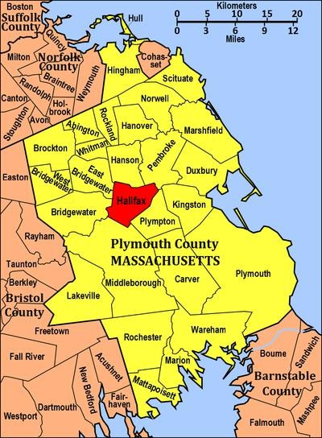

Brockton. Much of the town’s geography is dictated by water. The town lies on the western banks of Silver Lake, and is also the site of Robbins Pond, Indian Trail Reservoir and Burrage Pond in the west of town and East and West Monponsett Ponds near the Center of Town. The two Monponsett Ponds are separated by a strip of land barely 150 feet wide in some spots. This strip of land also accommodates part of MA Route 58. Part of the town’s border with Bridgewater is defined by the Taunton River, which also spans the Winnetuxet River and several brooks in town. On either side of the Monponsett Ponds lie swamps, with Great Cedar Swamp to the west and

Peterson Swamp to the east. The town also shares a small conservation area with neighboring Plympton and a larger Burrage Pond Wildlife Management Area with Hanson.

**Figure 1: Plymouth County Map**

The Town of Halifax can trace its history to 1669, the date of the earliest recorded history of the land, when the earliest European settlers, most notably the Bosworth Family from Bosworth Fields in England settled there. It was officially separated from the Town of Plympton and incorporated in 1734 and was named for Halifax, West Yorkshire, England.

The town was part of an early effort to create a canal between Buzzards Bay and Massachusetts Bay, when in 1795 a canal was proposed between the Taunton River and North River. However the plan never succeeded. The Town’s sawmills, cranberry production, iron furnaces and a wool mill were the main sources of industry and employment. The railroad came in the nineteenth century providing access for people from the city to the shores of Silver Lake and the Monponsett Ponds.

Today the town is mostly residential with a small retail area growing at the center of town. The population was fairly stable until the 1960’s, when suburban migration from Boston saw the town more than triple in population. According to the 2010 U.S. Census, the Town had a population of 7,518.

The Town’s two major routes are 58 and 106, which meet just east of the town center and south of the Monponsett Ponds. Route 36’s southern terminus meets Route 106. Route 105’s northern terminus is 1 ½ miles west of the intersection of Routes 58 and 106, at Route 106. The primary mode of transportation is the private automobile.

## Overview of a Housing Production Plan

The Massachusetts Department of Housing and Community Development (DHCD) defines a Housing Production Plan (HPP) as “a community's proactive strategy for planning and developing affordable housing by: creating a strategy to enable it to meet its affordable housing needs in a manner consistent with the Chapter 40B statute and regulations; and producing housing units in accordance with the HPP.”1 Chapter 40B, also known as the Massachusetts Comprehensive Permit Law (Chapter 774 of the Acts of 1969) is the statute under which Housing Production Plan regulations are issued, specifically 760 CMR 56.03(4). The regulation encourages communities to achieve the statutory minimum of 10% of their total year-round housing units on the Subsidized Housing Inventory (SHI).

To qualify for approval from DHCD, a Housing Production Plan must consist of three elements: a Comprehensive Needs Assessment, Affordable Housing Goals, and Implementation Strategies. The Comprehensive Needs Assessment is required to gain an understanding of who currently lives in the community, demographic trends affecting future growth, a community’s existing housing stock and the community’s future housing needs. The Affordable Housing Goals section identifies the appropriate mix of housing that is consistent with community needs, with particular attention paid to households with lower levels of income. This section also sets the community’s minimum affordable housing production goal, as determined by the total number of year-round housing units published in the most recent decennial Census. The minimum annual affordable housing production goal is greater or equal to 0.5% of the year-round housing stock.2 Lastly, the Implementation Strategies section consists of an explanation of the specific strategies by which the municipality will achieve its housing production goals as well as a timeframe/schedule for achieving the identified housing goals. This section also targets potential growth areas, identifies sites for development, assesses municipally owned land that the community has targeted for housing, and identifies regional housing development collaborations.

Upon completion of a HPP, the Plan must be approved by the Town’s Planning Board and Board of Selectmen and then sent to DHCD for review and approval. Once it is approved by DHCD, the Plan is valid for five years. Communities that have an approved HPP and that have met their 0.5% or 1.0% annual affordable housing production goals can apply to have their HPP certified by DHCD. Communities with certified HPPs have greater power in controlling new residential development because a decision by a community’s Zoning Board of Appeals (ZBA) to deny a Chapter 40B Comprehensive Permit application will be considered “consistent with local need”, meaning that the ZBAs decision to deny the permit would be upheld by DHCDs Housing Appeals Court (HAC).

A community invokes certification in the following manner under 760 CMR 56.03(4). If a community has achieved certification within 15 days of the opening of the local hearing for the Comprehensive Permit, the ZBA shall provide written notice to the Applicant, with a copy to DHCD, that it considers that a denial of the permit or the imposition of conditions or requirements would be consistent with local needs, the grounds that it believes have been met, and the factual basis for that position, including any necessary supportive documentation. If the applicant wishes to challenge ZBAs assertion, it must do so by providing written notice to the Department, with a copy to the Board, within 15 days of its receipt of the ZBAs notice, including any documentation to support its position. DHCD shall thereupon review the materials provided by both parties and issue a decision within 30 days of its receipt of all

1 Massachusetts Department of Housing and Community Development: Housing Production Plan: <http://www.mass.gov/hed/community/40b-plan/housing-production-plan.html>

2 Ibid.

materials. The ZBA shall have the burden of proving satisfaction of the grounds for asserting that a denial or approval with conditions would be consistent with local needs, provided, however, that any failure of DHCD to issue a timely decision shall be deemed a determination in favor of the municipality. This procedure shall toll the requirement to terminate the hearing within 180 days.

## Defining Affordable Housing

The U.S. Department of Housing and Urban Development (HUD) considers housing affordable if housing costs (including utilities) do not exceed 30% of a household’s income. When a household pays more than 30% of its income on housing (including utilities), it is considered to be cost burdened; when a household pays more than 50% of its income on housing (including utilities), it is considered to be severely cost burdened. As a result these households may have difficulty affording necessities such as food, clothing, transportation and medical care.

Affordable housing is also defined according to percentages of median income for an area. According to HUD, “extremely low income” housing is reserved for households earning at or below 30% of the Area Median Income (AMI); “very low income” households are households earning between 31% and 50% of the AMI; and “low income” households are households earning between 51% and 80% of the Area Median Income (AMI).

In assessing a community’s progress toward the Commonwealth’s 10% affordability goal, the Department of Housing and Community Development (DHCD) counts a housing unit as affordable if it is subsidized by state or federal programs that support households earning less than 80% of the AMI.

* + The units must be part of a subsidized development built by a public agency, non-profit or limited dividend organization;
  + At least 25% of the units in the development must be restricted to households earning less than 80% of the AMI and have rent or sale prices restricted to affordable levels. These restrictions must last at least 30 years;
  + The development must be subject to a regulatory agreement and monitored by a public agency or non-profit organization; and
  + Project owners must meet affirmative marketing requirements.

WHAT MAKES AFFORDABLE UNITS “COUNT” ON THE SHI?

Units must be:

1. Affordable to households with incomes at or below 80 percent of the Area Median Income.
2. Approved by a housing subsidy agency as eligible for a comprehensive permit or as “Local Action Units” (developed without a comprehensive permit).
3. Protected by a long-term affordable housing restriction; and
4. Marketed and sold or rented under a DHCD compliant Affirmative Fair Housing Marketing Plan.

# Comprehensive Housing Needs Assessment

An analysis of local demographic, housing stock, and housing affordability data reveals key characteristics and trends in Halifax that help explain housing need and demand. In order to understand how Halifax compares to other communities, Halifax’s data was compared to all of its neighboring communities as well as to Plymouth County and the Commonwealth of Massachusetts. The goal of this assessment is to provide a framework for housing production and to develop the strategies necessary to address the housing needs of Halifax.

## Demographics

This housing needs assessment is based on a thorough review of Halifax’s demographic profile. An analysis of population, household, age, race and ethnicity, education, disability, income and employment data was reviewed to help provide insight into the existing housing need and demand.

Key Findings

* + The population of Halifax increased 15.2% from 6,526 in 1990 to 7,518 in 2010. It is expected to decrease

-.93% between 2010 and 2040 to 7,448.

* + The number of households in Halifax increased 3.80% from 2,758 in 2000 to 2,863 in 2010. The number of households is expected to increase 12.36% between 2010 and 2040.
  + The majority of households in Halifax, 2,032 or 71%, are family households.
  + The average household size in Halifax decreased from 2.72 persons in 2000 to 2.63 persons in 2010. A significant majority (55.5%) of owner occupied households in Halifax consist of 2 people or less. There was a decrease in households consisting of 3, 4, 5 and 7 individuals, however and increase in the number of 6 person households, which may signify demand for family and multigenerational housing.
  + The town continues to age, as the population of Halifax over the age of 45 increased from 2000 to 2010, and the population under the age of 45 decreased during the same period. The population over 65 is expected to increase by 949 seniors by the year 2030.
  + The racial and ethnic composition of Halifax is largely homogenous, with 97% of the population identifying as white.
  + Enrollment at Halifax’s Public Schools remains stable. Population under age 15 is expected to decline by 289 minors by the year 2030.
  + The population of Halifax is well-educated, with 40.7% of the population age 25 and over having an Associate’s degree or higher.
  + Approximately 7.04% of the residents in Halifax reported having some type of disability in 2017. The most common types of disabilities were ambulatory difficulties, independent living difficulties, hearing and cognitive difficulties.
  + Halifax’s median household income was $77,993 in 2017, which trailed surrounding communities and the County, but exceeded the Commonwealth.
  + Approximately 29.9% of the households Halifax had an annual income of less than $50,000 in 2017.
  + The industries that employ the most residents of Halifax are the educational services, healthcare and social assistance industries (24.2%), construction (16.5%) and the retail trade industry (14.2%).
  + The unemployment rate in Halifax has steadily declined over the past five years, dropping from 6.4% in 2011 to 2.8% in 2018.

#### Population

From 1990 to 2010, Halifax’s population increased 15.2%, from 6,526 residents in 1990 to 7,518 residents in 2010. Halifax’s 15.2% increase in population trailed five neighboring communities including: Middleboro, Bridgewater, East Bridgewater, Pembroke and Plympton but surpassed the growth that occurred in Hanson as well as the County and the Commonwealth.

**Table 1: Population, 1990-2010**

*Source: U.S. Census Bureau, 1990, 2000, & 2010 Census*

The 2014 Metro Boston Population and Housing Projections indicate that Halifax’s population will decrease from 7,518 residents in 2010 to 7,448 residents by 2040. Halifax’s expected .93% decrease in population during this time period trails all of Halifax’s neighboring communities as well as the OCPC Region and the Commonwealth. The continued population growth in neighboring communities, the state and the County, suggests a continued increase in housing demand, although changes in household size and type will also have an impact on the type of housing that will be needed.

**Table 2: Projected Population, 2010-2040**

|  |  |  |  |  |  |
| --- | --- | --- | --- | --- | --- |
|  | **1990** | **2000** | **2010** | **Change 1990-2010** | |
| **Number** | **Percent** |
| Middleborough | 17,867 | 19,946 | 23,116 | 5,249 | 29.37% |
| Bridgewater | 21,249 | 25,196 | 26,563 | 5,314 | 25.00% |
| East Bridgewater | 11,104 | 12,952 | 13,794 | 2,690 | 24.22% |
| Pembroke | 14,544 | 16,927 | 17,837 | 3,293 | 22.60% |
| Plympton | 2,384 | 2,637 | 2,820 | 436 | 18.30% |
| **Halifax** | **6,526** | **7,500** | **7,518** | **992** | **15.20%** |
| Hanson | 9,028 | 9,495 | 10,209 | 1,181 | 13.08% |
| Massachusetts | 6,016,425 | 6,349,097 | 6,547,629 | 531,204 | 8.82% |
| Plymouth County | 435,276 | 472,822 | 494,919 | 59,643 | 13.70% |

|  |  |  |  |  |  |  |
| --- | --- | --- | --- | --- | --- | --- |
|  | **2010** | **2020** | **2030** | **2040** | **Change 2010-2040** | |
| **Number** | **Percent** |
| Middleborough | 23,116 | 25,407 | 27,245 | 28,131 | 5,015 | 21.70 % |
| Hanson | 10,209 | 10,734 | 11,237 | 11,351 | 1,142 | 11.19% |
| East Bridgewater | 13,794 | 14,492 | 15,057 | 14,967 | 1,173 | 8.50% |
| Plympton | 2,820 | 2,887 | 2,910 | 3,002 | 182 | 6.45% |
| Pembroke | 17,837 | 18,345 | 18,773 | 18,622 | 785 | 4.4% |
| Bridgewater | 25,563 | 27,055 | 27,619 | 27,456 | 1,893 | 3.36% |
| **Halifax** | **7,518** | **7,509** | **7,486** | **7,448** | **-70** | **-0.93%** |
| Massachusetts | 6,547,629 | 6,798,770 | 7,059,629 | 7,203,380 | 655,751 | 10.02% |
| OCPC Region | 348,527 | 361,527 | 372,470 | 372,907 | 24,380 | 7.00% |

*Source: Metro Boston Population and Housing Projections; January 2014*

#### Households

According to the U.S. Census Bureau, a household includes all people who occupy a housing unit, which can be a house, apartment, mobile home, group home or single room that is occupied as separate living quarters. The number of households in Halifax grew 3.80% from 2,758 in 2000 and 2,863 in 2010. Halifax’s 3.80% increase trailed the growth of all its neighbors, the County and the Commonwealth. The difference between household growth and population growth reflects the continuing decline in household size.

**Table 3: Households, 2000-2010**

*Source: U.S. Census Bureau, 2000 & 2010 Census*

Between 2010 and 2040, the number of households in Halifax is expected to increase from 2,863 in 2010 to 3,217 in 2040 according to the Mass DOT Demographic and Socio-Economic Forecast. Halifax’s 12.36% increase in the number of households trails the rate of growth that is expected to occur in all of the surrounding communities as well as the County and the Commonwealth.

**Table 4: Projected Households, 2010-2040**

|  |  |  |  |  |
| --- | --- | --- | --- | --- |
|  | **2000** | **2010** | **Change 2000-2010** | |
| **Number** | **Percent** |
| Middleborough | 6,981 | 8,468 | 1,487 | 21.30% |
| Plympton | 854 | 1,006 | 152 | 17.79% |
| Hanson | 3,123 | 3,468 | 345 | 11.04% |
| Pembroke | 5,750 | 6,298 | 548 | 9.53% |
| East Bridgewater | 4,344 | 4,750 | 406 | 9.34% |
| Bridgewater | 7,526 | 7,995 | 343 | 4.48% |
| **Halifax** | **2,758** | **2,863** | **105** | **3.80%** |
| Plymouth County | 168,361 | 181,126 | 12,765 | 7.58% |
| Massachusetts | 2,443,580 | 2,547,075 | 103,495 | 4.23% |

|  |  |  |  |  |  |  |
| --- | --- | --- | --- | --- | --- | --- |
|  | **2010** | **2020** | **2030** | **2040** | **Change 2010-2040** | |
| **Number** | **Percent** |
| Plympton | 1,006 | 1,212 | 1,345 | 1,415 | 409 | 40.65% |
| Hanson | 3,468 | 4,007 | 4,426 | 4,551 | 1,083 | 31.22% |
| Middleborough | 8,468 | 9,446 | 10,256 | 10,678 | 2,210 | 26.10% |
| East Bridgewater | 4,750 | 5,447 | 5,937 | 5,960 | 1,210 | 25.47% |
| Bridgewater | 7,995 | 8,907 | 9,637 | 9,725 | 1,730 | 21.63% |
| Pembroke | 6,298 | 7,073 | 7,601 | 7,633 | 1,335 | 21.19% |
| **Halifax** | **2,863** | **3,089** | **3,213** | **3,217** | **354** | **12.36%** |
| Plymouth County | 181,126 | 199,641 | 213,311 | 217,459 | 36,333 | 20.10% |
| Massachusetts | 2,547,075 | 2,725,127 | 2,884,084 | 2,973,292 | 426,217 | 16.70% |

*Source: MassDOT Demographics/Socio-Economic Forecasts* [*https://www.massdot.state.ma.us/planning/Main/MapsDataandReports/Data/Demographics.aspx*](https://www.massdot.state.ma.us/planning/Main/MapsDataandReports/Data/Demographics.aspx)

1. Household Types

Different household types often have different housing needs. As an example, a married couple with children usually require a larger dwelling unit than does a single person. A community’s composition of household types can indicate how well suited the existing housing inventory is to residents.

Halifax’s 2,863 households can be divided between family households and non-family households. Family households are defined as any household with two or more related persons living together, whereas non-family households are defined as one person or more than one non-related persons living together. In 2010, approximately 71.0% of Halifax’s households were family households and 29.0% were non-family households, which represented a decrease in the percentage of family households and an increase in the number of non-family households since 2000. In 2010, 32.1% of the households in Halifax included children under 18 years of age and 28.0% of households included residents aged 65 years and older. Between 2000 and 2010, the percentage of non- family households, people living alone, and senior citizens in the community has increased. These numbers suggest a need for smaller living spaces and for housing options suited for senior citizens.

**Table 5: Households Types in Halifax 2000-2010**

|  |  |  |  |  |  |  |
| --- | --- | --- | --- | --- | --- | --- |
|  | **2000** | | **2010** | | **Change 2000-2010** | |
| **Number** | **Percent** | **Number** | **Percent** | **Number** | **Percent** |
| Family Households | 2,055 | 74.5% | 2,032 | 71.0% | -23 | -1.11% |
| Husband-wife family | 1,690 | 61.3% | 1,619 | 56.5% | -71 | -4.20% |
| With own children under 18 years | 789 | 28.6% | 652 | 22.8% | -137 | -17.36% |
| Male householder, no wife present | N/A | N/A | 118 | 4.1% | N/A | N/A |
| With own children under 18 years | N/A | N/A | 46 | 1.6% | N/A | N/A |
| Female householder, no husband present | 273 | 9.9% | 295 | 10.3% | 22 | 8.05% |
| With own children under 18 years | 133 | 4.8% | 123 | 4.3% | -10 | -7.51% |
| Nonfamily Households | 703 | 25.5% | 831 | 29.0% | 128 | 18.20% |
| Householder living alone | 588 | 21.3% | 673 | 23.5% | 85 | 14.45% |
| Householder 65 years and over | 301 | 10.9% | 299 | 10.5% | -2 | -.66% |
| Households with individuals under 18  years | 1,042 | 37.8% | 919 | 32.1% | -123 | -11.80% |
| Households with  individuals 65 years and over | 722 | 26.2% | 801 | 28.0% | 105 | 10.94% |
| **Total Households** | **2,758** | **100.00%** | **2,863** | **100.00%** | **548** | **3.80%** |

*Source: U.S. Census Bureau, 2000 & 2010 Census*

*Source: U.S. Census Bureau, 2000 & 2010 Census*

#### Household Size

Another important factor when assessing the housing needs of a community is household size. According to the

U.S. Census Bureau, the average household size in Halifax decreased from 2.72 persons per household in 2000 to

2.63 persons per household in 2010. The decline in the average household size is also prevalent in most of Halifax’s neighboring communities as well as Plymouth County. According to the 2010 US Census in Halifax, the average household size for an owner occupied unit is 2.74 and the average household size of a renter occupied unit is 2.48.

From 2000 to 2010, the households that experienced the largest increase in Halifax were households consisting

of one (22.0%) and two (33.5%) people. This trend toward smaller household sizes suggests an increasing demand for smaller housing units. Although there was a decreases from 2000-2010 in 3, 4, 5, and 7 person households, there was a 53.33% increase in six person households, which may suggests a demand for blended family and multigenerational housing in the community.

**Table 6a: Owner Occupied Household Size in Halifax 2000-2010**

|  |  |  |  |  |  |  |
| --- | --- | --- | --- | --- | --- | --- |
|  | **2000** | | **2010** | | **Change 2000-2010** | |
| **Number** | **Percent** | **Number** | **Percent** | **Number** | **Percent** |
| *1 Person Household* | 505 | 20.0% | 579 | 22.0% | 74 | 14.65% |
| *2 Person Household* | 787 | 31.2% | 881 | 33.5% | 94 | 11.9% |
| *3 Person Household* | 488 | 19.4% | 459 | 17.5% | -29 | -5.94% |
| *4 Person*  *Household* | 453 | 18.0% | 8.0 | 15.3% | -50 | -11.03% |
| *5 Person Household* | 213 | 8.5% | 211 | 9.80% | -2 | -.93% |
| *6 Person*  *Household* | 45 | 1.8% | 69 | 2.6% | 24 | 53.33% |
| *7 or More Person Household* | 28 | 1.1% | 27 | 1.0% | -1 | -3.57% |
| **Totals** | **2,519** | **100.00%** | **2,629** | **100.00%** | **110** | **4.36%** |

*Source: U.S. Census Bureau, 2000 & 2010 Census*

5. Age Distribution

In order to determine how to meet future housing needs in Halifax, it is important to examine the current age of the population, as well as aging trends over time. Table 7 shows the population by age for the Town of Halifax from 2000 to 2010. The data shows significant population growth in all age groups above age 45.This trend reflects the growth and maturing of the “Baby Boom” generation (those born between 1946 and 1964) as they move across the age ranges. This aging trend is reflected in the increase in the median age, which rose from 37.5 years in 2000 to 42.8 years in 2010. According to MAPC’s population and Housing Projections, January 2014, Halifax’s total population less than 15 years of age is anticipated to decline by 289 minors between 2010 through 2030 under the Stronger Region Scenerio. The total population over 65 years is anticipated to increase by 949 seniors by 2030. The same study shows an increase in median age of the total population during the same time period of 4-6 years.

**Table 6b: Renter Occupied Household Size in Halifax 2000-2010**

|  |  |  |  |  |  |  |
| --- | --- | --- | --- | --- | --- | --- |
|  | **2000** | | **2010** | | **Change 2000-2010** | |
| **Number** | **Percent** | **Number** | **Percent** | **Number** | **Percent** |
| *1 Person*  *Household* | 83 | 34.7% | 94 | 40.2% | 11 | .13% |
| *2 Person Household* | 61 | 25.5% | 60 | 25.6% | -1 | -1.63% |
| *3 Person*  *Household* | 35 | 14.6% | 38 | 16.2% | 3 | 8.57% |
| *4 Person Household* | 31 | 13.0% | 25 | 10.7% | -6 | 19.35% |
| *5 Person*  *Household* | 19 | 7.9% | 12 | 5.1% | -7 | -36.84% |
| *6 Person Household* | 7 | 2.9% | 4 | 1.7% | -3 | -42.85% |
| *7 or More Person Household* | 3 | 1.3% | 1 | .40% | -2 | -66.66% |
| **Totals** | **239** | **100.00%** | **234** | **100.00%** | **-5** | **-2.09%** |

**Table 7: Age Distribution in Halifax, 2000-2010**

*Source: U.S. Census Bureau, 2000 & 2010 Census*

6. Race & Ethnicity

The racial and ethnic composition of Halifax has changed very little from 2000 to 2010. Halifax is a racially and linguistically homogenous community. In 2010, 97.0% of residents identified themselves as White, a very slight decrease from 98.1% in 2000. The American Indian, Asian, African American and two or more race populations saw the largest percentage increases from 2000 to 2010, with increases of 200%, 110%, 95.65% and 84.74% respectively.

**Table 8: Race and Ethnicity in Halifax 2000-2010**

|  |  |  |  |  |  |  |
| --- | --- | --- | --- | --- | --- | --- |
|  | **2000** | | **2010** | | **Change 2000-2010** | |
| **Number** | **Percent** | **Number** | **Percent** | **Number** | **Percent** |
| Under 5 Years | 518 | 6.9% | 376 | 5.0% | -142 | -27.41% |
| 5 to 9 Years | 544 | 7.3% | 456 | 6.1% | -88 | -16.17% |
| 10 to 14 Years | 546 | 7.3% | 554 | 7.4% | 8 | 1.46% |
| 15 to 19 Years | 472 | 6.3% | 515 | 6.9% | 43 | 9.11% |
| 20 to 24 Years | 297 | 4.0% | 351 | 4.7% | 54 | 18.18% |
| 25 to 34 Years | 1,026 | 13.7% | 709 | 9.4% | -317 | -30.89% |
| 35 to 44 Years | 1,329 | 17.7% | 1,122 | 14.9% | -207 | -15.57% |
| 45 to 54 Years | 1,098 | 14.6% | 1,297 | 17.2% | 199 | 18.12% |
| 55 to 64 Years | 711 | 9.5% | 1087 | 14.5% | 376 | 52.88% |
| 65 to 74 Years | 505 | 6.7% | 601 | 8.0% | 96 | 19.00% |
| 75 Years and Over | 454 | 6.0% | 450 | 6.0% | -4 | .88% |
| **Median Age (Years)** | **37.5** | **N/A** | **42.8** | **N/A** | **5.3** | **N/A** |

|  |  |  |  |  |  |  |
| --- | --- | --- | --- | --- | --- | --- |
|  | **2000** | | **2010** | | **Change 2000 - 2010** | |
| **Number** | **Percent** | **Number** | **Percent** | **Number** | **Percent** |
| *White Alone* | 7,360 | 98.1% | 7,291 | 97.0% | -69 | -.93% |
| *Black or African American Alone* | 23 | .30% | 45 | .60% | 22 | 95.65% |
| *American Indian or Alaskan Native Alone* | 2 | .00% | 6 | .10% | 4 | 200.% |
| *Asian Alone* | 20 | .30% | 42 | .60% | 22 | 110.% |
| *Native Hawaiian or Pacific Islander Alone* | 0 | .00% | 0 | .00% | 0 | 0 |
| *Some Other Race Alone* | 36 | .50% | 25 | .30% | -11 | -30.55% |
| *Two or More Races* | 59 | .80% | 109 | 1.40% | 50 | 84.74% |
| **Total Population** | **7,500** | **100.00%** | **7,518** | **100.00%** | **18** | **.24%** |
| *Hispanic or Latino (of any race)* | 41 | 0.50% | 81 | 1.10% | 40 | 97.56% |

*Source: U.S. Census Bureau, 2000 & 2010 Census*

#### School Enrollment

School enrollment trends are a critical component of Halifax’s growth and population trends. An analysis of school enrollment helps to frame a discussion of the potential future impacts of population change on both the school system and the community and helps better plan for future local housing needs.

For the purposes of this plan, we examined the enrollment numbers at the Elementary School in Halifax as well as the overall enrollment at Silver Lake Regional Middle and High Schools, where Halifax participates. According to data from the Massachusetts Department of Elementary and Secondary Education, enrollment at the Elementary School has been fairly stable in recent years. Enrollment peaked in 2004/05 at 712 students and has been on the decline since. With a high of 608 in 2018/19 and a low of 545 in 2015/16. Enrollment remains stable in recent years at the Silver Lake Regional Middle School and High School which currently services students from Halifax, Plympton and Kingston in grades 7-8 and 9-12 respectively.

Halifax & Silver Lake Regional School Enrollment

2000

1500

1000

500

0

96/97 00/01 04/05 08/09 12/13 14/15 15/16 16/17 17/18 18/19

Elementary School

Silver Lake Regional High

Silver Lake Regional Middle

Figure 2 shows the enrollment at Halifax Elementary School and Silver Lake Regional Middle and High Schools over the past 21 years.

Figure 2: Halifax Public School Enrollment

*Source: Massachusetts Department of Elementary and Secondary Education* [*http://profiles.doe.mass.edu/profiles/student.aspx?orgcode=02400010&orgtypecode=6&*](http://profiles.doe.mass.edu/profiles/student.aspx?orgcode=02400010&orgtypecode=6)

#### Educational Attainment

Table 9 shows the educational profile of adults aged 25 years and older in the region. In Halifax in 2017, 95.1% of those aged 25 years and older had a high school diploma or higher degree of education and 40.7% had an Associate’s degree or higher. These figures are slightly lower than many of Halifax’s neighboring communities, Plymouth County and the Commonwealth.

**Table 9: Educational Attainment (Ages 25+), 2017**

*Source: U.S. Census Bureau, 2013-2017 American Community Survey*

9. Disability Status

Understanding the needs of disabled residents of Halifax is a crucial aspect in planning for housing. There are 544 residents in Halifax that experience some type of disability, of which 27.03% were aged 65 years and over. The most common disability reported was an ambulatory disability, which is a disability that involves serious difficulty walking or climbing stairs. The next most common disabilities are independent living, hearing, cognitive difficulties, self-care and vision difficulties. It is important to note that some residents experience more than one disability, which is why the values in Figure 3 are greater than the total number of disabled residents.

**Table 10: Disabled Residents by Age in Halifax, 2017**

|  |  |  |  |  |  |  |
| --- | --- | --- | --- | --- | --- | --- |
|  | **Less than High School Diploma** | **High School Graduate or GED** | **Some College** | **Associate’s Degree** | **Bachelor’s Degree** | **Graduate or Professional Degree** |
| Bridgewater | 7.3% | 29.7% | 19.0% | 10.8% | 22.2% | 11.3% |
| East Bridgewater | 4.1% | 32.3% | 25.0% | 9.8% | 17.5% | 11.2% |
| **Halifax** | **4.8%** | **38.1%** | **16.3%** | **13.5%** | **17.5%** | **9.7%** |
| Hanson | 5.8% | 29.5% | 20.9% | 11.9% | 23.6% | 8.2% |
| Middleborough | 4.8% | 33.8% | 20.5% | 11.6% | 18.9% | 10.4% |
| Pembroke | 4.5% | 28.4% | 18.2% | 10.5% | 27.4% | 11.0% |
| Plympton | 5.2% | 34.6% | 16.5% | 11.6% | 21.0% | 11.2% |
| Plymouth County | 7.3% | 28.3% | 18.9% | 9.9% | 22.7% | 13.0% |
| Massachusetts | 9.7% | 24.7% | 15.8% | 7.7% | 23.4% | 18.7% |

|  |  |  |  |
| --- | --- | --- | --- |
|  | **Total Number of Residents** | **Disabled Residents** | |
| **Number** | **Percent** |
| *Disabled Children (Under 18 years)* | 1,608 | 35 | 2.17% |
| *Disabled Adults (18 to 64 years)* | 4,960 | 197 | 3.97% |
| *Disabled Seniors (65 years and over)* | 1,154 | 312 | 27.03% |
| **Totals** | **7,722** | **544** | **7.04%** |

*Source: U.S. Census Bureau, 2013-2017 American Community Survey*

**Figure 3: Disabilities Reported for Halifax Residents, 2017**

50

0

Difficulty

Difficulty

Difficulty

Living

Difficulty

Difficulty

Hearing Ambulatory

Self-Care Independent Cognitive

Vision

Difficulty

138

127

188

200

150

100

300

250 234 231

370

400

350

Disabilities by Type

*Source: U.S. Census Bureau, 2013-2017 American Community Survey*

Disabled residents often have unique housing needs, both in terms of physical design/accessibility of their homes as well as the cost relative to a fixed or limited income. For those reasons, an affordable housing plan should be sensitive to the needs of the disabled community and should incorporate their issues into the goals and strategies of all housing plans.

10. Income

Household income is defined as the total income of all people 15 years of age and older living in a household. The median household income of a community is determined by dividing the income distribution into two equal groups, one having incomes above the median, and the other having incomes below the median. The median household income in Halifax in 2017 was $77,993. When compared to the surrounding communities, Halifax’s median household income trailed all of its neighbors and the County, but exceeded the median household income of the Commonwealth.

**Figure 4: Median Household Income in Region, 2017**

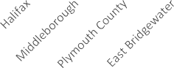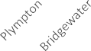

$120,000

$100,000

$77,993

$82,081

$80,000

$74,167

$60,000

$40,000

$20,000

$0

Less than $15,000

$15,000 to $24,999

$25,000 to $34,999

$35,000 to $49,999

$50,000 to $74,999

$75,000 to $99,999

$100,000 to $149,999

$150,000 or more

0%

5%

10%

15%

20%

25%

*Source: U.S. Census Bureau, 2013-2017 American Community Surve*y

While median household income is a valuable social and economic indicator, it does not account for the broad range of household incomes in a community. The 2017 American Community Survey (ACS) estimates showed that approximately 376 or 13.2% of the households in Halifax had an annual income of less than $25,000, and approximately 852 or 29.9% of the households in Halifax had an annual income of less than $50,000. The needs of low-income households are often overlooked in a community; this Housing Production Plan seeks to focus the

Town’s attention on the needs of its low-and moderate-income households.

**Figure 5: Household Income Distribution in Halifax, 2017**

*Source: U.S. Census Bureau, 2013-2017 American Community Survey*

#### 11. Employment

The residents of Halifax are employed in a variety of industries as shown in Table 11. The industries that employ the most residents are the educational services (24.2%), construction (16.5%) and the retail trade industry (14.2%). Employment data is important to review because it gives a sense as to how many people in Town are working in traditional high-paying industries such as management and finance versus people working in traditional low- paying industries, such as the retail, hospitality and food service industries.

**Table 11: Occupation of Residents by Industry, 2017**

|  |  |  |
| --- | --- | --- |
| **Industry** | **Number** | **Percent** |
| Educational services, healthcare and social assistance | 1,050 | 24.2% |
| Construction | 713 | 16.5% |
| Retail Trade | 614 | 14.2% |
| Professional, scientific, management, administrative and waste management services | 296 | 6.8% |
| Manufacturing | 295 | 6.8% |
| Finance, insurance, real estate rental and leasing | 290 | 6.7% |
| Transportation, warehousing and utilities | 250 | 5.8% |
| Arts, entertainment, recreation, accommodations and food services | 246 | 5.7% |
| Public administration | 184 | 4.2% |
| Wholesale Trade | 154 | 3.6% |
| Other services except public administration | 130 | 3.0% |
| Information | 59 | 1.4% |
| Agriculture, forestry, fishing, hunting and mining | 53 | 1.2% |
| **Total civilian employed population (16 years+)** | **4,334** | **100.00%** |

*Source: U.S. Census Bureau, 2013-2017 American Community Survey*

A related concern to employment and income is unemployment. Over the past several years, the unemployment rates in Halifax, its neighboring communities, the County and the Commonwealth have all dropped, as the economy continues to rebound from the most recent recession. Low unemployment rates are important in limiting the number of foreclosures as well as the overall strength of the housing market. In 2018, the unemployment rate in Halifax was 2.8%, which was lower than the County and the Commonwealth.

**Table 12: Annual Unemployment Rates, 2011-2017**

|  |  |  |  |  |  |  |  |  |
| --- | --- | --- | --- | --- | --- | --- | --- | --- |
|  | **2011** | **2012** | **2013** | **2014** | **2015** | **2016** | **2017** | **2018** |
| **Halifax** | **6.4%** | **6.4%** | **6.9%** | **6.2%** | **4.6%** | **3.4%** | **3.2%** | **2.8%** |
| Plymouth County | 7.8% | 7.1% | 7.0% | 6.1% | 5.2% | 4.1% | 3.9% | 3.5% |
| Massachusetts | 7.3% | 6.7% | 6.7% | 5.7% | 5.0% | 4.9% | 4.4% | 3.5% |

*Source: Massachusetts Executive Office of Labor and Workforce Development, based on May of each year.*

B.

Housing Stock Analysis

This section examines the characteristics and condition of the current housing stock and local housing market in

Halifax as well as the region. Included is an examination of the number of housing units, housing types, the age and condition of housing, household tenure, home sales trends, recent housing development, and projected housing demand.

Key Findings

* The number of housing units in Halifax increased 3.5% from 2,841 in 2000 to 2,941 in 2017.
* 70% of all housing units in Halifax are single-family detached structures.
* Halifax’s housing stock is relatively young, with 57.8% of Halifax’s housing stock being built after 1969, with 39.2% of that being built between 1970 and 1989.
* Most Halifax residents own their own home, as 88.4% of housing units are owner-occupied.
* Home ownership peaks in the 45 to 54 age group and then declines.
* Larger households in Halifax are more likely to purchase a home than rent, as 3+ person households account for 44.4% of owner-occupied households versus just 34.1% of renter-occupied households.
* Halifax’s housing market is very tight, with a 0% homeowner vacancy rate and a 0% rental vacancy rate.
* The median sales price of a single-family home in Halifax dipped during the recent recession, but has begun to climb in recent years. In 2018, the median sales price of a single-family home in Halifax was

$344,000 surpassing the high of $330,000 in 2005.

* Just like the median sales price, the number of single-family homes sold annually in Halifax dipped during the recent recession, but these numbers have also begun to climb in recent years. In 2018, there were 102 single-family home sales.
* The average sales price for a condominium in 2018 was $225,000.
* In 2018, there were 31 condominium sales.
* Between 2000 and 2017, Halifax issued permits for 311 housing units. 98% of these permits were for single-family homes.
* Halifax has a projected housing demand of 368 units by 2030 under MAPC’s Stronger Region Scenerio.

#### Housing Units

The number of housing units in Halifax increased by 100 units from 2,841 in 2000 to 2,941 units in 2017. Halifax’s 3.51% increase in the number of housing units trailed all of its neighbors, the County and the Commonwealth.

**Table 13: Total Housing Units, 2000-2017**

*Source: U.S. Census Bureau, 2000 Census & 2013-2017 American Community Survey*

1. Housing Unit Types

Halifax’s housing stock primarily consists of single-family detached homes. This type of housing accounts for 70% of the homes in Halifax. The remaining 30% of the housing stock consists of Mobile Homes (12.5%), single family attached homes (9.2%), 2 units (4.7%), 3-4 units (1.8%) and 5-9 units (1.2%) and 10-19 units (.5%).

**Table 14: Housing Units by Type in Halifax, 2017**

|  |  |  |  |  |
| --- | --- | --- | --- | --- |
|  | **2000** | **2017** | **Change 2000-2017** | |
| **Number** | **Percent** |
| Pembroke | 5,897 | 6,731 | 834 | 14.09% |
| East Bridgewater | 4,427 | 5,018 | 591 | 13.34% |
| **Halifax** | **2,841** | **2,941** | **100** | **3.51%** |
| Bridgewater | 7,652 | 8,435 | 783 | 10.23% |
| Hanson | 3,178 | 3,811 | 633 | 19.91% |
| Middleborough | 7,249 | 9,583 | 2,334 | 32.19% |
| Plympton | 872 | 1,067 | 195 | 22.36% |
| Plymouth County | 181,524 | 204,764 | 23,240 | 12.80% |
| Massachusetts | 2,621,989 | 2,864,989 | 243,000 | 9.26% |

|  |  |  |
| --- | --- | --- |
|  | **Number** | **Percent** |
| 1 unit, detached | 2,060 | 70.0% |
| 1 unit, attached | 271 | 9.2% |
| 2 units | 139 | 4.7% |
| 3 or 4 units | 53 | 1.8% |
| 5 to 9 units | 35 | 1.2% |
| 10 to 19 units | 15 | .5% |
| 20 or more units | 0 | .0% |
| Mobile Homes | 368 | 12.5% |
| **Totals** | **2,941** | **100.00%** |

*Source: U.S. Census Bureau, 2013-2017 American Community Survey*

#### Age and Condition of Housing

According to the 2013-2017 American Community Survey (ACS), approximately 57.8% of Halifax’s housing stock was built after 1969, with 39.2% of the total housing being built between 1970 and 1989.

**Table 15: Year Built of Residential Structure in Halifax, 2017**

*Source: U.S. Census Bureau, 2013-2017 American Community Survey*

1. Household Tenure

Data on housing tenure provides information as to the appropriate types of housing that is needed to accommodate current and future households. Table 16 compares Halifax’s housing occupancy and tenure with those of neighboring communities, Plymouth County and Massachusetts as a whole. As of 2017, 88.4% of the 2,519 occupied housing units in Halifax were owner-occupied. The percentage of housing units that were owner- occupied in Halifax trailed neighboring Hanson; but surpassed all other neighboring communities, as well as the County and the Commonwealth.

|  |  |  |
| --- | --- | --- |
|  | **Number** | **Percent** |
| Built 2014 or later | 12 | 0.4% |
| Built 2010 to 2013 | 87 | 3.0% |
| Built 2000 to 2009 | 179 | 6.1% |
| Built 1990 to 1999 | 269 | 9.1% |
| Built 1980 to 1989 | 454 | 15.4% |
| Built 1970 to 1979 | 700 | 23.8% |
| Built 1960 to 1969 | 413 | 14.0% |
| Built 1950 to 1959 | 253 | 8.6% |
| Built 1940 to 1949 | 208 | 7.1% |
| Built 1939 or earlier | 366 | 12.4% |
| **Totals** | **2,941** | **100.00%** |

**Table 16: Housing Tenure of Occupied Housing Units, 2017**

*Source: U.S. Census Bureau, 2013-2017 American Community Survey*

The age of householders, both owner-occupied and renter-occupied was also analyzed. Table 17 shows that home ownership peaks in the 45 to 54 age group and then declines.

**Table 17: Housing Tenure by Age in Halifax, 2010**

*Source: U.S. Census Bureau, 2010*

|  |  |  |  |  |
| --- | --- | --- | --- | --- |
|  | **Owner-Occupied** | | **Renter-Occupied** | |
| **Number** | **Percent** | **Number** | **Percent** |
| Pembroke | 5,676 | 87.8% | 788 | 12.2% |
| East Bridgewater | 4,065 | 83.7% | 789 | 16.3% |
| **Halifax** | **2,519** | **88.4%** | **331** | **11.6%** |
| Bridgewater | 5,829 | 73.8% | 2,068 | 26.2% |
| Hanson | 3,422 | 92.0% | 298 | 8.0% |
| Middleborough | 7,384 | 81.2% | 1,705 | 18.8% |
| Plympton | 870 | 86.6% | 135 | 13.4% |
| Plymouth County | 139,821 | 75.9% | 44,374 | 24.1% |
| Massachusetts | 1,612,329 | 62.4% | 973,386 | 37.6% |

|  |  |  |  |  |
| --- | --- | --- | --- | --- |
|  | **Owner-Occupied** | | **Renter-Occupied** | |
| **Number** | **Percent** | **Number** | **Percent** |
| 15 to 24 years | 14 | 0.5% | 5 | 2.1% |
| 25 to 34 years | 222 | 8.4% | 45 | 19.2% |
| 35 to 44 years | 476 | 18.1% | 58 | 24.8% |
| 45 to 54 years | 666 | 25.3% | 49 | 20.9% |
| 55 to 64 years | 597 | 22.7% | 32 | 13.7% |
| 65 to 74 years | 354 | 13.5% | 45 | 19.2% |
| 75 to 84 years | 219 | 8.3% | 77 | 5.1% |
| 85 years and over | 81 | 3.1% | 23 | 4.7% |
| **Totals** | **2,629** | **100.00%** | **234** | **100.00%** |

**Table 18: Housing Tenure by Household Size in Halifax, 2010**

*Source: U.S. Census Bureau, 2010*

The size of households, both owner-occupied and renter-occupied was analyzed as well. Table 18 shows that larger households in Halifax are far more likely to purchase a home than to rent, as 3+ person households account for 44.4% of owner-occupied households versus just 34.1% of renter-occupied households. Conversely, smaller households in Halifax are much more likely to rent than to purchase a home, as one and two person households account for 65.8% of renter-occupied households versus 55.5% of owner-occupied households.

5. Vacancy

Homeowner vacancy rates across the region, County and Commonwealth were extremely low, with none exceeding 2.5%. Rental vacancy rates varied a bit more, from zero in multiple communities up to 4.4% in Pembroke and 5.5% in the County. Low vacancy rates signify a tightening market and prices often respond by climbing. Halifax’s homeowner vacancy rate was 0% and the rental vacancy rate was 0%.

**Table 19: Housing Vacancy by Tenure, 2017**

|  |  |  |  |  |
| --- | --- | --- | --- | --- |
|  | **Owner-Occupied** | | **Renter-Occupied** | |
| **Number** | **Percent** | **Number** | **Percent** |
| 1-person household | 579 | 22.0% | 94 | 40.2% |
| 2-person household | 881 | 33.5% | 60 | 25.6% |
| 3-person household | 459 | 17.5% | 38 | 16.2% |
| 4-person household | 403 | 15.3% | 25 | 10.7% |
| 5-person household | 211 | 8.0% | 12 | 5.1% |
| 6-or-more person household | 96 | 3.6% | 5 | 2.1% |
| **Totals** | **2,629** | **100.00%** | **234** | **100.00%** |

|  |  |  |
| --- | --- | --- |
|  | **Homeowner** | **Rental** |
| Pembroke | 1.1% | 4.4% |
| **Halifax** | **0.0%** | **0.0%** |
| Hanson | 0.0% | 0.0% |
| East Bridgewater | 2.5% | 1.5% |
| Bridgewater | 1.0% | 2.4% |
| Middleborough | 0.8% | 3.3% |
| Plympton | 0.0% | 3.6% |
| **Plymouth County** | **1.0%** | **5.5%** |
| **Massachusetts** | **1.1%** | **4.0%** |

*Source: U.S. Census Bureau, 2013-2017 American Community Survey*

#### 6. Value of Owner Occupied Housing Units

In 2017, the median value of an owner-occupied housing unit in Halifax was $281,500. When broken down by value, 42.7% of the owner-occupied housing units in Halifax were valued at more than $300,000.

**Table 20: Value of Owner-Occupied Housing Units in Halifax, 2017**

$450,000

$400,000

$350,000

$300,000

$250,000

$200,000

$150,000

$100,000

$50,000

$0

Plympton

Halifax

Middleboro

Plymouth County Massachusetts

*Source: U.S. Census Bureau, 2013-2017 American Community Survey*

7. Median Sales Price

From 2000 to 2018 Halifax’s median sales price for a single-family home trailed all of its neighboring communities, the County and the Commonwealth, with the exception of Middleboro. Halifax’s median sales price during this period was $278,539 which was approximately $21,977 lower than the Plymouth County average and approximately $35,643 lower than the Commonwealth’s average. Figure 6a shows that sales prices peaked between 2004 and 2006 in the region, then dipped during The Great Recession. Prices have once again risen to exceed the 2004-2006 peak. In 2018, the average median price of a single family home in Halifax was $344,000, which exceeds the 2005 peak of $330,000. The graph shows how Halifax compares to the County, the Commonwealth and the neighboring communities with the lowest and highest median single family home prices.

**Figure 6a: Median Sales Price of Single Family Homes in the Region, 2000-2018**

|  |  |  |
| --- | --- | --- |
| **Value** | **Number** | **Percent** |
| Less than $99,999 | 318 | 12.6%. |
| $100,000 to $199,999 | 277 | 11.0% |
| $200,000 to $299,999 | 847 | 33.6% |
| $300,000 to $499,999 | 885 | 35.1% |
| $500,000 to $999,999 | 192 | 7.6% |
| $1,000,000 or More | 0 | 0.0% |
| **Total** | **2,519** | **100.00%** |

*Source: The Warren Group, Town Stats*

2000

2001

2002

2003

2004

2005

2006

2007

2008

2009

2010

2011

2012

2013

2014

2015

2016

2017

2018

Avg.

2000

2001

2002

2003

2004

2005

2006

2007

2008

2009

2010

2011

2012

2013

2014

2015

2016

2017

2018

AVG

From 2000 to 2018, Halifax’s median sales price for a condominium was $179,571. The median condominium price trailed all of its neighbors, the County and the Commonwealth, with the exception of Bridgewater. Halifax’s median condominium sales price trailed Plymouth County’s median by $49,821 and trailed the Commonwealth median by $93,259. Although condominium sales prices in Halifax declined during The Great Recession, the 2018 average of $225,000 is approaching the 2005 peak of $236,900. The graph shows Halifax, the County, the Commonwealth, Hanson who has the highest average and Bridgewater, who has the lowest average of condo sales prices amongst Halifax’s neighbors.

$400,000

$350,000

$300,000

$250,000

$200,000

$150,000

$100,000

$50,000

$0

Halifax

Massachusetts

Hanson

Bridgewater

Plymouth County

**Figure 6b: Median Sales Price of Condominiums in the Region, 2000-2018**

*Source: The Warren Group, Town Stats*

8. Number of Residential Sales

In 2018, there were 102 single-family homes sold in Halifax. This number was the second lowest amongst Halifax’s neighboring communities, trailing only Plympton with 36 units sold. Between 2000 and 2017, the median number of single-family homes sold in Halifax was 78 units per year. As was the case with single family home prices, Figure 7a below shows that the number of single family homes sold in each community also dipped during The Great Recession, but has begun to climb again in recent years.

**Figure 7a: Median Number of Single Family Homes Sold in the Region, 2000-2018**



Middleboro

East Bridgewater

Halifax

Bridgewater

Plympton

Pembroke Hanson

100

90

80

70

60

50

40

30

20

10

0

Bridgewater

Hanson

Pembroke

East Bridgewater

Middleboro

Halifax

Plympton

300

250

200

150

100

50

0

*Source: The Warren Group, Town Stats*

In 2018, 31 condominiums were sold in Halifax. From 2000-2018 the median number of condominiums sold in Halifax was 32 per year. This number was the one of the lowest amongst Halifax’s neighboring communities.

**Figure 7b: Number of Condominiums Sold, 2000-2018**

*Source: The Warren Group, Town Stats*

#### 9. Median Gross Rent

There is quite a range in the median gross rent in the region. At $1,138, Middleborough’s median gross rent is the lowest, while Halifax’s is second from the highest at $1,599, trailing only Pembroke at $1,633. It is hard to determine why there is such a difference in rent between these neighboring communities, but it may be due to the small sample size. There are relatively few opportunities for rental occupancy in many of these communities including Plympton (135 units), Hanson (298 units) and Halifax (331 units).

**Figure 8: Median Gross Rent in the Region, 2017**

40

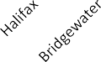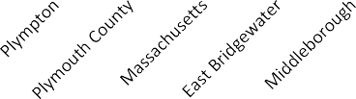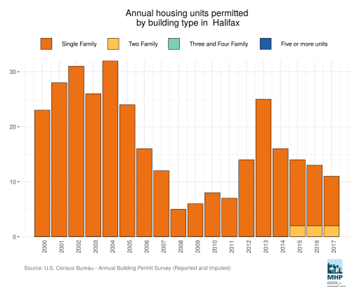

$1,800

$1,600

$1,400

$1,200

$1,000

$1,633

$1,599

$1,185 $1,173

$800

$600

$400

$200

$0

*Source: U.S. Census Bureau, 2013-2017 American Community Survey*

10. Housing Units Permitted

Between 2000 and 2017 Halifax issued permits for 311 housing units. Of those, 305 or 98% were for single-family homes and 6 or 2% were for two-family homes.

**Figure 9: Halifax -Housing Units Permitted, 2000-2017**

*Source: Mass Housing Partnership, DataTown*

#### Recent & Future Development

A map of potential housing sites identified by staff is provided for additional review and analysis and appears on page 76 of this document. The sites are numbered 1-6.

* 1. This 10 acre site is owned by the Housing Authority. It is located off of Thompson Street and west of Route 105 and has been the subject of past planning efforts. There are no current plans to expand at this time.
  2. This 4 acre site is owned by Halifax Country Club and is relatively close to the perceived center of town off the south side of Plymouth Street/Route 106 just west of the Intersection of Plymouth Street/Route 106 and Monponsett Street/Route 58. A 30 unit Chapter 40B proposal (10 buildings, 30 units, 8 to be affordable) is proposed for this site or a similar site in the area. It is before Mass Housing for initial site approval.
  3. Approximately 48 acres, including some wetlands, is located on Garden Road, just south of the commuter rail station off Route 36, Holmes Street. This is a unique opportunity for transit oriented development. The owner has advertised it for possible mixed use development in the past, but there was no movement.
  4. Approximately 86 acres of land on the east side of Route 58 near the Plympton town line. It is located on a major road, but it is unlikely to have future bus service as compared to site 2. There have not been any recent inquiries regarding this property.
  5. Approximately 147 acres (including significant wetlands) of Cumberland Farms/Haseotes land south of River Street and Wood Street. This land is located farthest from the Center of Town and in an area with commonly difficult soils and a high water table. A developer has started construction work on a solar facility on a piece of the parcel. Another piece is being considered for marijuana cultivation, though the cultivator has not filed the necessary permits with the State and the ZBA.
  6. No longer available for development as seven unit subdivision is under construction.

#### Projected Housing Demand

To determine future housing demand in Halifax, OCPC utilized the Metropolitan Area Planning Council’s (MAPC) *Population and Housing Demand Projections for Metro Boston*. MAPC projected the number of households using age-specific headship rates and municipal specific housing occupancy patterns and vacancy rates. Total household change and housing unit demand are shown in the tables below. New housing demand will outpace population growth due to declining household size.

##### Table 21a: Households and Housing Demand, 2000-2030 – Stronger Region Scenerio

|  |  |  |  |  |
| --- | --- | --- | --- | --- |
|  | 2000 | 2010 | 2020 | 2030 |
| Households | **2,758** | **2,863** | **3,089** | **3,214** |
| Housing Units | **2,841** | **3,014** | **3,255** | **3,382** |

*Source: Metro Boston 2030 Population and Housing Demand Projections*

According MAPC’s Stronger Region Scenario, Halifax has a projected demand for 241 new housing units by 2020 and 368 new housing units by 2030 when compared to the 2010 census numbers.

##### Table 21b: Households and Housing Demand, 2000-2030 – Status Quo Scenerio

|  |  |  |  |  |
| --- | --- | --- | --- | --- |
|  | 2000 | 2010 | 2020 | 2030 |
| Households | **2,758** | **2,863** | **3,043** | **3,126** |
| Housing Units | **2,841** | **3,014** | **3,208** | **3,292** |

*Source: Metro Boston 2030 Population and Housing Demand Projections*

According MAPC’s Status Quo Region Scenario, Halifax has a projected demand for 194 new housing units by 2020 and 278 new housing units by 2030 when compared to the 2010 census numbers.

## C. Housing Affordability

This section of the Plan examines the affordability of Halifax’s housing stock to its residents. Included is an analysis of the town’s poverty rate, the number of households eligible for assistance, rent prices, its current subsidized housing inventory, housing burdens by household type, and the number of foreclosures.

Key Findings

* Elderly (over the age of 65) have the highest levels of poverty in Halifax.
* Approximately 5.4% of Halifax families are below the federal poverty level; however, some family types are more likely to live in poverty, such as female householders with no husband present.
* Approximately 4.6% of individuals in Halifax are below the federal poverty level.
* 1,175 or 41.22% of the households in Halifax are considered to be low-income, earning less than 80% of the Area Median Income (AMI) and potentially eligible for federal and state housing assistance.
* Fair Market Rents (FMR) for the **Brockton, MA-NH HUD Metro FMR Area** have continued to rise.
* 28 units or .94% of Halifax’s housing units are on the state’s Subsidized Housing Inventory (SHI).
* 44% of owner-occupied households and 14% of renter-occupied households in Haifax are cost burdened (paying more than 30% of their gross income on housing).
* According to a Housing Affordability Gap Analysis, there is approximately a $46,700 gap between the cost of the average median single-family home and the cost of a home that the family earning the HUD Area Median Family Income of $93,400 can afford in Halifax.

1.

Poverty Rate

Halifax has a relatively low rate of individuals below the federal poverty level, which was $12,490 for a household

of one in 2019. Halifax’s poverty rate for all individuals was 4.6% in 2017, which was less than both Plymouth County’s rate of 8.0% and the Commonwealth’s rate of 11.1%. Individuals most likely to live in poverty in Halifax are individuals over 65 years old, which is consistent with regional, state, and national trends. US Census data reports no children under the age of 18 years in Halifax living below the poverty level, which is inconsistent with the state and county.

**Table 22a: Percentage of Individuals in Halifax Living below the Poverty Level, 2017**

|  |  |  |  |
| --- | --- | --- | --- |
| **Age Range** | **Total Number** | **Below Poverty** | |
| **Number** | **Percent** |
| All Individuals | 7,699 | 356 | 4.6% |
| Under 18 Years | 1,568 | 0 | 0.0% |
| 18 to 64 Years | 4,977 | 271 | 5.4% |
| 65 Years and Over | 1,154 | 85 | 7.4% |

*Source: U.S. Census Bureau, 2013-2017 American Community Survey*

In terms of families, Halifax has a low rate of families below the federal poverty level, which is $25,750 for a household of four in 2019. Halifax’s poverty rate for all families is 5.4%, which is less than both Plymouth County’s rate of 5.8% and the Commonwealth’s rate of 7.8% The family type most likely to live in poverty in Halifax are female householders with no husband present.

**Table 22b: Percentage of Families in Halifax below the Poverty Level, 2017**

*Source: U.S. Census Bureau, 2013-2017 American Community Survey*

1. Households Eligible for Housing Assistance

One measure of the need for affordable housing in a community is the number of households eligible for housing assistance. Federal and state programs use Area Median Income (AMI), along with household size to identify these households. Table 23 shows the U.S. Department of Housing and Urban Development (HUD) income limits for extremely low-income (below 30% of AMI), very low-income (30-50% of AMI), and low income (50-80% of AMI) households by household size for the Brockton, MA-NH HUD Metro FMR Area, which includes Halifax. Households at 80% of AMI and below are eligible for housing assistance, adjusted for household size.

**Table 23: FY2019 Affordable Housing Income Limits Brockton, MA-NH HUD Metro FMR Area**

|  |  |  |  |
| --- | --- | --- | --- |
| **Family Type** | **Total Number** | **Below Poverty** | |
| **Number** | **Percent** |
| All Families | 2,082 | 112 | 5.4% |
| With related children under 18 years | 903 | 0 | 0.0% |
| Married-Couple Families | 1,758 | 40 | 2.3% |
| With related children under 18 years | 766 | 0 | 0.0% |
| Female Householder, No Husband Present | 180 | 14 | 7.8% |
| With related children under 18 years | 81 | 0 | 0.0% |

|  |  |  |  |
| --- | --- | --- | --- |
| **Persons in Family** | **Extremely Low (30%) Income Limits** | **Very Low (50%) Income Limits** | **Low (80%)**  **Income Limits** |
| 1 | $19,450 | $32,400 | $51,800 |
| 2 | $22,200 | $37,000 | $59,200 |
| 3 | $25,000 | $41,650 | $66,600 |
| 4 | $27,750 | $46,250 | $74,000 |
| 5 | $30,170 | $49,950 | $79,950 |
| 6 | $34,590 | $53,650 | $85,850 |
| 7 | $39,010 | $57,350 | $91,800 |
| 8 | $43,430 | $61,050 | $97,700 |

*Source: U.S. Department of Housing and Urban Development (HUD)*

According to the most recent CHAS data available (2011-2015 estimates), 1,175 households or 41.22% of all households in Halifax are low-income households with a household income <=80% HAMFI. Of that population, 225 households are extremely low-income (<30% AMI) and 465 are very low-income (30%-50% AMI).

**Table 24: Halifax – Income Distribution**

*Source: HUD Comprehensive Housing Affordability Strategy (CHAS), 2011-2015*

3. Fair Market Rents

Another measure of housing affordability is whether local rents exceed the Fair Market Rents (FMR) or maximum allowable rents (not including utility and other allowances), determined by HUD for subsidized units in the **Brockton MA-NH HUD Metro FMR Area.** As seen in Figure 10, FMR have varied depending on the number of bedrooms in a unit. Rents for all types of apartments are on the rise. In 2019, studio apartment rent is $1,027, one bedroom $1,136, two bedroom, $1,475, three bedroom $1,853, four bedroom $2,155. A September 2019 search of Apartments.com showed only one (1), one-bedroom apartment available for rent in Halifax starting at

$1,100 per month.

**Figure 10: Fair Market Rent, Brockton, MA HUD Metro FMR Area**

$2,500

$2,000

$1,500

$1,000

$500

$0

FY2012 FY2013 FY2014 FY2015 FY2016 FY2017 FY2018 FY19

Efficiency One-Bedroom Two-Bedroom Three-Bedroom Four-Bedroom

|  |  |  |  |
| --- | --- | --- | --- |
|  | **Owner** | **Renter** | **Total Households** |
| Household income <=30% HAMFI | 225 | 0 | 225 |
| Household income >=30% to <=50% HAMFI | 410 | 55 | 465 |
| Household income >=50% to <=80% HAMFI | 470 | 15 | 485 |
| Household income >=80% to <=100% HAMFI | 285 | 0 | 285 |
| Household Income >100% HAMFI | 1,205 | 185 | 1,390 |
| **Total** | **2,595** | **255** | **2,850** |

*Source: U.S. Department of Housing and Urban Development (HUD)*

#### Current M.G.L. Chapter 40B Subsidized Housing Inventory

According to M.G.L. Chapter 40B, affordable housing is defined as housing that is developed or operated by a public or private entity and is reserved by deed restriction for income-eligible households at or below 80% of the Area Median Income (AMI). The regulation encourages communities to achieve the statutory minimum of 10% of their total year-round housing units on the Subsidized Housing Inventory (SHI).

**Figure 11: Percentage of Subsidized Housing Inventory*- Region, September 2017**

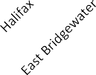

*Source: *Halifax’s .94% figure is from DHCDs Chapter 40B Subsidized Housing Inventory Detailed Report Dated 11-21-16 and State Wide report 9-2017*

Housing that meets these requirements, if approved by DHCD, are added to the SHI. A community’s SHI fluctuates with new development of both affordable and market-rate housing. The SHI percentage is determined by dividing the number of affordable units by the total number of year-round housing units in the most recent decennial Census.

**Table 25: Summary of Halifax’s Subsidized Housing Inventory**

10.0%

8.0%

6.0%

4.0%

2.0%

0.0%

|  |  |  |  |  |  |  |
| --- | --- | --- | --- | --- | --- | --- |
| **Project Name** | **Address** | **SHI**  **Units** | **Comp Permit** | **Year End** | **Tenure** | **Subsidizing Agency** |
| n/a | 1 Parsons Lane | 20 | no | Perp | Rental | DHCD |
| n/a | Monponsett Street | 4 | no | Perp | Rental | DHCD |
| n/a | 11th Avenue Homes/Chestnut | 4 | no | Perp | Rental | DHCD |

*Source: Massachusetts Department of Housing and Community Development*

Halifax’s current SHI dated November 2016, includes 28 housing units or .94% of the town’s 2,971 housing units (based on the 2010 census). All of the units are rental units. None of the units are ownership units. None of the units were developed via a Comprehensive Permit. The Town’s most recent SHI is included in the Appendix. When compared to its neighboring communities, Halifax trails all of them in the production of affordable housing.

In order to address unmet housing needs and to be compliant with M.G.L. Chapter 40B, Halifax needs an additional 269 units in order to achieve the M.G.L. Chapter 40B requirement of 10% of the year-round housing inventory designated for households earning at or below 80% of the AMI. To demonstrate progress towards meeting the 10% goal, the Town should set production goals of .05% (15 units) or 1% (30) units for two years to be granted relief from Comprehensive permit projects for one and two years respectively. In the future, the town should ensure that new housing developments include units that can be added to the SHI, so the Town can keep pace with the Commonwealth’s Chapter 40B requirement. There is a 30 unit 40B proposal before MassHousing Partnership for initial approval or site eligibility of the project/site. The location is off the South side of Plymouth Street/Route 106 just west of the intersection of Plymouth Street/Route 106 and Monponsett Street/Route 58.

**Table 25a. Summary of Housing Production Goals Based on Priority Needs**

|  |  |  |  |  |
| --- | --- | --- | --- | --- |
| Type of Units | Target Population | Annual Goals | 5 Year Goals | |
| Preservation of Existing  Housing Stock | <80% AMI  Ownership & Rentals | **28** | **28** | |
|  |  |  |  | |
| Increase the number of  Affordable Units | <80% AMI | **15** | **75** | |
| Rental Housing | <80% AMI Seniors (20%) | 3 | 15 | |
| Rental Housing | <80% AMI Individuals &  Disabled (20%) | 3 | 15 | |
| Rental Housing | <80% AMI Families (50%) | 7 | 35 | |
| First Time  Homeownership | 80% AMI (10%) | **2** | **10** | |
| TOTALS |  | 15 | **75** | |
| 5. Housing Cost Burden  Another way to determine if housing is affordable in a community is to analyze monthly housing costs as a percentage of household income. HUD defines households that spend more than 30% of their gross income on housing to be cost burdened. When analyzing the percentage of owner-occupied households that are cost burdened among its neighboring communities, Halifax has highest percentage at 44%. When analyzing the percentage of renter-occupied households that are cost burdened, Halifax has the lowest percentage at 14%. In the case of most of these communities, with the exception being Halifax, the percentage of renter-occupied  households that are cost burdened is higher than the percentage of owner-occupied households that are cost | | | |  |

burdened.

**Figure 12: Percentage of Owner-Occupied Cost Burdened Households, 2017**

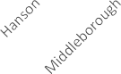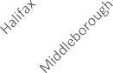

70%

60%

59%

60%

51%

52%

54%

50%

47%

40%

30%

20%

14%

10%

0%

50%

45%

40%

35%

30%

25%

20%

15%

10%

5%

0%

44%

41%

30%

27%

25%

25%

25%

*Source: U.S. Census Bureau, 2013-2017 American Community Survey*

**Figure 13: Percentage of Renter-Occupied Cost Burdened Households, 2017**

*Source: U.S. Census Bureau, 2013-2017 American Community Survey*

6. Rental Affordability for Current Households The median gross rent for Halifax in 2017 was $1,599; which placed it second among neighboring communities, trailing only Pembroke at $1,633. The median gross rent in Plymouth County was $1,185.

2-bedroom apartment. The estimated mean renter wage in the Massachusetts is $20.72, which is $9.18 more than the Brockton average mean renter wage of

$11.54 (2019). In this area, someone making the mean renter wage would need to work ninety-eight hours a week to afford the FMR for a 2-bedroom apartment. The monthly rent affordable at mean wage is $600.

**Wages needed to afford Fair Market Rent in MA in 2019**

In the Brockton MA HUD Area the Fair Market Rent (FMR) for a two-bedroom apartment is $1,475. To afford this level of rent and utilities- without paying more than 30% of income on housing – a household must earn 5$9,000 annually. Assuming a 40-hour work week, 52 weeks per year, this level of income translates into a housing wage of $28.37.

In MA, a minimum wage worker earns an hourly wage of

$12.00. The rent affordable at minimum wage is $624 per month. To afford the FMR for a 2- bedroom apartment of

$1,475, a minimum wage earner must work 95 hours per week, 52 weeks per year.

In MA, the estimated mean (average) wage for a renter is

$20.72. The rent affordable at the mean renter wage is $600. To afford the FMR for a 2- bedroom apartment of $1,475 at this wage, a renter must work 98 hours per week, 52 weeks per year or, working 40 hours per week year-round, a household must include 2.45 workers earning the mean renter wage to make the two bedroom FMR affordable.

IN MA and the Brockton HMFA area, the Supplemental Social Security (SSI) monthly payment is $885, which means the rent affordable to an SSI recipient is $266 per month.

Source: National Low Income Housing Coalition, Out of Reach 2019 MA

In 2019, Federal minimum wage was $7.25 per hour, Massachusetts minimum wage is $12.00 per hour. The estimated average hourly wage of $20.72 is earned by renters statewide. The average monthly rent affordable at minimum wage is $600.

Fair Market Rent in the Brockton area is $1,475 for a

*STRATEGY IMPLICATIONS*

*As income levels rise, housing costs will also rise, potentially leaving long-term residents with limited housing options. Consideration should be given to developing strategies and/or funding mechanis ms to assist those who may need help with housing as costs rise beyond their means.*

**Table 26: Halifax – Income by Cost Burden (Renters Only)**

*Cost burden is the ratio of housing costs to household income. For renters, housing cost includes gross rent (contract housing cost) plus utilities.*

*Source: HUD Comprehensive Housing Affordability Strategy (CHAS), 2011-2015*

7. Homeownership Affordability for Current Households

The U.S. Department of Housing and Urban Development (HUD) defines households that spend more than 30% of their gross income on housing costs to be “cost burdened” and households that spend more than 50% of their gross income on housing costs to be “severely cost burdened”. For homeowners, housing cost include mortgage payments, utilities, association fees, insurance and real estate taxes. As can be seen in table 27, 1,010 of

Halifax’s households are cost burdened and 525 households are severely cost burdened.

**Table 27: Halifax – Income by Cost Burden (Owners Only)**

*Cost burden is the ratio of housing costs to household income. For owners housing cost includes mortgage payment, utilities, association fees, insurance and real estate taxes.*

|  |  |  |  |
| --- | --- | --- | --- |
|  | **Cost Burden**  **>30%** | **Cost Burden**  **>50%** | **Total** |
| Household income <=30% HAMFI | 0 | 0 | 0 |
| Household income >=30% to <=50% HAMFI | 40 | 15 | 55 |
| Household income >=50% to <=80% HAMFI | 15 | 0 | 15 |
| Household income >=80% to <=100% HAMFI | 0 | 0 | 0 |
| Household Income >100% HAMFI | 0 | 0 | 0 |
| **Total** | **55** | **15** | **255** |

|  |  |  |  |
| --- | --- | --- | --- |
|  | **Cost Burden**  **>30%** | **Cost Burden**  **>50%** | **Total** |
| Household income <=30% HAMFI | 200 | 185 | 225 |
| Household income >=30% to <=50% HAMFI | 345 | 215 | 410 |
| Household income >=50% to <=80% HAMFI | 225 | 100 | 470 |
| Household income >=80% to <=100% HAMFI | 165 | 25 | 285 |
| Household Income >100% HAMFI | 75 | 0 | 1,205 |
| **Total** | **1,010** | **525** | **2,595** |

*Source: HUD Comprehensive Housing Affordability Strategy (CHAS), 2011-2015*

#### Housing Affordability Gap

Another way to measure the housing cost burden in a community is to conduct a Housing Affordability Gap Analysis. According to an analysis of single-family ownership costs in 2018, when compared to the single-family median sales price homes in Halifax, there is an affordability gap of $91,700 or more for households making less than the HUD Area Median Family Income (AMFI) of $84,100 in 2018 (Halifax is part of the Brockton, MA-NH HUD METRO FMR AREA). These figures, including the aforementioned housing burden figures indicate a need for more affordable housing – both in terms of market rate housing and subsidized housing.

**Table 28: Halifax Housing Affordability Gap, 2010-2018 (Single Family Homes)**

|  |  |  |  |  |
| --- | --- | --- | --- | --- |
|  | **A** | **B** | **C** | **D** |
| **HUD MFI** | **“Affordable Price” (A x 3)** | **Single Family Home Median Sales Price** | **“Affordability Gap” (C – B)** |
| 2010 | $79,800 | $239,400 | $265,000 | $25,6000 |
| 2011 | $82,600 | $247,800 | $235,000 | ($12,800) |
| 2012 | $83,700 | $251,100 | $245,000 | ($6,100) |
| 2013 | $78,300 | $234,900 | $277,250 | $42,350 |
| 2014 | $80,700 | $242,100 | $260,000 | $17,900 |
| 2015 | $81,200 | $243,600 | $258,500 | $14,900 |
| 2016 | $87,100 | $261,300 | $322,500 | $61,200 |
| 2017 | $81,000 | $243,000 | $320,000 | $77,000 |
| 2018 | $84,100 | $252,300 | $344,000 | $91,700 |

*Source: U.S. Department of Housing & Urban Development (HUD) & The Warren Group*

#### Waiting list for Affordable Housing

To assist in understanding the great need for affordable housing in Halifax, the waiting list for the Halifax Housing Authority are summarized below. Waits for public housing units total more than

**Commented [LS1]:** Check with Charlie, SHI versus Housing Authority Capacity

295 households, with the greatest demand for family units for which there is the least capacity.

**Table 29: Halifax Housing Authority Capacity**

|  |  |  |  |
| --- | --- | --- | --- |
| **Type of Unit** | **Current Number of Units** | **Number of Households**  **on Waiting list** | **Wait List Ratio** |
| **Elderly/Disabled** | **20** | **62** | **3.2** |
| **Family** | **7** | **233** | **33.2** |
| **Total** | **27** | **295** | **10.92** |

*Source: Pembroke Housing Authority which administers the available housing in Halifax*

There are 62 applicants on the waitlist for elderly/disabled (single bedroom) units. 22 of the 62 applicants are interested in accessible units. There are 233 applicants for family units. The Town can continue to request local preference as housing units are developed, if the desire is to serve local families, residents and veterans first.

In many regulated affordable housing developments, there are options for setting aside units for those with a Local Preference. The exact percentage and the precise definition for this Local Preference, or any other preferences, vary by project and are regulated within a specific affordable housing program. The local preference set-aside was created to allow communities to provide opportunities for their own, as a benefit for increasing affordable housing, though the details often vary between projects and programs.

The 40B units are often regulated by MassHousing and the Department of Housing and Community Development (DHCD) under the Local Initiative Program, using the regulations promulgated at 760 CMR 56 and Comprehensive Permit Guidelines published by DHCD. This guidance (which is the subject of this information), allows the Local Preference option of 70% of the units in a project (rounded down) to be set aside for local preference applicants, with all applicants eligible for the other 30%. [Note that 40B is a permitting mechanism for projects across many programs.

1. Allowable Preference Categories
2. Current residents: A household in which one or more members is living in the city or town at the time of application. Documentation of residency should be provided, such as rent receipts, utility bills, street listing or voter registration listing.
3. Municipal Employees: Employees of the municipality, such as teachers, janitors, firefighters, police officers, librarians, or town hall employees.
4. Employees of Local Businesses: Employees of businesses located in the municipality.
5. Households with children attending the locality’s schools, such as METCO students.
6. When determining the preference categories, the geographic boundaries of the local resident preference area may not be smaller than municipal boundaries.
7. Durational requirements related to local preferences, for example, how long an applicant has lived in or worked in the residency preference area, are not permitted in any case.
8. Preferences extended to local residents should also be made available not only to applicants who work in the preference area, but also to applicants who have been hired to work in the preference area, applicants who demonstrate that they expect to live in the preference area because of a bona fide offer of employment, and applicant households with children attending the locality’s schools, such as METCO students.
9. A preference for households that work in the community must not discriminate (including have a disproportionate effect of exclusion) against persons with disabilities and elderly households in violation of fair housing laws

Some publicly funded housing offers veterans' preference to veterans with wartime service who have a discharge or release under honorable conditions. As a veteran, you may qualify for veterans' preference. Disabled veterans can contact the Massachusetts Accessible Housing Registry for assistance

# Challenges to Producing Affordable Housing

Halifax has been slow to attract and develop 10% of its year round housing units in affordable housing, despite in part due to the reliance on private septic systems, automobile dependence, large lots requirements and zoning bylaws that favor single-family homes. The town hopes by implementation of a Housing Production Plan, that they can reach their affordable housing goals and produce and maintain diverse housing options for all income levels. This section examines land constraints and limitations that have an impact on future

development in Halifax. It includes an analysis of land use, an assessment of the natural and built environment, as well as an analysis of zoning, infrastructure and transportation.

## A. Land Availability

According to MassGIS L3 parcel file, which categorizes each parcel by type or land use, it was found that Halifax has 6,299.5 acres of wetlands of which 982 acres is open water. 2,259.6 acres is permanently protected open space and 288.6 acres are classified as other open space. 2,858.6 acres are located within the 100-year flood zone. Approximately 479 acres of developable land remains though this development may be constrained by

the Town’s many wetlands and floodplains, its need for onsite wastewater systems and large lot zoning requirements.

1. Watershed Areas

A watershed consists of an area of land where run-off from higher elevations is channeled into a specific body of water such as a pond, lake, river or ocean. Halifax is located within the Taunton River Watershed, one of 28 major watersheds in Massachusetts. The Taunton River Watershed is a 562-square mile watershed that spans over all of 20 towns and part of 23 others municipalities. In addition, Halifax has its own local watershed protection group called the Monponsett Watershed Association which focuses on monitoring the quality and restoring of the East and West Monponsett Ponds, which in addition to Silver Lake supply drinking water to the City of Brockton.

The purpose of the Floodplain and Watershed Protection District is to protect the health and safety of persons against the hazards of flooding, to conserve the value of land and buildings, to facilitate the adequate provision of a water supply through preservation and maintenance of the groundwater table, to protect and to preserve the marches, bogs, ponds and water courses and their adjoining wetlands, to encourage the most appropriate use of wetlands, to encourage the most appropriate use of the land and to preserve and increase the amenities of the Town.

1. Protected Open Space, Wetlands & Floodplains

Halifax’s terrain is relatively low with many small hilly upland areas surrounded by extensive low-lying areas, ranging from well-drained to poorly-drained areas; some of these areas have been developed as cranberry bogs. The Winnetuxet River creates extensive areas of flood plain, most of which remains a wooded swamp. The fact that 43% of the land consists of poorly or extremely-poorly drained organic and mineral soils significantly limits areas for new development. In addition to these challenges associated with poor soil conditions and wetlands, Halifax’s many ponds comprise about 982 acres of open water that are fed and drained by a web of streams and

brooks. These water bodies are not only important habitats for a wide range of wildlife, but also offer recreational and scenic values in addition to the town’s potable water supply. The Town has extensive wetlands, freshwater and river front protection act 100’ buffer areas. These have significant development constraints. These areas are protected via Halifax’s Wetlands Protection Bylaw and Halifax’s Floodplain and Watershed Protection District. The purpose of the Wetlands Protection Bylaw is to protect the wetlands, water resources, flood prone areas, and adjoining upland areas in the Town of Halifax.

## D. Water & Sewer

Halifax’s town water system is well developed and supplies are understood to be adequate for moderate growth. The 2003 Community Development Plan noted that “the maximum permittable build out under present zoning and disposal conditions” would increase average daily consumption from the 1.37 million gallons/day (MGD) of 2002 to 1.72 MGD, or 47.5% of the maximum safe yield of 3.62 MGD. Thus water supplies are not a constraint. Halifax has no wastewater collection and treatment facilities, though this lack can be partially mitigated with innovative alternative on-site systems.

1. Transportation

*Roadways*

The Halifax Department of Public Works is responsible for maintaining about 52 miles of town roadway, which includes state highway Routes 58, 106, 36 and 105. These roadways not only serve the residents of Halifax, but also serve the residents of the region as important north-south (Route 58, 36) and east-west (106, 105) corridors. Overall, the roadways in Halifax are in good condition and easily support the level of development within the town.

*Public Transit*

Halifax has the benefit of the commuter rail. The Kingston-Route 3 line of the MBTA’s commuter rail service passes through the northeastern corner of the town, with a station just west of Route 36. The route provides service between nearby Kingston and Plymouth and South Station in Boston. The Housing Authority Director, John McKeown is working with the Greater Attleboro Taunton Regional Transit Authority (GATRA) to extend local service to Halifax, similar to what is now available in some adjacent communities. Buildout projections prepared by the state’s Executive Office of Environmental Affairs

*Bicycle and Pedestrian Facilities*

Halifax is an auto-dependent community, with a limited amount of bicycle and pedestrian infrastructure in town. There is one regional bike path that runs near Halifax, The Claire Saltonstall Bikeway. The 135-mile bikeway was established in the 1970s and runs from Boston to Provincetown. The Bikeway runs through Plympton and along the Halifax and Kingston town lines.

1. Schools

Capacity does not appear to be an issue in the schools at this time.

## G. Residential Zoning

There are many direct and indirect constraints on preservation and expansion of affordable housing. Regulatory factors include the minimal provisions for multi-unit housing. Halifax does not allow duplexes or multi-unit housing by right in any districts and allows development of these dwellings only by special permit in some zones including: AR, B and C.

In-law apartments for immediate family members only are allowed by Special Permit in some zones including AR, B and C. In law apartments must share a major utility, some shared living space and one shared entrance with the primary dwelling. In law apartments must be occupied by a relative of the owner and/or a resident of the primary dwelling. In law apartments shall not be converted to income producing apartments. Special permits for in law apartments are granted for a period of five years and must be renewed after the five year period. The size of the apartment is limited to no larger than 50% of the first floor living space of the main residence or 900 square feet, whichever is greater. These units could be eligible for inclusion on the Subsidized Housing Inventory if there were affordability restrictions.

In addition, the town’s zoning bylaws put additional restrictions on the minimum lot size, minimum units per acre, the minimum front, side and rear yard requirements, minimum floor area for multifamily housing.

**Table 30:**

**Halifax’s Zoning Summary**

|  |  |  |  |  |  |  |
| --- | --- | --- | --- | --- | --- | --- |
| USE/DISTRICT | AR  Agricultural/Residential | B  Commercial/Business | I  Industrial | I2  Industrial 2 | C  Conservancy | |
| Single Family Detached | Y | Y | N | N | SP | |
| Two Family or Duplex | SP | SP | N | N | SP | |
| Multi Family or Apartments | SP | SP | N | N | SP | |
| In law Apartment/immediate family member accessory apartment | SP | SP | N | N | SP | |
| *Source: Town of Halifax’s Zoning and Municipal Bylaws Y= Yes, As of Right*  *N= NO*  *SP= Special Permit* | | | | | |  |

Minimum lot area in all districts is 40,000 square feet. Maximum lot coverage is 25% Minimum yard dimensions:

FRONT: 50’ all zones, exception 75’ for multifamily development SIDE: 30’ all zones, exception 100’ between multifamily buildings REAR: 40’ all zones, exception 100’ for multifamily development. Community Perceptions about Affordable Housing

The term “affordable housing” can sometimes conjure images of negative impacts to the community, decreased property values, increased crime and neglect. However, those responding to the Halifax Housing Production Plan Community Survey3 responded with a positive attitude toward affordable housing, suggesting that residents appreciate need for affordable housing for the elderly, disabled, families and young professionals who may not be in the position to afford steep homeownership costs but prefer to live or remain in the community. The Community of Halifax should continue that creative and proactive approach to affordable housing initiatives, so they can make progress toward the 10% affordable housing goal.

# Affordable Housing Goals and Strategies

## A. Housing Goals

An analysis of demographics, housing needs, projected demand and zoning policy indicate the need for more affordable and deed-restricted housing in Halifax in order to meet the community’s affordable housing needs. To that end, the following goals and strategies were developed to serve as a guide for generating a diverse and affordable housing stock that will meet Halifax’s current and future housing demands.

##### Goal #1: Meet and maintain the 10% state standard for affordable housing so that Halifax is no longer vulnerable to Chapter 40B housing developments. Create and maintain a level of total affordable housing units that equals 10% of total housing units.

State law, Chapter 40B, dictates that if a municipality has less than 10% of its year-round housing set-aside for low and moderate income residents, it is not meeting local need for affordable housing. Not meeting this affordability standard makes the town susceptible to a state override of local zoning if a developer chooses to create affordable housing through the Chapter 40B comprehensive permit process.

Halifax, due to significant development constraints, has a ways to go toward meeting its goal of 10% total year round housing units affordable to households with incomes less than or equal to 80% AMI (Per Chapter 40B state mandate). Once achieved, the Town will work to sustain 10% affordable housing in proportion with future growth of total housing units. The Town will lead the effort to ensure expiring affordable units are preserved.

Halifax will encourage the development of rental units affordable for lower income households and homeownership units that are affordable to households at or below 80% of area median income to meet the need for affordable starter homes, multi-family units and housing for the elderly and disabled. Currently, 88.4% of units in Halifax are owner occupied while 11.6% are renter occupied. The Plymouth County average for rental occupation is 24.1 % and the Commonwealth renter average is 37.6%. The Town needs to continue to maintain the affordability of existing rental units and as the number of market rate units grows, create additional rental units that are affordable with incomes at or below 30% of the area median income. In addition, the Town needs to continue to maintain and create homeownership opportunities that are affordable to households at or below 80% of the area median income, especially family housing.

3 The Halifax Housing Production Plan Community Survey results appear in Appendix F.

##### Goal #2: Build capacity in terms of staff, consultants, volunteers and community support toward achieving Halifax’s affordable housing goals.

Halifax is a small town and it does not have substantial state or federal funding to support continuing local housing initiatives. Halifax has not adopted the Community Preservation Act that has supported affordable housing in addition to historic, open space preservation and recreational investments in other neighboring communities. Halifax does not have a Town Planner or a history of utilizing other staff/consultants to coordinate planning, zoning and housing activities. However, Halifax does have some important resources

**Commented [LS2]:** Matches up with online info, but not housing authority report. Double check.

|  |  |  |  |
| --- | --- | --- | --- |
| available to them to support local housing efforts. | The Halifax Housing Authority owns and manages all 28 units | | |
| that are on the SHI and manages 14 rental subsidy | vouchers. | In the past, the Town had an Affordable Housing |  |

Committee, which is currently inactive, but could be reactivated to assist with implementing and coordinating affordable housing actions based on local needs, community input and through utilization of existing resources. The Housing Production Plan itself, is a measure that will help to build capacity by increasing the town’s competitiveness for state housing funding and helping the town retain greater local control over affordable housing development. The Town can utilize the Regional Planning Agency to provide technical assistance on specific housing matters through District Local Technical Assistance funding requests available at the beginning of each calendar year.

##### Goal #3: Consider adopting more flexible zoning bylaws to allow for the creation of mixed income housing.

The Town should explore and consider adopting changes to the current zoning to promote the creation of additional affordable units and to appropriately direct new development. Housing production reflects the Town’s land use regulations affecting private and public actions. To best execute this plan and meet production goals the Town needs greater flexibility and more appropriate dimensional standards in the zoning bylaw and subdivision rules and regulations. New tools may also be needed to capture more affordable units and guide development to strategic locations.

The zoning bylaw requires at least one acre per unit for all housing although some multi-unit projects like the Twin Lakes are at a slightly higher density. The bylaw also requires frontage, setback and other dimensional standards that constrain affordable development, since this often relies on economies of scale and density. These provisions require regulatory relief for most affordable residential development. The Comprehensive Permit Act (Chapter 40B) allows towns and developers to over-ride overly restrictive requirements, but it may be better to put appropriate standards into the zoning bylaw that suite the Town’s needs while encouraging development of mixed income housing.

##### Goal #4: Create affordable housing units through adaptive reuse of existing buildings and town owned properties.

To accomplish the actions included in this Housing Production Plan and meet production goals, it will be essential for the Town of Halifax to continue to reach out to the development community and sources of public and private financing to secure the necessary technical and financial resources. While some of the units produced may rely on the participation of existing property owners, most of the production will continue to rely on join ventures with developers, for profit and non-profit, to create affordable units.

Over and above the participation of the development community, Halifax will need assistance from state and federal agencies including the Department of Housing and Community Development (DHCD), MassHousing, MassDevelopment, the Department of Developmental Services, the Department of Mental Health and the Community Economic Development Assistance Corporation (MHIC). There are also regional resources such as Housing Solutions for Southeastern Massachusetts, South Shore Habitat for Humanity along with private lenders from whom the Town could seek assistance.

##### Goal #5: Promote a diversity of housing options in Halifax to meet the needs of a changing and aging population

***and promote a socio-economically diverse population***.

The community’s housing needs are diverse, yet the majority of stock consists of single-family homes. It is important to enable children who grew up in town, to return to raise their own families here, to offer town employees the opportunity to live in the community in which they work, to provide housing alternatives to elderly residents who have spent much of their lives in town but now require alternatives to their large single- family homes, and to offer families the flexibility of moving to larger homes as their families grow. It would be optimal to provide a mix of both home ownership and rental opportunities within the community.

***Goal #6: Promote and prioritize affordable housing for infill development on abandoned and vacant properties.***

Create affordable housing opportunities through adaptive reuse of vacant properties and infill development. This can include preservation of historic buildings, redevelopment of previously developed properties to utilize existing infrastructure, capitalizing on underutilized sites and mixed-use development on appropriate sites.

Halifax may have municipal structures that become abandoned, underutilized, or functionally obsolete. There may be opportunities to convert town-owned property to accommodate some affordable housing. Future tax title property may also provide the community with opportunities to construct affordable housing for its residents. Additionally, privately owned properties (for example, a farmhouse) might be converted to multi-unit dwellings that would include affordable units.

B. Implementation Strategies

To meet and maintain a 10% affordable housing rate in a manner reflective of its rural character, Halifax will need to strategically work to preserve the affordability of the current units on the subsidized housing inventory and to create new affordable rental and homeownership opportunities as the number of market rate units increases.

The Town should explore and consider the following planning and zoning related strategies to promote the creation of additional affordable units and to appropriately direct new development. The intent of this plan is to identify strategies that can promote new affordable housing opportunities. When these strategies are applied to particular circumstances they will enable new affordable unit creation that is more responsive to local needs and priorities.

It should also be noted that recent changes to Chapter 40B regulations expand the items that a subsidizing agency must consider when determining the appropriateness of a site for eligibility through the comprehensive

permit process. These items include information provided by the municipality or other parties regarding municipal actions previously taken to meet affordable housing needs, including inclusionary zoning, multi-family and mixed-use districts. In short, the state has created an incentive for municipalities to adopt these measures. Halifax’s progress in reforming its land use provisions to promote affordable housing and community appropriate growth will likely have a meaningful impact on the determination of project eligibility/site approval for comprehensive projects in the future.

Halifax has defined the following implementation strategies to accomplish the affordable housing goals, as outlined in this section. The strategies defined in this section are the specific initiatives by which Halifax can continue to meet and maintain its housing production goals.

In order to carry out the strategies including in the Housing Production Plan and meet production goals, it will be important for the Town of Halifax to build its capacity to promote affordable housing activities. This capacity includes gaining access to greater resources – financial and technical – as well as building local support, developing partnerships with public/private developers and lenders, and creating a local organization and systems that will support housing production.

Specific actions to help build local capacity to meet local housing needs and production goals are detailed below. While these strategies do not directly produce affordable units, they provide the foundation to implement a proactive affordable housing agenda.

It is important to note that these strategies are presented as a package for the Town to consider, prioritize and process, each through the appropriate regulatory channels.

*Goal #1: Meet the 10% state standard for affordable housing so that Halifax is no longer vulnerable to Chapter 40B housing developments. Create and maintain a level of affordable housing units that equals 10% of total housing units.*

##### Strategy 1.1: Make sure all eligible units are added to the Subsidized Housing Inventory on a timely basis.

It is important to insure that affordable units produced through this Plan get counted, to the greatest extent possible, as part of the Subsidized Housing Inventory (SHI), administered by the state’s Department of Housing and Community Development (DHCD). In order to be counted as part of the SHI, the units must meet the following criteria: units must be the result of municipal action or approval, sold or rented based on procedures articulated in an affirmative fair marketing and lottery plan approved by DHCD, sale prices and rents must be affordable to households earning at or below 80% of area median income and long term affordability is enforced through affordability restrictions approved by DHCD.

A Subsidized Housing Inventory New Units Request Form must be submitted to DHCD to insure that the units are counted. Refer to Appendix K for details.

***Timeframe:*** Priority 1.

***Responsible Entities:*** The Town Administrator’s Office or his designee should be responsible for adding units to the Subsidized Housing Inventory (SHI) on a timely basis.

##### Strategy 1.2: Preserve the existing affordable housing stock including its diversity of prices, building types, lot sizes, and restrictions on existing affordable units.

The Town should consider and explore incentives or other methods to preserve affordability restrictions on existing affordable units for the longest period allowable under the law, fostering housing stability for households of all income levels. If the Town were to adopt CPA and an Affordable Housing Trust, the Town could consider using available funds to preserve affordability on expiring units or could utilize right of first refusal to purchase available units until income eligible householders can be found.

***Timeframe:*** Priority 1

***Responsible Entities:*** The Board of Selectmen or The Affordable Housing Committee and/or Trust.

##### Strategy 1.3: Investigate funding sources for affordable housing maintenance and rehabilitation.

Seek regional housing rehabilitation programs that provide grants to correct code violations, upgrade deficient systems, and make energy improvements in existing Subsidized Housing Inventory (SHI) stock to help insure it remains in good condition.

***Timeframe:*** Priority 2

***Responsible entity:*** The Housing Authority or The Affordable Housing Committee and/or Trust.

##### Strategy 1.4: Identify specific sites which the municipality will encourage the filing of comprehensive permit projects.

***Timeframe:*** Priority 2

***Responsible Entity:*** The Town Administrator along with the Board of Selectmen and the Affordable Housing Committee and/or Trust should study opportunities and build professional networks to support affordable housing opportunities in preferred locations.

##### Strategy 1.5: Utilize the local initiative program.

The Planning Board should review Local Initiative Program criteria to make sure it meets the Town’s needs and to further develop a cooperative relationship with private not-for-profit developers of affordable housing. Too often comprehensive permit developments create adversarial contests with neighbors, who may feel high density proposals are detrimental to the value of their single family home. A LIP proposal, however, sometimes referred to as a “Friendly 40B” creates a different dynamic. The Town can negotiate with the developer to help realize a project that will benefit the community with an appropriate scale, better design, open space and other

amenities, and sensitivity to neighborhood concerns. Affordable units created through this process are eligible for the SHI.

***Timeframe:*** Priority 1

***Responsible Entity:*** The Town Administrator and The Board of Selectmen will work with The Affordable Housing Committee and/or Trust in conjunction with the Planning Board and other appropriate boards and committees.

*Goal #2: Build capacity in terms of staff, consultants, volunteers and community support toward achieving Halifax’s Affordable Housing Goals.*

##### Strategy 2.1: Conduct ongoing community education to establish the need for and garner support of affordable housing initiatives.

Education of the community at large, as well as members of specific boards, will be an important component of successfully meeting the goals of this plan.

* Increase resident awareness of unmet housing needs and demand and the meaning of affordable housing. Town-wide, there may be concerns about the impacts of developing additional affordable housing.
* The Town should promote dialogue on this issue to promote the exchange of ideas and concerns.
* Engage the local real estate community and property owners to increase understanding of and foster development/redevelopment opportunities.
* Provide and encourage affordable and fair housing education/training opportunities to Town Boards, Committee members and staff, to take advantage of ongoing training and educational programs related to affordable housing and ensure compliance with the Fair Housing Act and the Americans with Disabilities Act (ADA) and other legal housing requirements.

Specific learning opportunities include the University of Massachusetts Extension's Citizen Planner Training Collaborative (CPTC) offers classes periodically throughout the year and may provide customized training sessions to individual communities. The Massachusetts Housing Partnership (MHP) conducts the annual Massachusetts Housing Institute "a workshop that actively engages participants in discussion and problem solving around issues related to the development of affordable housing". Other organizations, such as Department of Housing and Community Development (DHCD), Citizens Housing and Planning Association (CHAPA), and the Community Preservation Coalition (CPC) also provide conferences, training sessions and publications on a wide variety of housing issues. If fees are involved, funding should be made available. This training should also be accessed on an ongoing basis as membership of these boards and committees turns over. Specialized training should also be made available to professional staff persons to keep them up-to-date on new and changing regulations and best practices.

***Timeframe:*** Priority 1

***Responsible entity:*** The Board of Selectmen, The Town Administrator and The Affordable Housing Committee and/or Trust.

***Strategy 2.2:* Re-establish an Affordable Housing Committee.**

The Town should re-establish or reactivate the Affordable Housing Committee who will be responsible for helping the Town achieve many of their affordable housing goals, coordinating issues related to affordable housing and serving as the initial municipal contact with developers who are interested in pursuing developments that include affordable housing and engaging and educating the public and officials.

***Timeframe:*** Priority 1

***Responsible entity:*** The Board of Selectmen and the Town Administrator.

##### Strategy 2.3: Secure professional support ie: Town Planner, Housing Coordinator and/or Consultants.

In order for the Town to assume a more proactive role in promoting affordable housing and effectively implementing actions included in this Housing Plan, it will have to augment its capacity to coordinate these activities. Being a small community, Halifax does not currently have a Town Planner, although the 2002 Master Plan suggested adding this position. Halifax does not have a staff person or consultant with substantial affordable housing expertise. If the Town is unable to bring on permanent help, consultants are available and state agencies often offer technical assistance to support the creation of affordable housing.

##### Timeframe: Priority 1

***Responsible entity:*** The Board of Selectmen and The Town Administrator

##### Strategy 2.4: Consider establishing a Municipal Affordable Housing Trust (MAHT).

Affordable Housing Initiatives require accessible and available funds in order to respond immediately and effectively to housing opportunities as they arise. Many state subsidy sources require local contributions either through local funds, donation of town owned property or private donations. In order to receive donations and avoid paying taxes, it is useful for each locality to have a dedicated housing fund that offer communities greater ability to support the development of affordable housing. In June 2005, legislation called the Municipal Affordable Housing Trust Fund Act was adopted simplifying the process of establishing such funds. The law provides guidelines on what trusts can ado and allows communities to collect funds for housing, segregate them out of the general budget and use these funds without going back to Town Meeting for approval. It enables trusts to own and manage real estate, not just receive and disburse funds. The law requires that local housing trusts be governed by at least a five member board of trustees appointed and confirmed by the Board of Selectmen, in the case of towns, and including a member of the board of Selectmen or the Town Administrator.

Trusts must be in compliance with Chapter 30B, the law that governs public procurement as well as public bidding and construction laws.

Halifax’s Board of Selectmen should consider the benefits of a MAHT and seek approval at a future Town Meeting for establishment of a Municipal Affordable Housing Trust Fund and appoint Board of Trustees. This housing trust would serve as the town’s permanent committee for overseeing housing issues and implementation of the Housing Production Plan, managing the Affordable Housing Trust Fund, defining policy issues that are in the public interest and working with the Planning Board on establishing bylaws in support of affordable housing and smart growth development. Because the Affordable Housing Trust offers the advantage of additional powers over the Affordable Housing Committee, perhaps even transferring the existing members, with substantial interest and expertise in affordable housing to the Housing Trust. Most communities with MAHT’s have in fact passed the Community Preservation Act which requires allocating at least 10% of their annual CPA funding (surcharge and state match) for affordable housing (benefitting those earning at or below 100% of the area median income. Which has provided a substantial boost to local housing efforts. Halifax attempted to obtain approval of a 2% surcharge several years ago, but did not receive sufficient support from Town Meeting. Nevertheless, the Town might consider another attempt at some point in the future to not only capitalize the Housing Trust for affordable housing but also to support open space and historic preservation activities.

***Timeframe:*** Priority 2

***Responsible entity:*** The Board of Selectmen, Town Administrator and The Affordable Housing Committee

*Goal #3: Consider adopting more flexible zoning bylaws to allow for the creation of mixed income housing.*

***Strategy 3.1:* Encourage more flexible cluster zoning.**

Halifax’s zoning bylaw currently precludes Smart Growth development options such as cluster development, but this type of bylaw is ideal for Halifax due to its extensive wetlands and desire to preserve the natural environment. The Planning Board should create a draft bylaw after reviewing models from the Metropolitan Area Planning Council, Massachusetts Audubon, and others on the Citizen Planner Training Collaborative

website and the state’s smart growth toolkit website. The new bylaw should have significant density bonuses and affordability requirements to encourage its use and support project feasibility. The bylaw also might allow small multi-family dwellings and include design guidelines and inclusionary requirements to ensure that the results benefit the town.

***Timeframe:*** Priority 1

***Responsible entity:*** The Board of Selectmen and the Town Administrator.

***Strategy 3.2:* Adopt a two-family dwelling development bylaw.**

The current bylaw allows development of two family and multi-family housing by special permit in the agricultural/residential, business/commercial and conservation districts. The Town will explore allowing two family house as of right if one of the units is affordable and eligible for the SHI. Tow family housing, can particularly fit affordable housing in the following configurations; one ounit over the other, one rental and the other for the owner-occupant, two condos, or even two rentals managed by a non-profit organization or the Housing authority.; side by side duplexes with one owner’s unit and one rental unit.

***Timeframe:*** Priority 1

***Responsible entity:*** The Board of Selectmen and the Town Administrator.

***Strategy 3.3* Promote mixed income housing in mixed use development.**

The zoning bylaw does not allow mixed residential and commercial uses, though grandfathered properties

remain. Planning for Halifax’s growth should consider guiding commercial development to areas where great density fits and where commerce and housing can be integrated. This rural village concept is meant to direct somewhat higher density development to appropriate areas that are already commercially zoned.

***Timeframe:*** Priority 2

***Responsible entity:*** The Board of Selectmen and the Town Administrator.

***Strategy 3.4* Allow affordable “starter home” development on non-conforming lots.**

The Planning Board will explore what other communities are doing with respect to undersized lots and prepare a zoning amendment to enable some of these lots to be developed based on specific criteria. One potential model is to adapt a bylaw that has been approved in Dennis to allow “affordable lots” that enables nonconforming lots to be built on by special permit, if they meet the following conditions: contains at least 10,000 square feet and satisfies other Board of Health requirements; has safe and adequate access to a public or private way; is similar in size and shape to surround lots; cannot have more than three bedrooms with a minimum of 500 square feet per bedroom; the front, rear and side yar requirements are determined by establishing an average setback based on the homes adjacent to and across the street from the lot in question; and if two lots are in common ownership; one of the two lots must be deed restricted to ensure permanent affordability. If there are more than two lots held in common ownership, the second and third lots (and fifty percent of the remaining lots) to be built upon shall be deed restricted as permanently affordable (the fourth lot may be market rate, fifth affordable, sixth market rate, etc.)

***Timeframe:*** Priority 1

***Responsible entity:*** The Board of Selectmen and the Town Administrator.

***Strategy 3.5* Consider adopting inclusionary zoning.**

Inclusionary zoning is a zoning provision that requires a developer to include affordable housing as part of a development or potentially contribute to a fund for such housing. The Halifax Planning Board should revisit the past draft bylaw, explore other models with input from interested parties and submit a draft to the town and Town Meeting for adoption.

***Timeframe:*** Priority 2

***Responsible entity:*** The Board of Selectmen and the Town Administrator.

***Strategy 3.6* Consider broader use and acceptance of Accessory Dwelling Units.**

The current Halifax Zoning Bylaw also allows in-law apartments by special permit, restricting their occupancy to an actual in-law or immediate family member. Even though accessory apartments are not eligible for the SHI, they diversify the housing stock within the community. More widely available, well regulated accessory units can help to meet many objectives including providing appropriately sized units for growing numbers of smaller households, increasing the rental housing stock at lower cost than new construction and without the loss of open space and offering opportunities to keep extended families in closer contact. A draft bylaw should consider the following elements: not require the occupant to be a family member; not require shared spaces between the principle and accessory units; allow clearly separate additions or detached structures on the same lot; allow accessory units in investor-owned properties; have an amnesty program for “illegal” units and review the effect of a recent state provisions for counting accessory apartments on SHI requiring owners to fill their units from a prequalified list and requiring deed restrictions which can be revoked by the owner.

***Timeframe:*** Priority 2

***Responsible entity:*** The Board of Selectmen and the Town Administrator.

*Goal #4: Create affordable housing units through adaptive reuse of existing buildings and town owned properties.*

##### Strategy 4.1: Conduct screening analysis of town-owned land.

The Town of Halifax will conduct screening analysis of town-owned land to target other opportunities for developing affordable housing. Land that is not otherwise committed to a specific purpose may be suitable for affordable housing development. The screening analysis will filter out properties that are not suitable; factors to consider include environmental constraints, slope, soils, road access, and neighborhood compatibility. If one or more properties offer promise, the Board will propose engaging professionals to perform a feasibility study, including soil testing to estimate septic capacity and installing test wells to judge the quantity and quality of ground water. For those sites with high development suitability, the Planning Board will reach out to the neighborhood and collaborate with other boards to seek to develop a consensus on a preferred housing concept.

***Timeframe****:* Priority 1: Begin process of analyzing town-owned land for affordable housing suitability. Rank sites and identify priority locations. Year 3: Hold informational meeting(s) on the process and generate support for proceeding to the next step. Request funding for testing and engineering costs. Year 4: Conduct preliminary site planning process. Year 5: Pending the outcome of the previous phases, prepare a strategy for implementation.

***Responsible Entity:*** The Board of Selectmen, Town Administrator and The Affordable Housing Committee and/or Trust

##### Strategy 4.2: Study opportunities for re-use of existing buildings or use previously developed or town-owned sites for new community housing.

In the future, Halifax may have municipal structures that become abandoned, underutilized, or functionally obsolete. There may be opportunities to convert town-owned property to accommodate some affordable housing. Future tax title property may also provide the community with opportunities to construct affordable housing for its residents. Additionally, privately owned properties (for example, a farmhouse) might be converted to multi-unit dwellings that would include affordable units.

* Prioritize affordable housing on abandoned and vacant properties.
* Identify potential funding and grant options.
* Target development projects to town-owned properties where feasible to take advantage of parcels that will have discounted or nominal acquisition costs to make affordable housing more financially feasible.
* The Town can explore whether any town-owned parcels or buildings could be developed as affordable.
* Consider streamlining the permitting process.
* Consider discounting permitting fees for development of affordable housing units.

***Recommended Action:*** The Board of Selectmen and The Affordable Housing Committee and/or Trust will study municipal land holdings to determine if any are appropriate for affordable housing. The town will study the potential for re-using structures as the need arises. Reusing properties as housing is a strategy that enables the community to accommodate growth in established locations instead of on green space and at the same time preserve or restore the architectural fabric of the community.

In the future, whenever the community analyzes property for future municipal uses, affordable housing potential will be taken into consideration. If any parcel is determined to have potential, land planners or other consultants could be hired to conduct a more rigorous analysis of the property. If a property is deemed appropriate for the construction of affordable housing, the town will work with a not-for-profit developer and target the disposition of the property for the specific purpose of creating affordable housing. The town will retain control over the review process and will structure the deed in such a way as to protect the community and public interest.

***Timeframe:*** Priority 2

***Responsible Entity:*** The Board of Selectmen, Town Administrator Affordable Housing Committee and/or Trust, Planning Board

##### Strategy 4.3: Encourage mixed use development to promote a mix of commercial and affordable units near downtown amenities.

Mixed-use should be facilitated in commercial zones to allow high density residential uses to be integrated with commercial uses, pursuant to appropriate design criteria. This approach makes for optimal use of commercial areas while providing efficient locations for housing units.

***Timeframe:*** Priority 2

***Responsible Entities:*** Board of Selectmen, Town Administrator, Planning Board, Zoning Board of Appeals.

##### Strategy 4.4: Collaborate with Housing Partners.

The implementation of this Housing Production Plan will likely require the support and assistance from a variety of resources. The Town of Halifax will establish or strengthen partnerships with housing providers, funding agencies and other housing experts to achieve the goals of this Plan. Local community housing development organizations that the town should reach out to include Housing Solutions for Southeastern Massachusetts, NeighborWorks Southern Mass and South Shore Habitat for Humanity. These organizations can provide technical assistance, resources, funding and development services to help the Town of Halifax achieve its housing goals.

***Timeframe:*** Priority 1

*Goal #5: Promote a diversity of housing options in Halifax to meet the needs of a changing and aging population and promote a socio-economically diverse population, including constructing new units and preserving existing dwellings.*

##### Strategy 5.1: Support aging in the community through increased multi-generational housing options, and progressive senior facilities.

* Maximize existing community resources to enable seniors to continue living in the housing of their choice, and provide education about a range of housing options.
* Provide multi-generational community housing opportunities that give priority to local residents, veterans, town employees, and families of students enrolled in the town public schools.

***Timeframe:*** Priority 2

***Responsible Entities:*** The Board of Selectmen and The Affordable Housing Committee and/or Trust.

##### Strategy 5.2: Distribute and diversify new production and insure that new housing creation is harmonious with the rural character of Halifax.

* Spread new affordable housing development geographically throughout town to avoid substantial impacts in any one residential neighborhood.
* Create housing in neighborhoods that currently have little or no affordable housing.
* Develop project alternatives in recognition of a range of housing needs in town including rental and homeownership options as well as housing for seniors, veterans, families, and individuals with disabilities.
* Help eligible homeowners and home buyers access housing assistance.
  + Encourage the creation of workforce-housing units that are affordable to middle income households making between 80% and 120% of AMI. Workforce households, both local municipal employees and employees of local businesses, earn slightly over the 80% income limits, and cannot afford market rate housing in Halifax. Enabling people who work in Halifax to live in Halifax creates a sustainable community and helps to reverse the trend of exporting professionals during the day, and importing the service workers.

***Timeframe:*** Priority 1

***Responsible Entities:*** The Board of Selectmen, Town Administrator, The Affordable Housing Committee and/or Trust will work with the appropriate board and committees (Zoning Board & Planning Board and Conservation Commission) to accomplish this goal.

##### Strategy 5.4: Consider broader use & acceptance of Accessory Dwelling Units.

Accessory Dwelling Units, ADU’s are sometimes referred to as in-law apartments can accommodate young or old, relatives or the unrelated, students or the working or the retired. These small units inside larger single family homes already exist in some communities both authorized and unauthorized. The zoning rules vary widely across the state and that is one of the reasons ADU’s haven’t caught on faster. US Census figures show that household sizes have decreased significantly in recent decades. Single family houses are the most prominent housing type in most communities. Most baby boomer homeowners have some empty rooms. Add to that the fact that older people with fixed incomes and rising costs may want to stay in their homes but find it financially difficult or two physically demanding. In these cases an ADU may be a valuable option with obvious benefits for both the homeowner and the tenant. The minimum criteria might be require an owner occupied single family house on a lot of more than 5,000 square feet, must contain sleeping, cooking and sanitary facilities, maintain a separate entrance from the inside or the outside. In order for a unit to count on the subsidized housing inventory, accessory dwelling units would need to be restricted to low income tenants and would be subject to DHCD guidelines. This would require monitoring and income verification.

***Timeframe:*** Priority2

***Responsible Entities:*** The Board of Selectmen and the Affordable Housing Committee and/or Trust would consider broader guidelines through interactions with appropriate committees (Zoning Board, Planning Board, Conservation Commission and Board of Health).

##### Strategy 4.4: Review private properties for housing opportunities.

The Town should review private parcels for affordable housing development when the opportunity arises. Some private properties of interest include Chapter 61 (Forestry), Chapter 61A (Agriculture) and 61B (Recreation) property. These properties are under special designated tax status to the benefit of both the Town and the landowners. Many of the parcels enrolled in this program are of interest for preservation of open space and conservation. Some parcels would also be suitable for a small number of housing units in addition to the larger open space use. These are explored in detail when those properties are sold or converted and the Town considers exercising its Right of First Refusal. The Town will review any property under Chapter 61, 61A or 61B for suitability for affordable housing, when the Town considers exercising its Right of First Refusal.

***Timeframe:*** Priority 2

***Responsible Entities:*** The Board of Selectmen, The Town Administrator and the Affordable Housing Committee and/or Trust will work with the appropriate board and committees (Planning Board, Conservation Commission, Board of Health, Zoning Board of Appeals) coordinate the review of properties under Chapter 61 to determine which properties are suitable for the construction of affordable housing when those properties become eligible for sale.

*Goal #6: Promote and prioritize affordable housing on infill development and abandoned and vacant properties.*

##### Strategy 6.1: Encourage mixed use development to promote a mix of commercial and affordable units near downtown amenities.

Mixed use should be facilitated in commercial zones to allow high density residential uses to be integrated with commercial uses, pursuant to appropriate design criteria. This approach makes for optimal use of commercial areas while providing efficient locations for housing units.

***Timeframe:*** Priority 1

***Responsible Entities:*** The Board of Selectmen, The Town Administrator and The Affordable Housing Committee and /or Trust will work with the appropriate board and committees (Planning Board, Zoning Board of Appeals, Conservation Committee) to accomplish this goal.

##### Strategy 6.2: Distribute and diversify new production and insure that new housing creation is harmonious with the rural character of Halifax.

* Spread new affordable housing development geographically throughout town to avoid substantial impacts in any one residential neighborhood.
* Create housing in neighborhoods that currently have little or no affordable housing.
* Develop project alternatives in recognition of a range of housing needs in town including rental and homeownership options as well as housing for seniors, veterans, families, and individuals with disabilities.
* Help eligible homeowners and home buyers access housing assistance.
* Encourage the creation of workforce-housing units that are affordable to middle income households making between 80% and 120% of AMI. Workforce households, both local municipal employees and employees of local businesses, earn slightly over the 80% income limits, and cannot afford market rate housing in Halifax. Enabling people who work in Halifax to live in Halifax creates a sustainable community and helps to reverse the trend of exporting professionals during the day, and importing the service workers.

***Timeframe:*** Priority 1

***Responsible Entities:*** The Board of Selectmen, The Town Administrator and The Affordable Housing Committee and/or Trust will work with the appropriate board and committees (Zoning Board of Appeals, Planning Board, Conservation Commission) to accomplish this goal.

***Strategy 6.3: Encourage Transit Oriented Development in close proximity to the commuter rail.*** Transportation costs have a significant impact on overall affordability. Moderate-income households are often cost burdened when housing and transportation costs are combined. Currently, 44% of owner-occupied

households and 14% of renter-occupied households in Halifax are cost burdened (paying more than 30% of their

gross income on housing). So it is probable that many moderate-income households in Halifax, the County and Massachusetts are spending a large portion of their income on combined housing and transportation costs.

These high costs are particularly difficult for lower-income households. Facilitating the creation and preservation of affordable housing in compact, mixed-use neighborhoods served by transit helps to decrease these costs.

Transit-oriented development (TOD) has been shown to effectively stimulate economic development, increase transit ridership, and reduce traffic congestion and greenhouse gas emissions.

Encouraging affordable housing opportunities for low and moderate-income households in transit-served neighborhoods and promoting additional policies and land-use strategies in high-opportunity areas should help Halifax meet the growing need for affordable housing.

***Timeframe:*** Priority 1

***Responsible Entities:*** The Board of Selectmen, The Town Administrator, The Affordable Housing Committee and/or Trust

##### Strategy 6.4: Create flexible zoning standards for affordable housing by allowing development of substandard lots through special permit process to create affordable units.

The Planning Board will explore what other communities are doing with respect to undersized lots and prepare a zoning amendment to enable some of these lots to be developed based on specific criteria. One potential model is to adapt a bylaw that has been approved in Dennis to allow “affordable lots” that enables nonconforming lots to be built on by special permit, if they meet the following conditions: contains at least 10,000 square feet and satisfies other Board of Health requirements; has safe and adequate access to a public or private way; is similar in size and shape to surround lots; cannot have more than three bedrooms with a minimum of 500 square feet per bedroom; the front, rear and side yar requirements are determined by establishing an average setback based on the homes adjacent to and across the street from the lot in question; and if two lots are in common ownership; one of the two lots must be deed restricted to ensure permanent affordability. If there are more than two lots held in common ownership, the second and third lots (and fifty percent of the remaining lots) to be built upon shall be deed restricted as permanently affordable (the fourth lot may be market rate, fifth affordable, sixth market rate, etc.)

***Timeframe:*** Priority 1

***Responsible Entities:*** The Board of Selectmen, The Town Administrator, The Affordable Housing Committee and/or Trust

*Affordable Housing Committee=AHC; Board of Selectmen=BOS; Planning Board=PB; Conservation Commission=CC; Zoning Board of Appeals=ZBA, Town Administrator = TA, Board of Health = BOH

**Table 31: Halifax Housing Production Plan Strategy**

|  |  |  |  |
| --- | --- | --- | --- |
| **Strategies** | **Priority 1** | **Priority 2** | **Responsible Entities** |
| **Goal #1: *Meet the 10% state standard for affordable housing so that Halifax is no longer vulnerable to Chapter 40B housing developments. Create and maintain a level of total affordable housing units that equals***  ***10% of total housing units.*** |  |  |  |
| *Strategy 1.1: Add eligible units to SHI* | √ |  | TA |
| *Strategy 1.2: Preserve existing affordable housing stock.* | √ |  | BOS, AHC |
| *Strategy 1.3: Investigate funding sources for affordable housing maintenance and*  *rehabilitation.* |  | √ | BOS, TA, AHC, PB, ZBA |
| *Strategy 1.4: Identify specific sites which the*  *municipality will encourage the filing of comprehensive permits.* |  | √ | BOS, TA, AHC |
| *Strategy 1.5: Utilize the local initiative program.* | √ |  | BOS, TA, AHC, PB |
| **Goal #2: *Build capacity in terms of staff, consultants, volunteers and community support toward achieving affordable housing***  ***goals.*** |  |  |  |
| *Strategy 2.1: Conduct ongoing community education.* | √ |  | BOS, TA |
| *Strategy 2.2: Establish or reactivate Affordable Housing Committee.* | √ |  | BOS, TA |
| *Strategy 2.3: Secure professional support:*  *Town Planner, Housing Coordinator, Consultants.* | √ |  | BOS, TA |
| *Strategy 2.4: Consider establishing a Municipal Affordable Housing Trust.* |  | √ | BOS, TA |

*Affordable Housing Committee=AHC; Board of Selectmen=BOS; Planning Board=PB; Conservation Commission=CC; Zoning Board of Appeals=ZBA, Town Administrator = TA, Board of Health = BOH

|  |  |  |  |
| --- | --- | --- | --- |
| **Strategies** | **Priority 1** | **Priority 2** | **Responsible Entities** |
| **Goal #3: *Consider adopting more flexible***  ***zoning bylaws to allow for the creation of mixed income housing.*** |  |  |  |
| *Strategy 3.1: Encourage more flexible cluster zoning.* | √ |  | BOS, TA, AHC |
| *Strategy 3.2: Adopt a two-family dwelling development bylaw.* | √ |  | BOS, TA, AHC, PB |
| *Strategy 3.3: Promote mixed income housing in mixed use development.* |  | √ | BOS, PB, ZBA |
| *Strategy 3.4: Allow affordable development on non-conforming lots.* | √ |  | BOS, PB, ZBA |
| *Strategy 3.5: Adopt inclusionary zoning.* |  | √ | BOS, PB, ZBA |
| *Strategy 3.6: Consider broader use and acceptance of Accessory Dwelling Units.* |  | √ | BOS, PB, ZBA |
| ***Goal #4: Create affordable housing units through adaptive reuse of existing buildings and town owned properties.*** |  |  | BOS, TA, AHC, PB |
| *Strategy 4.1: Conduct screening analysis of Town-owned land.* | √ |  | BOS, PB, ZBA |
| *Strategy 4.2: Study opportunities for re-use of existing building or use previously developed or town owned sites for new community*  *housing.* |  | √ | BOS, TA, AHC, PB, ZBA, CC |
| *Strategy 4.3: Encourage mixed use development to promote a mix of commercial and affordable units near downtown*  *amenities.* |  | √ | BOS, TA AHC, PB, ZBA, CC, BOH |
| *Strategy 4.4: Collaborate with private housing partners and non-profits.* | √ |  | BOS, TA, AHC, PB, ZBA,  CC, BOH |

*Affordable Housing Committee=AHC; Board of Selectmen=BOS; Planning Board=PB; Conservation Commission=CC; Zoning Board of Appeals=ZBA, Town Administrator = TA, Board of Health = BOH

|  |  |  |  |
| --- | --- | --- | --- |
| **Strategies** | **Priority 1** | **Priority 2** | **Responsible Entities** |
| ***Goal #5: Promote a diversity of housing options in Halifax to meet the needs of a changing and aging population and promote a more social-economically diverse population.*** |  |  |  |
| *Strategy 5.1: Support aging in the community through increased multi-generational housing*  *and progressive senior facilities.* |  | √ | BOS, TA, AHC, PB |
| *Strategy 5.2: Distribute and diversify new production and insure that new housing creation is harmonious with the suburban*  *character of Halifax.* | √ |  | BOS, TA, AHC, PB |
| *Strategy 5.3: Consider broader use of acceptance of Accessory Dwelling Units.* |  | √ | BOS, TA, AHC, PB |
| *Strategy 5.4: Review private properties for affordable housing opportunities.* |  | √ | BOS, TA, AHC, PB |
| ***Goal #6: Promote and prioritize affordable housing on infill development and***  ***abandoned and vacant properties.*** |  |  |  |
| *Strategy 6.1: Encourage mixed use development to promote a mix of commercial and affordable units near downtown*  *amenities.* | √ |  | BOS, TA, AHC, PB, ZBA, CC |
| *Strategy 6.2: Distribute and diversify new production and ensure that new housing creation is harmonious with the rural*  *character of Halifax.* | √ |  | BOS, TA, AHC, PB, ZBA, CC |
| *Strategy 6.3: Encourage transit oriented development in close proximity to the*  *commuter rail with an affordable component.* | √ |  | BOS, TA, AHC, PB, ZBA, CC, BOH |
| *Strategy 6.4: Create flexible zoning standards for affordable housing by allowing development of substandard lots through special permit process to create affordable*  *units.* | √ |  | BOS, TA, AHC, PB, ZBA, CC |

# Appendix A: Halifax Zoning Map

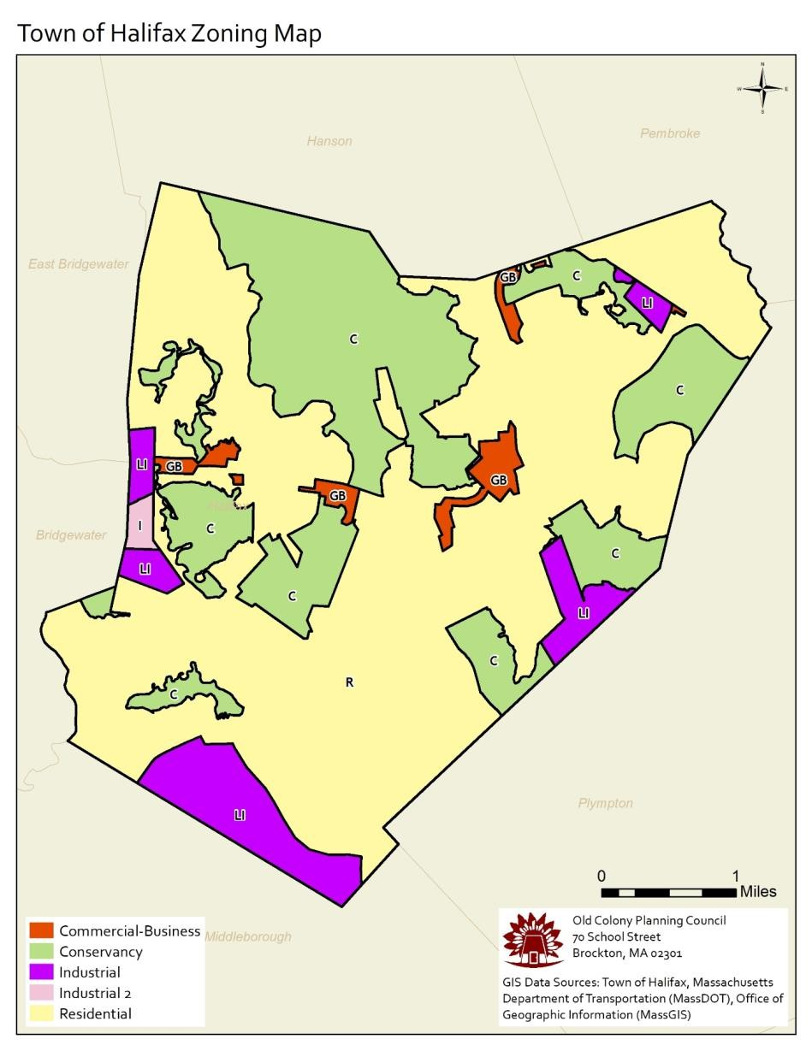

# Appendix B: Halifax Developmental Constraints Map

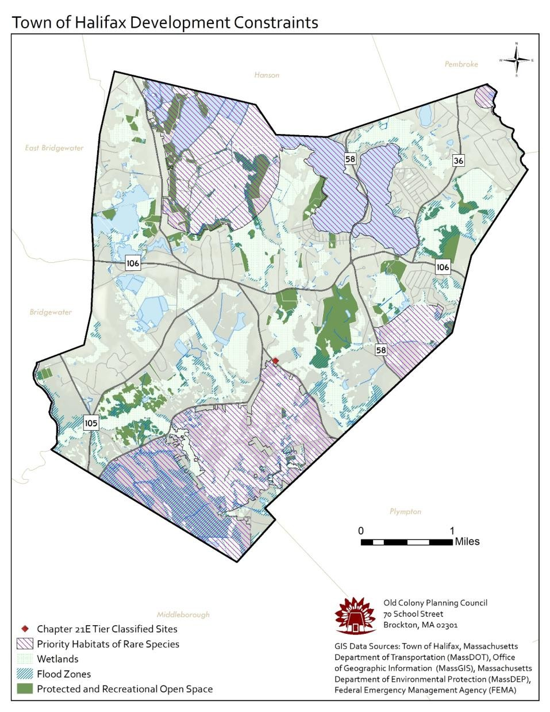

# Appendix C: Halifax – Potential Affordable Housing Sites

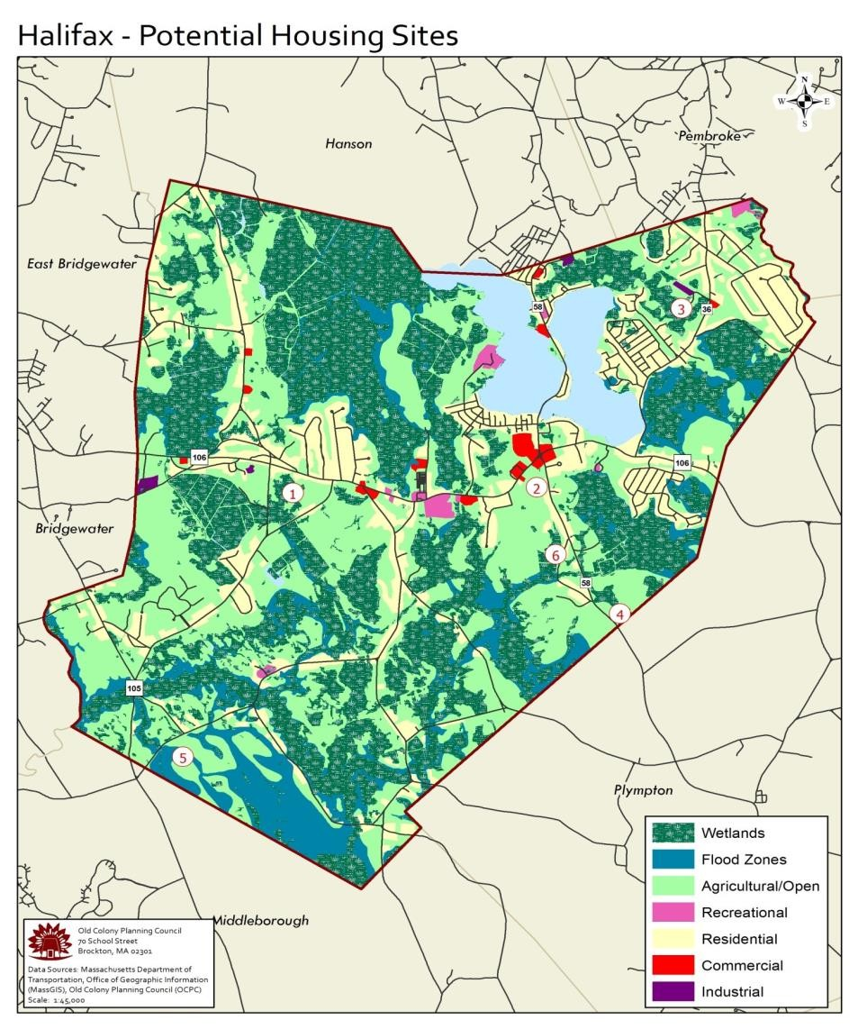

# Appendix D: Available Housing Resources & Programs

**U.S. Department of Housing and Urban Development (HUD)**

HUDs mission is to create strong, sustainable, inclusive communities and quality affordable homes for all. HUD is working to strengthen the housing market to bolster the economy and protect consumers; meet the need for quality affordable rental homes; utilize housing as a platform for improving quality of life; build inclusive and sustainable communities free from discrimination, and transform the way HUD does business. Additional information can be found at <https://portal.hud.gov/hudportal/HUD>

**Massachusetts Department of Housing and Community Development (DHCD)**

DHCDs mission is to strengthen cities, towns and neighborhoods to enhance the quality of life of Massachusetts residents. DHCD provides leadership, professional assistance and financial resources to promote safe, decent affordable housing opportunities, economic vitality of communities and sound municipal management. Additional information can be found at <http://www.mass.gov/hed/housing/>

**Citizens’ Housing and Planning Association (CHAPA)**

The Citizens’ Housing and Planning Association (CHAPA) is a non-profit umbrella organization for affordable housing and community development activities in Massachusetts. Established in 1967, CHAPAs mission is to encourage the production and preservation of housing that is affordable to low and moderate income families and individuals and to foster diverse and sustainable communities through planning and community development.

CHAPA pursues its goals through advocacy with local, state, and federal officials; research on affordable housing issues; education and training for organizations and individuals; programs to expand rental and homeownership opportunities; and coalition building among a broad array of interests in the housing and community development field. Additional information can be found on CHAPAs website at <https://www.chapa.org/>

**Massachusetts Housing Partnership (MHP)**

The Massachusetts Housing Partnership (MHP) is a statewide public non-profit affordable housing organization that works in concert with the Governor and the state Department of Housing and Community Development (DHCD) to help increase the supply of affordable housing in Massachusetts.

MHP was established in 1985 to increase the state's overall rate of housing production and work with cities and towns to demonstrate new and better ways of meeting the need for affordable housing. The MHP focuses its efforts in three main areas: community assistance, rental development, and homeownership. Additional information can be found on MHPs website at <http://www.mhp.net/>

**South Shore Habitat for Humanity**

Habitat for Humanity is a global nonprofit housing organization working in nearly 1,400 communities across

the United States and in approximately 70 countries around the world. Habitat’s vision is of a world where everyone has a decent place to live. Habitat works toward their vision by building strength, stability and self-reliance in partnership with people and families in need of a decent and affordable home.

The South Shore Chapter of Habitat for Humanity was founded in 1986, and covers 35 cities and towns south and southwest of Boston. In the 30 years since its inception, South Shore Habitat for Humanity has built 56 homes in 21 communities, helping more than 99 adults and 194 children build a place to call home. Additional information can be found on the Chapter’s website at <https://sshabitat.org/>

**Housing Solutions for Southeastern Massachusetts**

Housing Solutions for Southeastern Massachusetts – formerly known as South Shore Housing – is a regional nonprofit organization focused on providing housing services and developing affordable housing in Plymouth and Bristol counties. Its mission is to help low- and moderate-income families and individuals secure affordable housing and use that housing as a foundation for improving their economic stability and wellbeing.

This is accomplished through a wide variety of programs and resources, including: housing for homeless families, homeless prevention initiatives, training and support for homebuyers and owners, the effective administration of 2,200 rental subsidies, the development and management of affordable housing, technical assistance to help cities and towns increase the supply of affordable housing, and through partnerships with service providers to address the housing needs of individuals with mental illness and developmental disabilities. Additional information can be found at <http://housingsolutionssema.org/>

**NeighborWorks Southern Mass**

NeighborWorks Southern Mass is non-profit corporation that believes affordable housing and stable neighborhoods help individuals and families realize their full dignity and potential. NeighborWorks Southern Mass consists of a partnership of residents, businesses, and local governments. Its mission is to help people have a safe and affordable place to live. They accomplish this by developing and managing affordable housing, educating and assisting homeowners and homebuyers, and helping homeowners repair and maintain their homes. Additional information can be found at <http://nwsoma.org/>

**MassHousing**

MassHousing is an independent public authority that provides financing for the construction and preservation of affordable rental housing, and for affordable first and second mortgages for homebuyers and homeowners. MassHousing is a self-supporting not-for-profit public agency that raises capital by selling bonds and then lending the proceeds to low- and moderate-income homebuyers and homeowners, and to developers who build or preserve affordable and/or mixed-income rental housing. Additional information can be found at [http://masshousing.com](http://masshousing.com/)

**Community Preservation Act (CPA)**

The Community Preservation Act (CPA) was signed into law in Massachusetts in 2000, and allows communities to create a local Community Preservation Fund through a real estate tax surcharge of no more than 3% that can be used for open space protection, historic preservation, affordable housing, and outdoor recreation. The funds earned by a community are matched each year by a state trust fund, which varies from year to year.

To adopt the CPA, Town Meeting must first vote by simple majority to place the CPA on the ballot for the next town election, where it then needs a simple majority approval from town voters to pass. Communities can choose to place certain exemptions on the tax surcharge to lessen the burden on residents, such as exempting low income residents from paying the surcharge, or exempting the first $100,000 of a property’s assessed value. Each year at least 10% of the funds earned must be spent or set aside for open space, historic preservation, and community housing. The remaining funds can be used for any of these areas and outdoor recreation. The CPA requires that a local Community Preservation Committee be created that makes recommendations to the Board of Selectmen and Town Meeting on how to use the funds. To date, 172 municipalities (49% of the municipalities in Massachusetts) have adopted the CPA, including the local communities of Pembroke, Kingston, Hanson, Norwell, Marshfield, Hanover, Duxbury and Plympton. Halifax is one of the few communities in the area that has not adopted CPA. Additional information can be found at <http://www.communitypreservation.org/>

**Local Initiative Program (LIP)**

The Local Initiative Program (LIP) is a state program that encourages the creation of affordable housing by providing technical assistance to communities and developers who are working together to create affordable rental opportunities for low- and moderate-income households. Unlike conventional housing subsidy programs, in which a state or federal agency must approve every aspect of financing, design and construction, the LIP allows most of these decisions to be made by the municipality. LIP regulations and guidelines address those program components that must be reviewed and approved by DHCD. For example, incomes of households served, fair marketing, profit limitation and establishing long-term affordability for the units which are built. Eligible applicants include both for-profit and non-profit developers working in concert with a city or town, as the municipality and developer jointly submit the application. Additional information can be found at <http://www.mass.gov/hed/housing/affordable-own/local-initiative-program-lip.html>

**HOME Investment Partnerships Program (HOME)**

HOME is a federally funded program that assists in the production and preservation of affordable housing for low and moderate-income families and individuals. HOME funds can be used for the acquisition and/or rehabilitation of existing structures for sale to income-eligible first-time homebuyers, including distressed or failed properties, or for the new construction of homeownership projects. Projects seeking HOME funds must include a minimum of 3 HOME-assisted ownership units, the sites for which must be secured with a signed Purchase & Sale Agreement at the time of application. Eligible applicants include for-profit developers; non-profit developers; non-profit organizations designated as Community Housing Development Organizations (CHDOs) and municipalities in cooperation with any of the above. Additional information can be found at <http://www.mass.gov/hed/housing/affordable-own/home-investment-partnerships-program.html>

**Housing Stabilization Fund**

The Housing Stabilization Fund (HSF) is a state funded bond program that assists in the production and preservation of affordable housing for low-income families and individuals. HSF monies may be used for the acquisition and/or rehabilitation of existing structures for sale to income-eligible first-time homebuyers, including distressed or failed properties, or the new construction of homeownership projects. Projects seeking HSF must have a minimum of 3 HSF-assisted ownership units, which must be secured with, at a minimum, a signed Purchase & Sale Agreement at the time of application. Eligible applicants include for-profit developers, non-profit developers, local housing authorities and municipalities in cooperation with for-profit or non-profit developers. Additional information can be found at [http://www.mass.gov/hed/housing/affordable-own/housing-](http://www.mass.gov/hed/housing/affordable-own/housing-stabilization-fund.html) [stabilization-fund.html](http://www.mass.gov/hed/housing/affordable-own/housing-stabilization-fund.html)

**The Massachusetts Affordable Housing Trust Fund (AHTF)**

The AHTF is designed to provide resources to create or preserve affordable housing throughout the state for households whose incomes are not more than 110% of median income. AHTF funds are focused on those activities that create, preserve or acquire housing throughout the state for the benefit of those households. AHTF funds may also be used for permanent or transitional housing for homeless families and individuals, and for the modernization, rehabilitation and repair of public housing. Eligible applicants include governmental subdivisions, community development corporations, local housing authorities, community action agencies, community-based or neighborhood-based non-profit housing organizations, other nonprofit organizations, for-profit entities, and private employers. Additional information can be found on the AHTFs website at <http://www.mass.gov/hed/housing/affordable-rent/ahtf.html>

**Community Development Block Grants (CDBG)**

The Massachusetts Community Development Block Grant Program is a federally funded, competitive grant program designed to help small cities and towns meet a broad range of community development needs.

Assistance is provided to qualifying cities and towns for housing, community, and economic development projects that assist low and moderate-income residents, or by revitalizing areas of slum or blight. Municipalities with a population of under 50,000 that do not receive CDBG funds directly from the federal Department of Housing and Urban Development (HUD) are eligible for CDBG funding.

Eligible CDBG projects include but are not limited to housing rehabilitation or development, micro-enterprise or other business assistance, infrastructure, community/public facilities, public social services, planning, removal of architectural barriers to allow access by persons with disabilities, and downtown or area revitalization. Additional information can be found at [http://www.mass.gov/hed/community/funding/community-development-block-](http://www.mass.gov/hed/community/funding/community-development-block-grant-cdbg.html) [grant-cdbg.html](http://www.mass.gov/hed/community/funding/community-development-block-grant-cdbg.html)

**Federal Low-Income Housing Tax Credit (LIHTC)**

The Low-Income Housing Tax Credit (LIHTC) was created by Congress in 1986 to promote the construction and rehabilitation of housing for low income persons. The tax credit provides a means by which developers may raise capital for the construction or acquisition and substantial rehabilitation of housing for low income persons. Both for-profit and nonprofit developers are eligible to take advantage of the tax credit. At least 20% of the units must be reserved for persons with incomes at/or below 50% of the area median income adjusted for family size; or at least 40% of the units must be made affordable for persons with incomes at/or below 60% of the area median income adjusted for family size. In addition, the project must be retained as low-income housing for at least 30 years. Additional information can be found at [http://www.mass.gov/hed/housing/affordable-rent/low-income-](http://www.mass.gov/hed/housing/affordable-rent/low-income-housing-tax-credit-lihtc.html) [housing-tax-credit-lihtc.html](http://www.mass.gov/hed/housing/affordable-rent/low-income-housing-tax-credit-lihtc.html)

**Community Economic Development Assistance Corporation (CEDAC)**

CEDAC is a public-private community development finance institution that provides financial resources and technical expertise for community-based and other non-profit organizations engaged in effective community development in Massachusetts. CEDAC’s work supports three key building blocks of community development: affordable housing, workforce development, and early care and education. In terms of housing programs, CEDAC helps community development corporations and other non-profit developers by providing them early stage capital financing and technical assistance throughout the development process. CEDAC Housing’s financing options, which include predevelopment, acquisition, and bridge lending, provide developers with the patient capital to acquire property, hire a team of professional consultants that are needed for moving a development forward, and assemble financing packages to complete the projects. Additional information can be found at <https://cedac.org/>

**MassWorks Infrastructure Program**

The MassWorks Infrastructure Program provides a one-stop shop for municipalities and other eligible public entities seeking public infrastructure funding to support economic development, multi-family housing opportunities, community revitalization, and job creation. The Program represents an administrative consolidation of the following six former grant programs: Public Works Economic Development (PWED), Community Action Development Grant (CDAG), Growth Districts Initiative (GDI), Massachusetts Opportunity Relocation and Expansion Program (MORE), Small Town Rural Assistance Program (STRAP), and the Transit Oriented Development (TOD) Program. Additional information can be found at <http://www.mass.gov/hed/economic/eohed/pro/infrastructure/massworks/>

# Appendix E: DHCD, MHP, CEDAC, MassHousing and MassDevelopment Bedroom Mix Policy

INTERAGENCY AGREEMENT

Regarding Housing Opportunities for Families with Children

This Interagency Agreement (this "Agreement") is entered into as of the 17th day of January, 2014 by and between the Commonwealth of Massachusetts, acting by and through its Department of Housing and Community Development ("DHCD"), the Massachusetts Housing Partnership Fund Board ("MHP"), the Massachusetts Housing Finance Agency (in its own right and in its capacity as Project Administrator designated by DHCD under the Guidelines for Housing Programs in Which Funding is Provided By Other Than a State Agency, “MassHousing”), the Massachusetts Development Finance Agency (“MassDevelopment”) and the Community Economic Development Assistance Corporation (“CEDAC”). DHCD, MHP, MassHousing, MassDevelopment and CEDAC are each referred to herein as a “State Housing Agency” and collectively as the “State Housing Agencies”.

Background

1. DHCD’s 2013 Analysis of Impediments to Fair Housing Choice (“AI”) includes action steps to improve housing opportunities for families, including families with children, the latter being a protected class pursuant to fair housing laws, including the federal Fair Housing Act, as amended (42 U.S.C. §§ 3601 et seq.) and Massachusetts General Laws Chapter 151B. In order to respond to development patterns in the Commonwealth that disparately impact and limit housing options for families with children, such steps include requiring a diversity of bedroom sizes in Affordable Production Developments that are not age-restricted and that are funded, assisted or approved by the State Housing Agencies to ensure that families with children are adequately served.
2. The State Housing Agencies have agreed to conduct their activities in accordance with the action steps set forth in the AI.
3. This Agreement sets forth certain agreements and commitments among the State Housing Agencies with respect to this effort.

Definitions

* 1. “Affordable” - For the purposes of this Agreement, the term “Affordable” shall mean that the development will have units that meet the eligibility requirements for inclusion on the Subsidized Housing Inventory (“SHI”).
  2. “Production Development” - For purposes of this Agreement “Production Development” is defined as new construction or adaptive reuse of a non-residential building and shall include rehabilitation projects if the property has been vacant for two (2) or more years or if the property has been condemned or made uninhabitable by fire or other casualty.

Agreements

NOW, THEREFORE, DHCD, MHP, MassHousing, MassDevelopment and CEDAC agree as follows:

Bedroom Mix Policy

1. Consistent with the AI, it is the intention of the State Housing Agencies that at least ten percent (10%) of the units in Affordable Production Developments funded, assisted or approved by a State Housing Agency shall have three (3) or more bedrooms except as provided herein. To the extent practicable, the three bedroom or larger units shall be distributed proportionately among affordable and market rate units.
2. The Bedroom Mix Policy shall be applied by the State Housing Agency that imposes the affordability

restriction that complies with the requirements of the SHI.

1. The Bedroom Mix Policy shall not apply to Affordable Production Developments for age-restricted housing, assisted living, supportive housing for individuals, single room occupancy or other developments in which the policy is not appropriate for the intended residents. In addition, the Bedroom Mix Policy shall not apply to a Production Development where such units:
   1. are in a location where there is insufficient market demand for such units , as determined in the reasonable discretion of the applicable State Housing Agency; or
   2. will render a development infeasible, as determined in the reasonable discretion of the applicable State Housing Agency.
2. Additionally, a State Housing Agency shall have the discretion to waive this policy (a) for small projects that have less than ten (10) units and (b) in limited instances when, in the applicable State Housing Agency’s judgment, specific factors applicable to a project and considered in view of the regional need for family housing, make a waiver reasonable.
3. The Bedroom Mix Policy shall be applicable to all Production Developments provided a Subsidy as defined under 760 CMR 56.02 or otherwise subsidized, financed and/or overseen by a State Housing Agency under the M.G.L. Chapter 40B comprehensive permit rules for which a Chapter 40B Project Eligibility letter is issued on or after March 1, 2014. The policy shall be applicable to all other Affordable Production Developments funded, assisted, or approved by a State Housing Agency on or after May 1, 2014.

# Appendix F: Draft Inclusionary Zoning Bylaw

**Exemptions**. This Section of the Bylaw shall not apply to the reconstruction of any Dwelling Units that were destroyed by fire, flood, earthquake or other act of nature, or a project of less than six (6) Dwelling Units.

**Halifax Draft Zoning Bylaw – Inclusionary Housing**.

1. **Purpose and Intent.**
   1. The purpose of this Section of this Bylaw is to promote the public welfare by promoting the development and availability of housing affordable to a broad range of households with varying income levels within the Town, and to outline and implement a coherent set of policies and objectives for the development of affordable housing which will satisfy the Town’s obligations under

G. L.c. 40B, §§ 20-23, its regulations, or any amendments thereto, and which will be consistent with the Refined Village Centers Plan, as well as any Affordable Housing Plan and/or Comprehensive Master Plan for the Town as may be adopted from time to time.

* 1. It is intended that the Affordable Units that result from this Section of the Bylaw be considered as Local Initiative Program (LIP) Dwelling Units in compliance with the requirements for the same as specified by the Massachusetts Department of Housing and Community Development (MHDC), and that said units count toward the Town’s requirements under G. L. c. 40B, §§20-23, Regulations thereunder, or any amendments thereto

1. **Definitions**

**AFFORDABLE UNIT –** A Dwelling Unit constructed per the requirements of the Bylaw which meets the following conditions:

* 1. In a Project in which Affordable Units will be rented, a unit shall be considered an Affordable Unit if:
     1. It is rented to an eligible LOW or MODERATE INCOME HOUSEHOLD; and
     2. It is made available at a cost including rent, insurance and tenant-paid utilities of no more than 30% of gross household income of households at LOW or MODERATE HOUSEHOLD INCOME LEVELS.
     3. The Massachusetts Department of Housing and Community Development (DHCD) regulations and guidelines for qualification of the Affordable Units towards meeting the requirements under Chapter 40B of the Massachusetts General Laws, its regulations, or any amendments thereto, including maximum rents and sale price, will be followed in order to enable the Town to qualify the Dwelling Units created under this Section of the Bylaw towards the Town’s subsidized housing inventory.
  2. In a Project in which Affordable Units will be sold, a unit shall be considered an Affordable Unit if:
     1. It is sold to an eligible LOW or MODERATE HOUSEHOLD INCOME; and
     2. It is made available at a cost including mortgage interest, principal, taxes, insurance and common charges of no more than 30% of gross household income of LOW OR MODERATE HOUSEHOLD INCOME LEVELS.
     3. The Massachusetts Department of Housing and Community Development (DHCD) regulations and guidelines for qualification of the Affordable Units towards meeting the requirements under G. L. c. 40B, its regulations, or any amendments thereto, including

maximum rents and sale price, will be followed in order to enable the Town to qualify the Dwelling Units created under the Bylaw towards the Town’s subsidized housing inventory**.**

**HOUSEHOLD INCOME, LOW –** A combined household income which is less than or equal to 50% of MEDIAN HOUSEHOLD INCOME or any other limit established under Chapter 40B, its regulations or any amendment thereto.

**HOUSEHOLD INCOME, MEDIAN –** The median income, adjusted for household size, as reported by the most recent information from, or calculated from regulations promulgated by, the United States Department of Housing and Urban Development (HUD), pursuant to Section 8 of the Housing Act of 1937, as amended by the Housing and Community Development Act of 1974, and/or the Commonwealth’s Local Initiative Program (LIP) and/or any successor federal or state program.

**HOUSEHOLD INCOME, MODERATE –** A combined household income which is less than or equal to 80% of MEDIAN HOUSEHOLD INCOME or any other limit established under G.L. c.40B, its regulations or any amendment thereto.

**HOUSING TRUST –** An account established by: (a) the Town for the specific purpose of creating affordable housing, or (b) a housing trust or community development corporation designated by the Town and created under the laws of the Commonwealth of Massachusetts; for the specific purpose of creating affordable housing, including use of the funds for the purchase of land or units, or the development of new or rehabilitation of existing Dwelling Units for low or moderate income housing occupants.

**MARKET RATE UNIT** – a Dwelling unit in a residential or mixed-use development that is not restricted in terms of price or rent.

**PROJECT** – any residential development, including the subdivision of land, pursuant to G. L. c. 41, §81-U, which results in the construction of new Dwelling Units within the Town of Halifax as defined in Paragraph C(1) of this Bylaw.

**RURAL SERVICE AREA** – As defined in the Bylaw.

**SPECIAL PERMIT GRANTING AUTHORITY (SPGA)** – ***Planning Board and/or Board of Appeals***. VILLAGE SERVICE AREA – As defined in §204-5 of the Bylaw.

1. **Procedure.**
   1. Applicability. In all zoning Districts, a Special Permit pursuant to the provisions of this Section shall be required for the following uses:
2. any residential use of land that requires a Special Permit and results in any net increase of six (6) or more Dwelling Units, whether on one or more contiguous parcels, and whether by new construction or by the alteration, expansion, reconstruction or change of existing residential or non-residential space; and
3. a residential subdivision of land into six (6) or more lots for residential use pursuant to G.L. c.41, §81-U; and
4. any development of less than six (6) Dwelling Units or less than six (6) lots is eligible for this Special Permit on a voluntary basis.

The requirements of this Section are applicable to lots within a tract of land in whole or in part. For purposes of this section, a tract of land shall mean a single parcel or lot or a set of contiguous parcels or lots which were held in common ownership on April 4, 2005 or on any date subsequent thereto.

* 1. **Local Preference.** The SPGA shall require the applicant to comply with local preference requirements, if any, as established by the Board of Selectmen and/or the Director of the Office of Community Development.
  2. **Affordable Units Required.**
     1. **Requirement**. All Projects shall include the number of Affordable Units required under this Section of the Bylaw. No application for uses noted in Section (C) (1) shall be approved, nor shall any such Project be constructed, without compliance with this Section of the Bylaw.
     2. **Exemptions**. This Section of the Bylaw shall not apply to the reconstruction of any Dwelling Units that were destroyed by fire, flood, earthquake or other act of nature, or a project of less than six (6) Dwelling Units.
  3. **Information in Application.** Applications for Projects shall include the following information, in addition to information otherwise required under the Bylaw: three (3) copies of ONE of the following (a through e), and f, in order of preference:
     1. **The Memorandum of Understanding (MOU)** between the Developer and ***the Halifax Housing Authority*** as of the date of the Application, OR
     2. The information requested for submittal to the Halifax Housing Authority and the ***Halifax Planning Board/Zoning Board of Appeals***, OR
     3. The following information:
        1. The location, structure, proposed tenure (rental or ownership) and size of the proposed Market Rate and Affordable Units;
        2. The calculations used to determine the number of required Affordable Units;
        3. A floor plan or site plan depicting the location of the Affordable Units;
        4. The income level targets for each Affordable Unit;
        5. The mechanisms that will be used to assure that the Affordable Units remain affordable for the required term;
        6. for phased developments, a phasing plan;
        7. a description of any requested incentives as allowed in Paragraph C(9); and
        8. a marketing plan for the process by which qualified households will be reviewed and selected to either purchase or rent affordable units, consistent with the Local Initiative Plan requirements of the Massachusetts Department of Housing and Community Development; OR
     4. A written request for waivers of this requirement stating the reasons for this request, OR
     5. A written explanation of reasons Petitioner seeks confirmation of exemption from said requirements, AND
     6. Any other information requested by the SPGA.
  4. **Number of Affordable Units**.

a) **Basic Requirement**. The required number of Affordable Units included in a Project shall depend upon the total number of Dwelling Units in the Project. The Developer of the Project may choose which type of Affordable Units to include.

Once the total number of Dwelling Units is established within a Project, based on the underlying zoning regulations and/or applicable subdivision rules and regulations (the “By-Right Dwelling Units”), there shall be added to and included within Rental Projects or Ownership Projects an additional number of Affordable Units consisting of not less than ten (10) percent of the By-Right Dwelling Units. The SPGA and the applicant can mutually agree upon a number that exceeds the Basic Requirement number. The SPGA shall have the authority as part of the Special Permit provided in this Section to waive the dimensional, intensity and other applicable regulations of the Bylaw to implement the creation of the Affordable Units required herein.

1. **Fractional Units.** When the application of the percentages specified above results in a number that includes a fraction, the fraction shall be rounded up to the next whole number if the fraction is 0.7 or more. If the result includes a fraction below 0.7, the Developer shall have the option of rounding up to the next whole number and providing the Affordable Unit on-site.
2. **Blended Targeted Income Levels**. The Developer may request that the project include Affordable Units that are targeted to a mix of income levels (Moderate and Low) instead of just to one income level. The final decision regarding the mix of targeted income levels shall be made by the SPGA pursuant to Paragraph D.
3. **Unit Mix.** The unit mix (i.e. the number of bedrooms per unit) of the Affordable Units shall be in the same proportion as the unit mix of the market rate units. For example, if a project has 10 two-bedroom units and 20 one-bedroom units and is required to include 3 Affordable Units, then the Affordable Units must consist of 1 two-bedroom unit and 2 one-bedroom units. If only one Affordable Unit is required and the other units in the project have various numbers of bedrooms, the Developer may select the number of bedrooms for that unit. If Affordable Units cannot mathematically be exactly proportioned in accordance with the Market Rate Units, the unit mix shall be determined by the SPGA pursuant to Paragraph D.
4. **Location of Affordable Units.** Except as provided in Paragraph C (6) Alternatives, all Affordable Units shall be built on the same site as the remainder of the project.
5. **Replacement Units.** If a proposed residential project would result in the demolition or elimination of existing Dwelling Units that have (or within the twelve months prior to submittal of the application had) rent levels affordable to Low-Income Households, and these Dwelling Units were built less than 30 years ago, and these Dwelling Units did have an affordable deed-restriction, the affordable Dwelling Units must be replaced on a one-for-one basis affordable to Low-Income Households under the provisions of this Section of the Bylaw. If the number of required Affordable Units is less than the number of low- income units being eliminated, then Developer shall include a number of Affordable Units affordable to Low Income Households in an amount equal to the number of low-income units being eliminated.
   1. **Alternatives.** The Developer may propose an alternative means of compliance with this Section of the Bylaw instead of provision of on-site Affordable Units. The Developer is required to submit the reasons by which the alternative to construction of affordable units on-site is being offered for consideration. The Town has a

preference for construction of affordable units on site where feasible. If an alternative is proposed, information supporting the request is required at the time of the submittal of the Petition.

1. **Off-Site Construction of Affordable Units**. Affordable Units may be constructed offsite upon a determination by the SPGA that on-site construction is infeasible, or that on-site construction is not in the best interests of the Town, or that off-site construction would be more advantageous, as demonstrated to the satisfaction of the SPGA by the proponent. The proponent is required to provide a written summary with respect to the proposal’s consistency with the State’s Smart Growth guidelines and the Town of Halifax’s Comprehensive Master Plan, and in making said determination, the SPGA will evaluate whether the proposal is consistent with said criteria. If this option is chosen, then the off-site Affordable Units must be constructed prior to or concurrently with construction of the on-site project. The Affordable Unit size must meet the same requirements as if the Affordable Units were constructed on-site. No Certificate of Occupancy will be issued for any corresponding Market Rate Unit prior to Affordable Unit construction completion.
2. **Land Dedication.** The SPGA, in its sole discretion, only upon a determination by the SPGA that construction of the affordable units per Paragraph C(5) or Paragraph C(6)a is infeasible and/or is not in the best interest of the Town, determine that, in lieu of building Affordable Units, the Developer may offer to the Town land within the Town of Halifax, and the SPGA, in concert with the Board of Selectmen, may recommend to Town Meeting to accept, donations of land in fee simple, on or offsite, that the SPGA determines is suitable for the construction of at least the number of Affordable Units otherwise required per Section C(5). The proponent is required to provide a written summary with

respect to the proposal’s consistency with the State’s Smart Growth guidelines and the Town of Halifax’s Comprehensive Master Plan, and in making said determination the SPGA will evaluate whether the proposal is consistent with said criteria. The SPGA shall require prior to accepting land as satisfaction of the requirements of this Bylaw, that the Developer shall submit two (2) appraisals of the land in question (future values may be taken into account in this appraisal), as well as other data relevant to the determination of equivalent value. The value of donated land shall be equal to or greater than 115% of the construction or set-aside of affordable units. The Developer must also supply certified information that the land to be donated will support the required number of Dwelling Units per then current Halifax Zoning Bylaws, Halifax Board of Health Regulations, and Halifax Conservation Commission requirements as of the date of transfer (i.e. that the land is buildable). The transfer of said land shall be at no cost to the Town, and shall include title insurance. Providing that Town Meeting accepts said land, the developer will not have to build the Affordable Units otherwise required under this Section of the Bylaw.

1. **Fees in Lieu of Affordable Housing Units.**
   1. As an alternative to Section (C) (5A), and allowed by law, a Developer may contribute a fee to the Halifax Affordable Housing Trust Fund or other 501 (C) (3) fund established for the purposes of creating affordable housing as designated by the SPGA to be used for the development of affordable housing in-lieu of constructing and offering affordable units within the locus of the proposed development or off-site.
   2. **Calculation of fees-in-lieu of units** is subject to current pricing of affordable housing units and related land and construction costs.
   3. **Payment of Fees-in-lieu of Affordable Housing Units** shall be paid according to the following schedule; 25% of Calculated Fee to be paid by developer to the Halifax Affordable Housing Trust Fund or other Internal Revenue Code, §501 (C) (3) fund as designed by the SPGA within ten (10)

days from the date on which a copy of the Special Permit is filed with the Town Clerk, excluding the amount of time required for the appeal period to expire and the amount of time required to pursue and await the determination of any such appeal, then these Special Permits shall expire, except insofar as the foregoing statement is modified by Chapter 195 of the Acts of 1984. The balance to be paid in three (3) equal payments; first payment due when 1/3 of the total units have been built, second payment due when 2/3 of the total units have been built, and final payment due when ninety percent of the units have been built. This payment schedule may be negotiated at the sole discretion of the SPGA and may include incentives for earlier payments

* 1. **Affordable Unit Standards**.

1. **Design.** Affordable Units must be dispersed throughout a Project and be comparable in construction quality and exterior design to the Market Rate Units. The Affordable Units must have access to all on- site amenities.
2. **Timing.** All Affordable Units must be constructed and occupied concurrently with or prior to the construction and occupancy of Market Rate Units or development. In phased developments, Affordable Units may be constructed and occupied in proportion to the number of units in each phase of the Project.
3. **Terms of Affordability**. Rental Affordable Units must remain affordable in perpetuity, as documented through an affordable housing agreement recorded against the property per Paragraph C (8). Ownership Affordable Units must remain affordable in perpetuity pursuant to an affordable housing agreement recorded against the property per Paragraph C (8).
   1. **Inclusionary Housing Agreement**.
      1. **Agreements Required.** Applications for Projects shall be approved only concurrently with the approval of an Inclusionary Housing Agreement pursuant to this Section.
      2. **Approval.** An Inclusionary Housing Agreement between the Developer and the Town of Halifax in a form approved by the SPGA shall be executed and recorded at the Plymouth County Registry of Deeds or Land Court Registry District of Plymouth County prior to issuance of a building permit. The Inclusionary Housing Agreement shall provide for the implementation of the requirements of this Section of the Zoning Bylaw. All Inclusionary Housing Agreements must include, at minimum, the following:
         1. Description of the development, including whether the Affordable Units will be rented or owner-occupied;
         2. The number, size and location of the Affordable Units, or any approved alternative;
         3. Inclusionary incentives by the Town of Halifax (if any);
         4. Provisions and/or documents for resale restrictions, deeds of trust, rights of first refusal or rental restrictions that shall be recorded against the property;
         5. Provisions for monitoring the ongoing affordability of the units, and the process for marketing units, and qualifying prospective residents household for income eligibility; and
         6. Deed Restriction acceptable to the Town of Halifax.
   2. **Incentives.**

In approving an Inclusionary Housing Agreement, the SPGA may, in its sole discretion, include one or more of the following incentives:

* + 1. **Unit Size Reduction.** The size of the Affordable Units may be smaller than the Market Rate Units as long as the units meet the requirements under G. L. c. 40B, §§20-23, its regulations, or any amendments thereto, and consistent with all other provisions herein.
    2. **Interior Finishes.** Affordable Units may have different interior finishes and features than Market Rate Units so long as the interior features are durable, of good quality and consistent with current State Building Code standards for new housing

1. **Administration.**

For the purposes of this Section, the designated SPGA shall be (a) the Planning Board in the case of Special Permits issued by the Planning Board in accordance with the provisions of the Bylaw and for residential subdivisions, or (b) the Zoning Board of Appeals in the case of Special Permits issued by the Zoning Board of Appeals in accordance with the provisions of the Bylaw. In reviewing an Inclusionary Zoning proposal, the SPGA shall be governed by the Special Permit procedures as specified in Section 6.D, and shall take advisory

recommendations from the Town’s Office of Community Development and Affordable Housing Committee under consideration on all Projects regarding consistency with the Town’s Affordable Housing Plan. The SPGA may adopt regulations for carrying out its duties under this Bylaw.

# Appendix G: Community Housing Survey

1.How long have you lived in Halifax? (Choose one) Less than 1 year

1-5 years

6-10 years

11-20 years



More than 20 years

1. Which best describes your current living situation? (Choose one) Own my home.

Rent my home.

Live with parents/relatives.

I reside in Halifax Mobile Estates.

Other (please specify)

1. Have you been able to find the housing situation you need? (Choose one) I am happy with my housing situation.

I need a more affordable rental. I need a larger rental.

I want to change from ownership to rental. I want to change from renter to ownership. I own a home and would like to downsize. Other (please specify)

* 1. If you would like to change your living situation, please indicate why: (Choose as many as apply) I need a more affordable living situation.

I would like to leave Halifax.

I would like to change my family/household situation. I would like to live closer to work.

I would like to live near more amenities.



I have empty bedrooms and would like to downsize.

I would like to downsize in order to reduce my expenses in retirement. Other (please specify)

1. Which of the following best describes your household? (Choose as many as apply.)

Family with children. Couple without children. Empty nest couple.

Single, below age of 65.

Single, 65 years of age or older.

Share your home with an elderly parent or grandparent who requires financial or physical assistance.

Share your home with adult children who require financial or physical assistance.

Other (please specify)

1. How would you describe your ability to meet your monthly housing costs including: mortgage/rent, insurance, taxes and utilities? (Choose one)

It is very easy.

It is somewhat easy.

I am just able to meet my needs.

It is somewhat difficult. It is very difficult.

7. Which best describes your housing plans for the next five years? (Choose one) Plan to stay in the same home.

Plan to move to a larger home. Plan to move to a smaller home.

Plan to move to a more affordable location.

Other (please specify)

8. If a variety of Senior Housing options were available in your area; please rank the following features based on their importance to you with 1 being the most important and 4 being the least

important?

Affordability

Modest Size

Available Amenities (Pool, Golf, Tennis, Walking Trails)

Available Services (Transportation, Medical Support, Organized Activities)

9. How would you rank the following groups in regard to their need for affordable housing? Please rank these from 1-4 with 1 having the most need.

Elderly and the Disabled

Families

Single Person Households

Young Adults

10. What are your priorities when it comes to solving Halifax's housing challenges? Please rank the

following features based on their importance to you with 1 being the most important and 4 being the least important?

Maintain the character of my Town.

Create more housing options for households earning less than $46,000 annually.

Create more housing options for recent graduates, couples and young families earning between

$47,000-$85,000 annually.

Create more mixed income housing options for the elderly and the disabled.

1. What types of affordable housing (available to qualifying individuals/families at 65-80% of the market rate) should be included in the Halifax Housing Production Plan? Please indicate how much you favor each housing type.

|  |  |  |  |
| --- | --- | --- | --- |
|  | Won't support | Might support, under appropriate circumstances | Support |
| Single Family Homes |  |  |  |
| Duplexes |  |  |  |
| Multi Family Homes 3+ |  |  |  |
| Apartments |  |  |  |
| Condominiums |  |  |  |
| Conversion of existing large homes or municipal buildings into  housing. | |  |  |

1. What housing strategies do you support? Please indicate how much you favor each strategy.

|  |  |  |  |  |
| --- | --- | --- | --- | --- |
|  | Do not  support | Somewhat  Support | Support | Need more  information |
| Allowing increased density in certain areas. |  |  |  |  |
| Allow new, small scale homes on reduced lot sizes (less than the normal 1 acre). |  |  |  |  |
| Allowing the conversion of existing homes into two family or multi-family housing. |  |  |  |  |
| Allowing multi-family housing to be built in designated areas. |  |  |  |  |
| Expanding or allowing the addition of accessory apartments, in-law suites or nanny flats. |  |  |  |  |
| Allowing denser development in areas, but conserving adjacent open space. |  |  |  |  |
| Requiring developers to create affordable housing units as a percentage of the market rate units they create. |  |  |  |  |

.

1. Which category best describes your age?

Under 25

25-34

35-44

45-54



55-64

65-74

75 years and older

1. Which best describes your annual household income, before deductions? Less than $15,000

$15,000-$24,999

$25,000-$34,999

$35,000-$49,999

$50,000-$74,999

$75,000-$99,999

$100,000 – $149,999

$150,000 +

1. Is there anything you want to add to the discussion or to tell your Selectmen, Planning Board or Affordable Housing Committee?

16. Please provide your e-mail address if you would like to receive follow up information

or participate in any meetings.



# Appendix H: Community Housing Survey Results

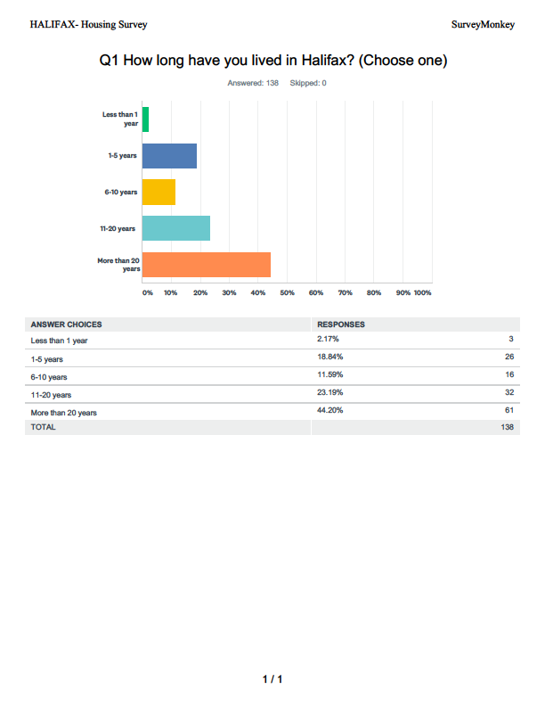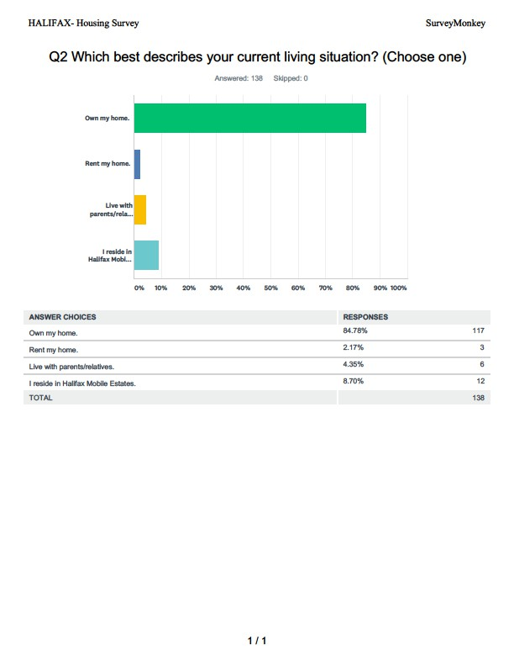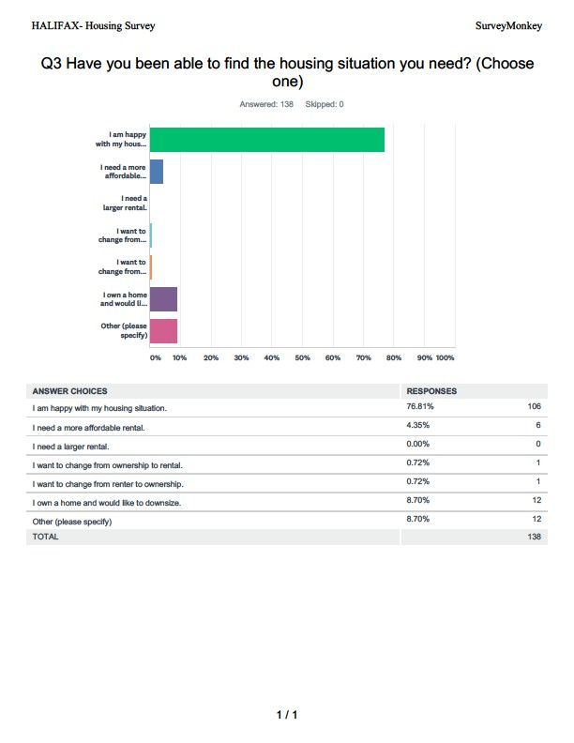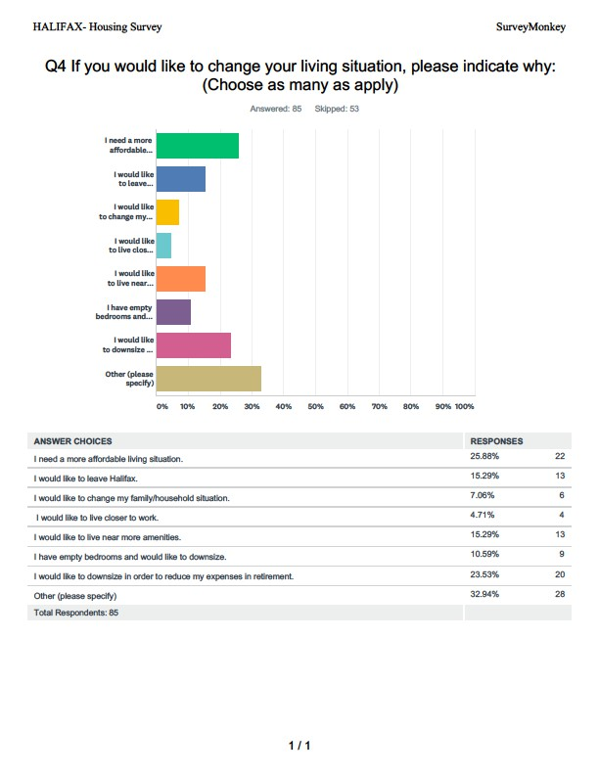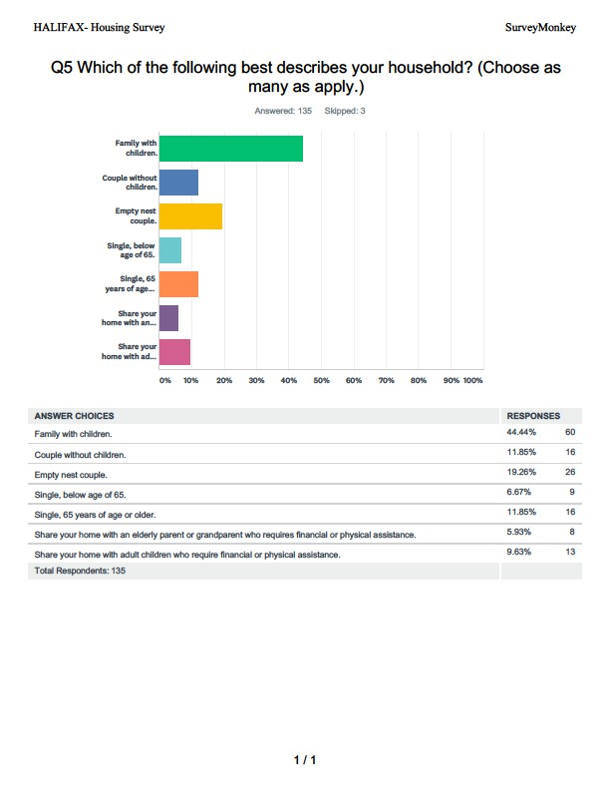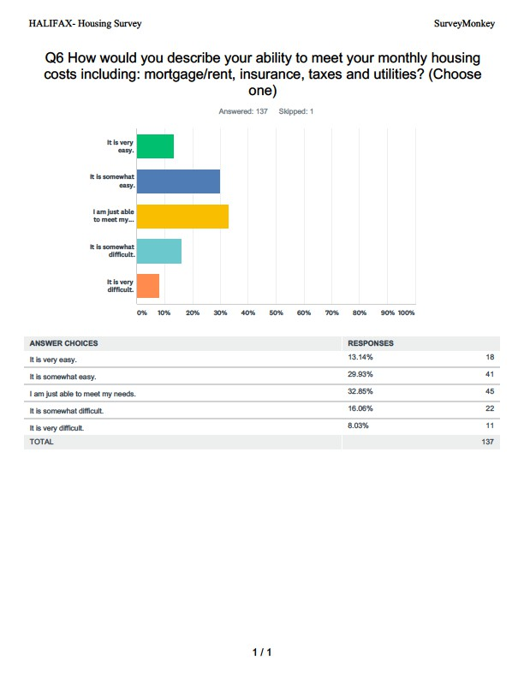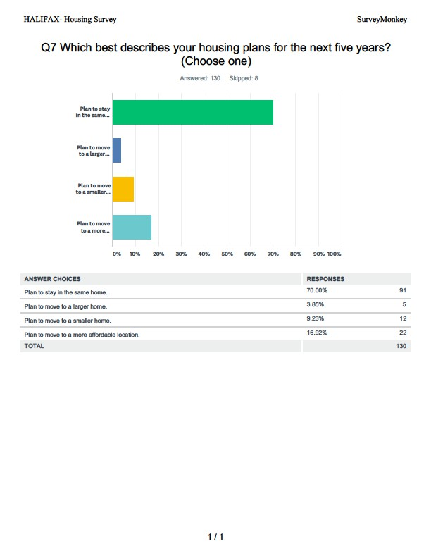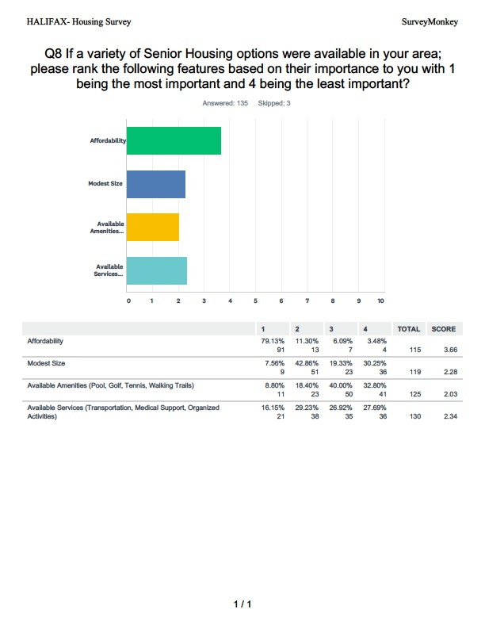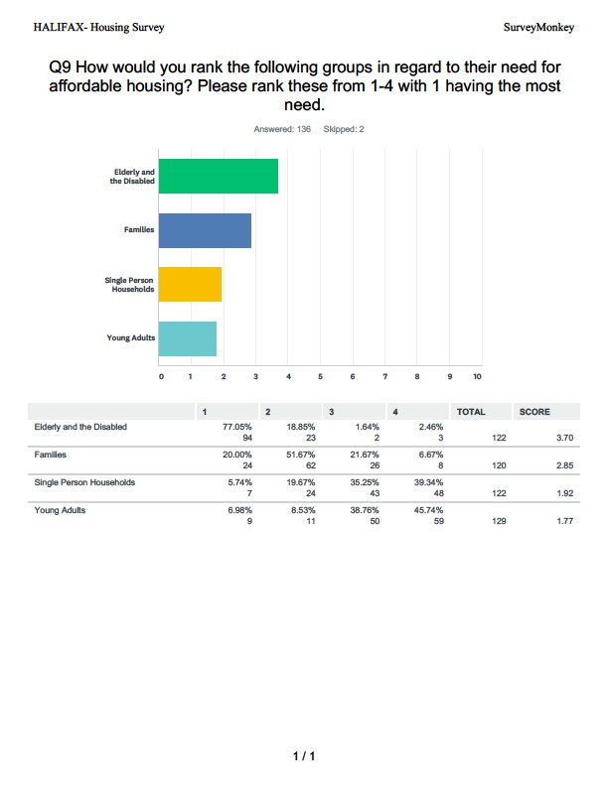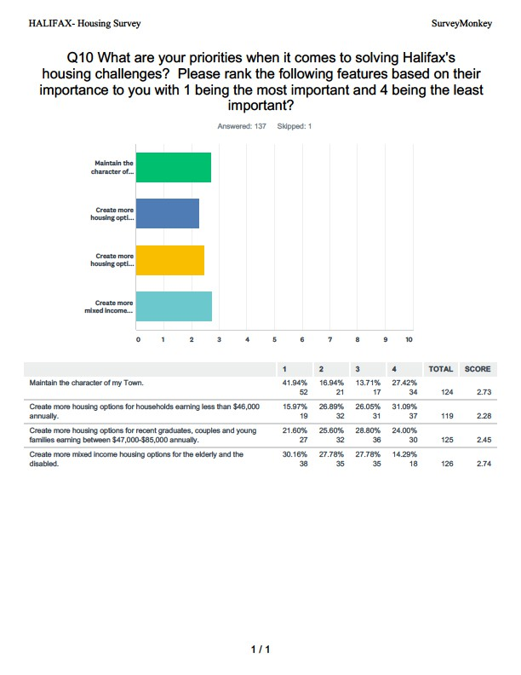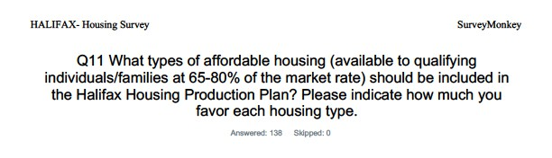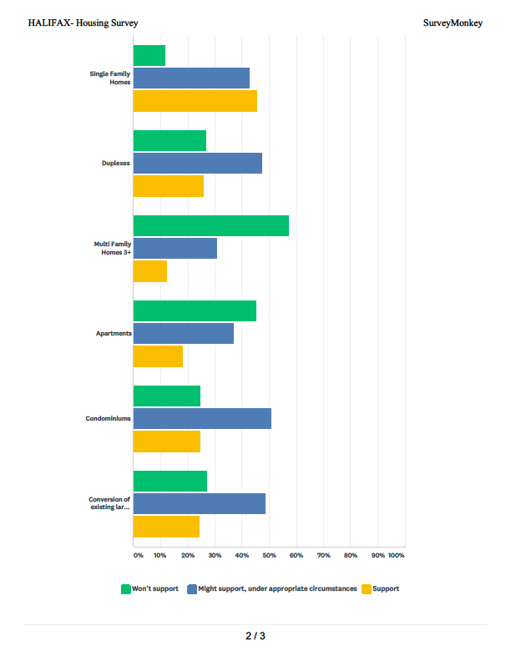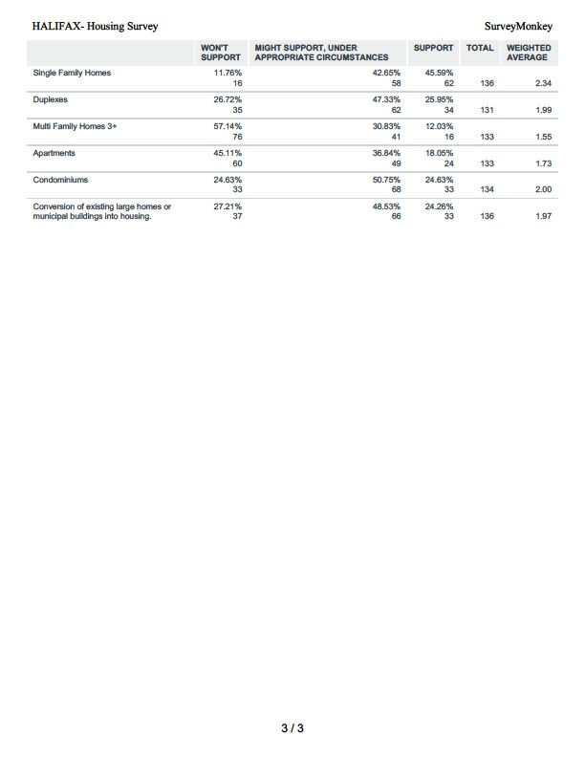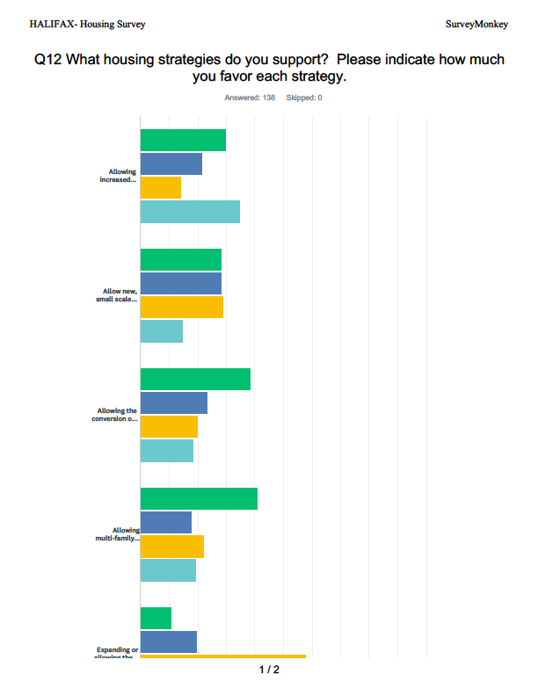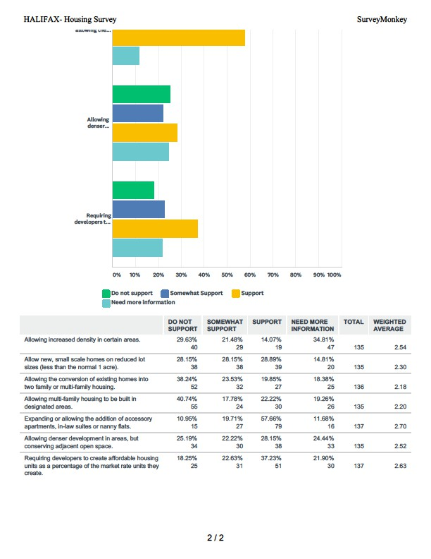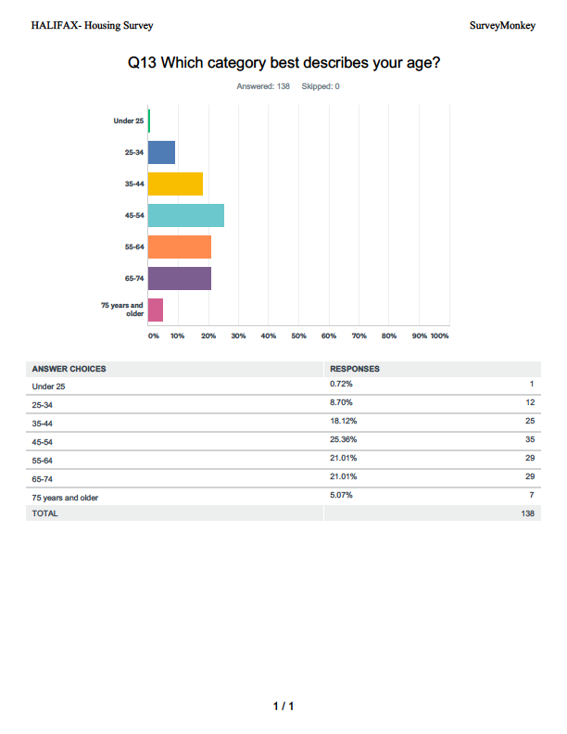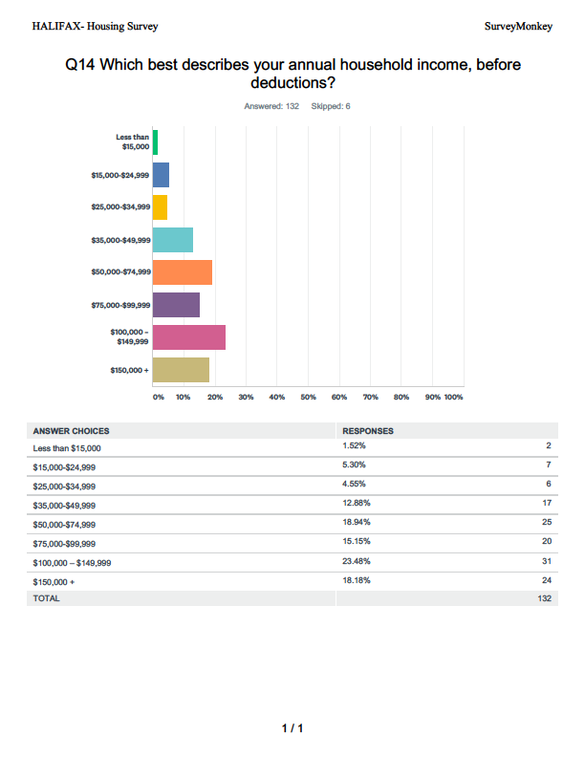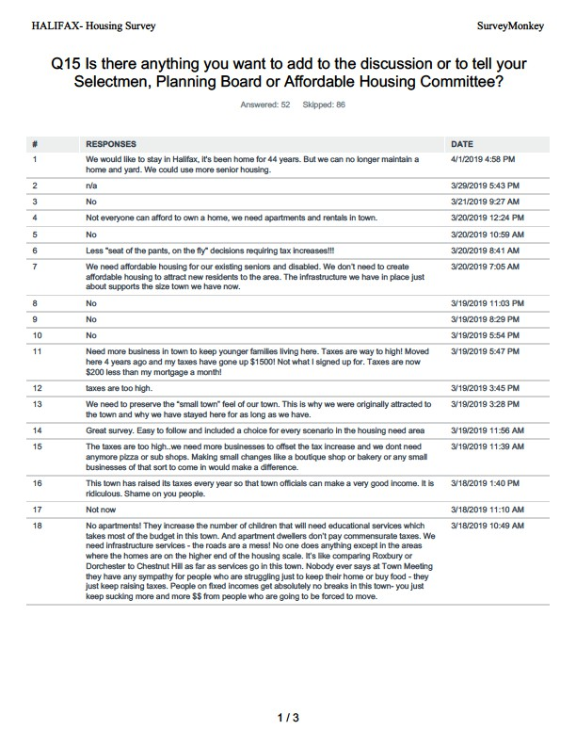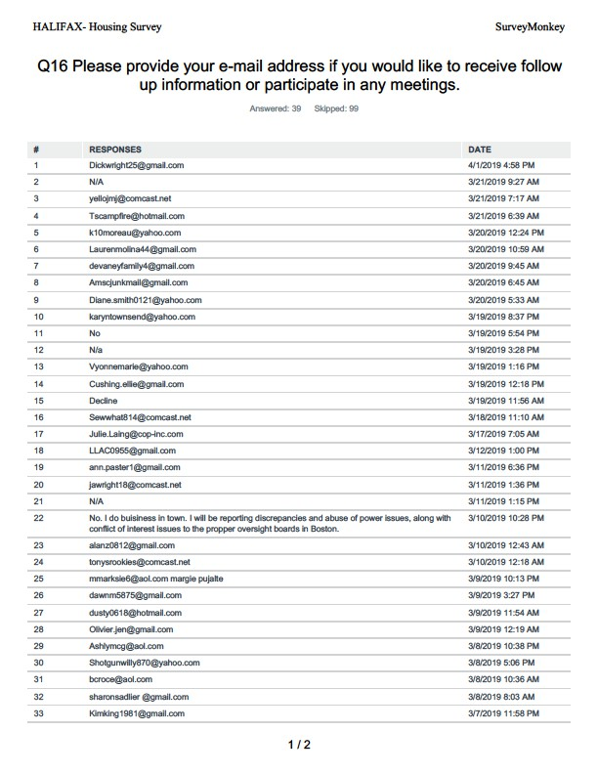

# Appendix I: Subsidized Housing Inventory - Halifax

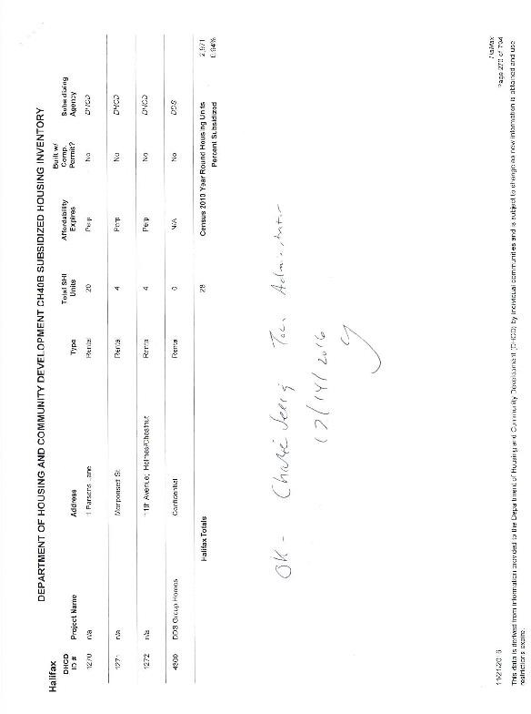

# Appendix J: Subsidized Housing Inventory- Facts, Questions, Answers

Subsidized Housing Inventory Information and Procedures The Department of Housing and Community Development (DHCD) maintains the Subsidized Housing Inventory (SHI) to track each municipality’s stock of eligible affordable housing. The SHI includes housing units that are either: • Developed through the issuance of a Comprehensive Permit • Developed under G.L. c. 40A, c. 40R • Developed by other statutes, regulations, and

programs, so long as the units are subject to a use Restriction, an Affirmative Fair Marketing Plan, and the

requirements of guidelines issued by DHCD. For Regulatory Authority, see: G.L. C 40B, s. 20-23 and 760 CMR 56.00, particularly 760 CMR 56.03.

Communities must follow these steps to add units to the Subsidized Housing Inventory (SHI).

More detail is available at <http://www.mass.gov/hed/docs/dhcd/legal/comprehensivepermitguidelines.pdf>

1. The community may request for units to be added to the SHI at any time by submitting a “Requesting New Units Form” with supporting documentation.
2. For rehabilitation units, the party administering the grant locally submits the necessary information using the “Housing Rehab Units Only” form.
3. Requests to include new units or corrections are submitted by the municipality, a developer, or a member of the public to: Department of Housing and Community Development Office of General Counsel 100 Cambridge Street, Suite 300 Boston, MA 02114-2524 Attention: Subsidized Housing Inventory.
4. Every two years, the municipality must submit a statement to DHCD certified by the Chief Executive Officer stating the number of SHI eligible housing units besides those created in a Comprehensive Permit project.
5. DHCD updates the SHI every two years or more frequently if information is provided by the municipality and verified by the Department.

Requesting new SHI units form: <http://www.mass.gov/hed/docs/dhcd/hd/shi/rnuf.doc>

Requesting new rehabbed SHI units form: <http://www.mass.gov/hed/docs/dhcd/hd/shi/rehabunits.xls>

# Appendix K: Important Affordable Housing Resources

**SUBSIDIZED HOUSING INVENTORY – REQUESTING NEW UNITS FORM**

Development Address

Total Acreage

Subsidizing Agency – List All (i.e., MassHousing, DHCD)

Subsidy Program – List All (i.e., Housing Starts, NEF, LIP, HOME)

|  |  |  |
| --- | --- | --- |
|  | Rental | Ownership |
| Total Units in Development |  |  |
| Total Affordable Units |  |  |
| Restricted at 80% of AMI |  |  |
| Restricted at 50% of AMI |  |  |
| Restricted at 30% of AMI |  |  |

Date of Building Permit(s)

(Provide a listing of issued building permit numbers and corresponding unit numbers and addresses. Please note that foundation permits are not to be included as building permits)

Date of Occupancy Permit(s) (Provide a listing of issued occupancy permit numbers and corresponding unit numbers and addresses)

For Comprehensive Permit Projects, Zoning Approvals under M.G.L. c.40A, and Completed Plan Reviews under M.G.L. c.40R (provide copy of applicable permit, approval, or plan review):

* Date comprehensive permit application was filed with the ZBA:
* Date comprehensive permit, zoning approval under M.G.L. c.40A, or completed plan review under

M.G.L. c.40R was filed with the town clerk:

* Was an appeal filed? YES or NO

Was an appeal filed by the Zoning Board of Appeals? YES or NO

* Date the last appeal was fully resolved: (Provide documentation)

Documentation* evidencing the following must be submitted with this form:

1. The zoning or permitting mechanism under which the housing development is authorized
2. The units are subsidized by an eligible state or federal program
3. The units are subject to a long term use restriction limiting occupancy to income eligible households for a specified period of time (at least thirty years or longer for newly created affordable units, and at least fifteen years for rehabilitated units)
4. The units are subject to an Affirmative Fair Housing Marketing Plan
5. The last appeal has been fully resolved (where applicable)

**Submit form and documentation to: DHCD Office of the General Counsel**

**Attn: Subsidized Housing Inventory 100 Cambridge Street, Suite 300**

**Boston, MA 02114**

Submitted by: Name & Title:

Mailing Address:

Phone and email:

*Please review Section II of the DHCD Comprehensive Permit Guidelines, “Measuring Progress Towards Local Goals,” available at <http://www.mass.gov/hed/docs/dhcd/legal/comprehensivepermitguidelines.pdf> for more information about the required criteria for inclusion on the Subsidized Housing Inventory.

# Appendix L: Important Affordable Housing Resources

Housing Production Plan Guidelines: <http://www.mass.gov/hed/docs/dhcd/cd/pp/hpp-guidelines.pdf>

Comprehensive Permit Guidelines [http://www.mass.gov/hed/docs/dhcd/legal/comprehensivepermitguidelines.pdf 760 CMR 56.00](http://www.mass.gov/hed/docs/dhcd/legal/comprehensivepermitguidelines.pdf%20760%20CMR%2056.00)

Local Initiative Program (LIP) and links to forms <http://www.mass.gov/hed/community/40b-plan/local-initiative-program-lip.html>

* LIP Comprehensive Permit application
* LIP LAU application
* LIP LAU accessory apartment application
* LIP affordable housing deed rider 40B Design Review Handbook

<http://www.mass.gov/hed/economic/eohed/dhcd/fact-sheets/lip.html>

DHCD Program Facts and FAQ <http://www.mass.gov/hed/economic/eohed/dhcd/fact-sheets/>

<http://www.mass.gov/hed/housing/affordable-rent/Compact> Neighborhoods Zoning <http://www.mass.gov/hed/docs/dhcd/cd/ch40r/compact-neighborhoodspolicy.pdf>

40R Smart Growth Zoning Overlay <http://www.mass.gov/hed/economic/eohed/dhcd/legal/regs/760-cmr-59.html>

<http://www.mass.gov/hed/community/planning/chapter-40-r.html>

<http://www.chapa.org/pdf/Ch40RFinal0704.pdf>

Municipal Affordable Housing Trust Operations Manual <https://www.mhp.net/writable/resources/documents/MAHT-Ops-Manual_final.pdf>

Municipal Affordable Housing Trust Guidebook – <https://www.mhp.net/writable/resources/documents/municipal_affordable_housing_trust_guidebook.pdf>

Housing Toolbox for Massachusetts Communities: <https://www.housingtoolbox.org/>

Create, Preserve, Support, Guide to utilizing Community Preservation Funds to foster local housing initiatives <https://www.mhp.net/writable/resources/documents/CPA-guidebook-2016_lowres.pdf>

Intro, tips for building an effective trust, fair housing and eligible funding activities [https://www.mhp.net/writable/resources/documents/Intro-Trust-Operations-Fair-Housing-and-Eligible-](https://www.mhp.net/writable/resources/documents/Intro-Trust-Operations-Fair-Housing-and-Eligible-Activities-May-18-2018.pdf) [Activities-May-18-2018.pdf](https://www.mhp.net/writable/resources/documents/Intro-Trust-Operations-Fair-Housing-and-Eligible-Activities-May-18-2018.pdf)

Trust Building: Building Relationships, Establishing Credibility and Acknowledging & Addressing the Elephant(s)

in the Room

<https://www.mhp.net/writable/resources/documents/MHP-Training-Trust-Building-DPolitis-051818.pdf> Legal and Operational Issues

<https://www.mhp.net/writable/resources/documents/Legal-and-Operational-Issues-for-MAHTs-051818.pdf>

# Appendix M: Model Bylaw for Accessory Dwelling Units



### MODEL BYLAW FOR ACCESSORY DWELLING UNITS

**Introduction**

Accessory dwelling units (also known as ‘accessory apartments’, ‘guest apartments’, ‘in-law

apartments’, ‘family apartments’ or ‘secondary units’) provide units that can be integrated into existing single family neighborhoods to provide low priced housing alternatives that have little or no negative impact on the character of the neighborhood.

The regulatory approach used by most municipalities for accessory dwelling units is a zoning bylaw that permits an accessory unit, thereby allowing certain improvements to be made to the existing dwelling. Provisions can address certain restrictions based on whether the dwelling existed as of a certain date, the maximum allowed building and site modifications, the options for choosing inhabitants, whether the main unit needs to be owner occupied, and minimum lot sizes. However, the greater the number of restrictions, the fewer options there are available to homeowners for adding the units.

The following is a model bylaw for accessory dwelling units. It is recognized that there is no single “model” that can be added to community regulations without some tailoring, therefore revisions to the text within this model is encouraged. There may also be a need to examine local development review process to find ways that the process can be streamlined to encourage homeowners to use the accessory dwelling unit ordinance.

The annotation included in this model bylaw will not be part of the adopted bylaw, but will serve as a “legislative history” of the intent of the drafters and the interpretation to be given to certain terms and provisions. The annotation includes some recommended positions that reduce burdens on both homeowners and municipalities when implementing the bylaw.

### MODEL BYLAW

**01.0 Purpose and Intent**: The intent of permitting accessory dwelling units is to:

1. Provide older homeowners with a means of obtaining rental income, companionship, security and services, thereby enabling them to stay more comfortably in homes and neighborhoods they might otherwise be forced to leave;
2. Add moderately priced rental units to the housing stock to meet the needs of smaller households and make housing units available to moderate income households who might otherwise have difficulty finding housing;
3. Develop housing units in single-family neighborhoods that are appropriate for households at a variety of stages in their life cycle;
4. Provide housing units for persons with disabilities;
5. Protect stability, property values, and the residential character of a neighborhood.

***COMMENT:*** *Accessory dwelling units are a relatively rare circumstance in most communities,*

*but can be very important to the homeowner that needs this option. There are various provisions*

*in this model bylaw that will ensure that the appearance of neighborhoods are not substantially*

*affected, including limitations on fl oor area, number of bedrooms, setbacks, ingress/egress*

*location, and ensuring that accessory dwelling units are installed only in owner-occupied houses.*

### 02.0 Definitions:

#### Accessory Dwelling Unit: An Accessory Dwelling Unit is a self-contained housing unit incorporated within a single-family dwelling (not within accessory structures, except with a Special Permit) that is clearly a subordinate part of the single-family dwelling and complies with each of the criteria stated below.

***COMMENT:*** *The definition of an accessory dwelling unit can restrict tenants to family members, low- or moderate-income tenants, or be unrestricted. However, unrestricted or family-member only units will not count towards the 10% goal of the Subsidized Housing Inventory (SHI). This bylaw is not intended to provide housing which would count towards the Commonwealth’s Local Initiative Program (“LIP”). Please see the Department of Housing and Community Development’s regulations for addition information and requirements regarding the LIP.*

***RECOMMENDED POSITION:*** *Do not restrict tenants. Allowing only family members is easiest politically and may limit the overall impact of the units, but it will also limit the use (and reuse) of these units and may result in additional administration costs associated with enforcement. Having no restrictions on accessory dwelling unit tenants gives greater control over the unit to the homeowner while offering more diverse housing opportunities.*

***COMMENT:*** *Restricting accessory dwelling units to low-income tenants may help add units to the town’s SHI list; however, the units must be permitted under a DHCD-approved bylaw. This model does not contemplate the SHI compliance.*

***COMMENT:*** *The following definitions (or similar) are typically used in an accessory dwelling unit bylaw to support the accessory dwelling unit definition.*

1. Building, Attached: A building having any portion of one or more walls in common or within five feet of an adjacent building.
2. Building, Detached: A building having a five feet or more of open space on all sides.
3. Dwelling, Single-Family: A building designed or used exclusively as a residence and including only one dwelling unit.

***COMMENT:*** *The limitations on accessory dwelling units that are identified in the bylaw will strengthen the distinction between two-family dwellings, and single-family dwellings with accessory dwelling units. However, it is recommended that a community review its other definitions and residential bylaws to ensure the distinction.*

1. Dwelling Unit: One or more rooms designed, occupied or intended for occupancy as separate living quarters, with cooking, sleeping and sanitary facilities provided within the dwelling unit for the exclusive use of a single family maintaining a household. This defi nition does not include a trailer, however mounted.
2. Primary Residence: A building in which is conducted the principal use of the lot on which it is located. For residentially zoned lots, such a building would be a dwelling.

### 03.0 Procedural Requirements:

#### 1. Review procedure: [Refer to the existing Special Permit or Site Plan Review procedures for your municipality.]

***COMMENT:*** *Permitting can be through Special Permit; Site Plan Review; or As-of-Right. The Special Permit procedure is a legislative procedure that provides the highest level of control to the municipality. A Special Permit approval is attached to the land, meaning that it is not affected by change of ownership unless specified. Site Plan Review provides an opportunity for a local entity within the municipality (other than the Building Commissioner) to review the design (possibly including both site plans and elevations) of a proposed development to determine the impacts on surrounding properties. The As-of-Right procedure allows property owners to submit construction plans to the Building Commissioner for assessment against relevant zoning bylaws (including accessory dwelling unit bylaws) prior to issuing a construction permit.*

***RECOMMENDED POSITION:*** *For accessory dwelling units within a home, use as-of-right; for attached or detached accessory dwelling units use Special Permit. As-of-Right permitting will facilitate the development of units that have limited or no impact from the street; for attached and detached units, towns may wish to have a heightened level of control especially on issues of design compatibility and privacy.*

### 04.0 Use and Dimensional Regulations:

1. The Building Commissioner may issue a Building Permit authorizing the installation and use of an accessory dwelling unit within an existing or new owner-occupied, single-family dwelling and the Special Permit Granting Authority (SPGA) may issue a Special Permit authorizing the installation and use of an accessory dwelling unit in a detached structure on a single-family home lot only when the following conditions are met:

***COMMENT:*** *The SPGA is usually designated as either the Zoning Board of Appeals or Planning Board.*

***COMMENT:*** *Some towns allow all single-family homes to contain accessory dwelling units, while others restrict it to homes existing prior to a certain date, or to a maximum percentage of the community.*

***RECOMMENDED POSITION:*** *Allow accessory dwelling units in all single-family homes that can meet the requirements of the bylaw. This will enable more accessory dwelling units and reduce administration burdens on the municipality associated with assessment of each unit.*

1. The unit will be a complete, separate housekeeping unit containing both kitchen and bath.

***COMMENT:*** *This provision is to ensure that the unit is separately habitable.*

1. Only one accessory dwelling unit may be created within a single-family house or house lot.

***COMMENT:*** *This provision is to ensure that accessory dwelling units remain ancillary to the principal single-family dwellings.*

1. The owner(s) of the residence in which the accessory dwelling unit is created must continue to occupy at least one of the dwelling units as their primary residence, except for bona fi de temporary absences.

***COMMENT:*** *This helps to protect the stability and character of the neighborhood. Provided that similar circumstances prevail, a change of ownership should not automatically result in a Special Permit lapse (refer to 04.5 below).*

* 1. Any new separate outside entrance serving an accessory dwelling unit shall be located on the side or in the rear of the building.

***COMMENT:*** *This is to ensure that the principal dwelling has the appearance of a single family dwelling. However, entrances could be combined in a single location.*

* 1. The gross floor area of an accessory dwelling unit (including any additions) shall not be greater than nine hundred (900) square feet.

***COMMENT:*** *The sizes of accessory dwelling units allowed in the various bylaws studied ranged from 500 to 900 square feet. The purpose of stating a maximum floor area is to ensure that the unit remains subordinate to the single-family dwelling. An additional limitation that can be placed on accessory dwelling units is the number of bedrooms (see 04.1(g) below). This limitation may be more important in areas that are not served by a sewer and/or water supply*. *Another alternative is to use the Special Permit to allow larger ADU’s when located in larger homes with additional size criteria added to the bylaw/ordinance*.

***COMMENT:*** *An option for the size of the unit could be a percentage of the existing main dwelling, with a minimum to ensure appropriate living space is available in the accessory dwelling unit.*

#### Once an accessory dwelling unit has been added to a single-family residence or lot, the accessory dwelling unit shall never be enlarged beyond the nine hundred (900) square feet allowed by this bylaw/ordinance.

***COMMENT:*** *This enables homeowners to make modifications and additions to the accessory dwelling unit while remaining subordinate to the single-family dwelling.*

#### An accessory dwelling unit may not be occupied by more than three (3) people nor have more than two bedrooms.

***COMMENT:*** *The intent of this provision is to limit impacts on sewer and water supply systems. This is an important issue for accessory dwelling units in areas that are not served by a sewer or water supply (see 04.1.(h)). Local conditions may suggest a different number of bedrooms and a different number of people allowed.*

#### The construction of any accessory dwelling unit must be in conformity with the State Building Code, Title V of the State Sanitary Code and other local bylaws/ordinances and regulations.

***COMMENT:*** *Provisions can be added in the bylaw stating that the accessory dwelling unit must*

*conform to all applicable health, building, and other codes. In areas without sewer and water*

*infrastructure, a minimum lot size may needed to ensure that the accessory dwelling unit has*

*adequate and safe water supply and sewage disposal. It should be noted that the provisions of the*

*accessory dwelling unit bylaw may not conflict with the State Building Code, Title V of the State*

*Sanitary Code or other local bylaws relating to health and safety without appropriate variance.*

* 1. Off-street parking spaces should be available for use by the owner-occupant(s) and tenants.

***COMMENT:*** *The accessory dwelling unit may result in demand for extra vehicle parking; however, the number of additional vehicles associated with the property may be minimal due to the limited size of the unit. The typical requirement is for one additional on-site parking space for the accessory dwelling unit.*

***RECOMMENDED POSITION:*** *Require one additional parking space and consider allowing a waiver when transit is a reasonable option.*

1. In order to encourage the development of housing units for disabled and handicapped

individuals and persons with limited mobility, the SPGA may allow reasonable deviation from the stated conditions where necessary to install features that facilitate access and mobility for disabled persons.

1. Approval for an ADU requires that the owner must occupy one of the dwelling units. The zoning approval and the notarized letters required in 04.4 and 04.5 below must be recorded in the County Registry of Deeds or Land Court, as appropriate, in the chain of title to the property, with documentation of the recording provided to the Building Commissioner, prior to the occupancy of the accessory dwelling unit.
2. When a structure, which has received a permit for an accessory dwelling unit, is sold, the new owner(s), if they wish to continue to exercise the Permit, must, within thirty (30) days of the sale, submit a notarized letter to the Building Commissioner stating that they will occupy one of the dwelling units on the premises as their primary residence, except for bona fi de temporary absences.

***COMMENT:*** *Some municipalities include a provision in the bylaw/ordinance stating that the zoning approval or Special Permit for the accessory dwelling unit will lapse if the owner no longer occupies one of the dwelling units. This adds unnecessary administrative burden on the municipality. Provided that similar circumstances prevail, a change of ownership should not automatically result in a permit lapse.*

1. Prior to issuance of a permit, the owner(s) must send a notarized letter stating that the owner will occupy one of the dwelling units on the premises as the owner’s primary residence, except for bona fi de temporary absences.

***COMMENT:*** *Some bylaws/ordinances specify time periods for which the owner must occupy the dwelling in any given year, however, enforcement of this adds unnecessary administrative burden on local officials.*

1. Prior to issuance of a permit, a floor plan must be submitted showing the proposed interior and exterior changes to the building.

***COMMENT:*** *This is to demonstrate that the accessory dwelling unit will not significantly affect the appearance of the single-family dwelling.*

### 05.0 Administration and Enforcement

***COMMENT:*** *Cities and towns need to examine their development review processes to find ways that the review process can be streamlined so homeowners are encouraged to use the accessory dwelling unit ordinance. It is recognized that most towns have existing illegal accessory dwelling units, and if a town is to encourage homeowners to legalize the existing units or create new accessory dwelling units under this bylaw, the process should be made as straight forward as possible. Making the process simple for the homeowners while still imposing all reasonable requirements for accessory dwelling units helps reduce the administrative burden on municipalities.*

***COMMENT:*** *Some towns require annual notarized letters attesting to the conditions of the accessory dwelling unit (owner-occupancy and any restriction on tenancy). Some bylaws require annual renewal of the permit.*

***RECOMMENDED POSITION:*** *No requirements for annual compliance or renewal are recommended. This places unnecessary burden on local officials. Using change in ownership as the trigger for renewal of the accessory dwelling unit is preferable.*

1. It shall be the duty of the Building Commissioner to administer and enforce the provisions of this Bylaw.
2. No building shall be constructed or changed in use or configuration, until the Building Commissioner has issued a permit. No permit shall be issued until a sewage disposal works permit, when applicable, has first been obtained from the Board of Health and the proposed building and location thereof conform with the town’s laws and bylaws. Any new building or structure shall conform to all adopted state and town laws, bylaws, codes and regulations. No building shall be occupied until a certificate of occupancy has been issued by the Building Inspector where required.
3. The Building Commissioner shall refuse to issue any permit, which would result in a violation of any provision of this chapter or in a violation of the conditions or terms of any special permit or variance granted by the Board of Appeals or its agent.
4. The Building Commissioner shall issue a cease and desist order on any work in progress or on the use of any premises, either of which are in violation of the provisions of this chapter.
5. Construction or use according to a building permit or special permit shall conform to any subsequent amendment of this chapter unless the construction or use is begun within a period of not more than six months after the issuance of a permit granted before the effective date of the amendment. To qualify for this exemption, construction must be completed in a continuous and expeditious manner.
6. The SPGA specified in this section may, after making findings of fact that support the decision, approve modifications to the dimensional standards of this bylaw, section 04.0, that will not exceed those standards by more than [10] percent.

***COMMENT:*** *These provisions may be standard within the community’s regulations, and can be simply referenced in this section. Additional references may be made to the Site Plan Review and Special Permit processes if included in this bylaw.*

# Appendix N: Local Initiative Program(LIP) / Local Action Units

“Friendly 40Bs” (Local Initiative Program Comprehensive Permits) For Regulatory Authority see: G.L. C 40B, s. 20-23 and 760 CMR 56.00. For LIP Comprehensive Permit guidance refer to GUIDELINES: G.L. C 40B Comprehensive Permit Projects; Subsidized Housing Inventory, section VI. Local Initiative Program (LIP) E.1. Summary of the process [For complete information see GUIDELINES, section VI] STEP ONE: Project must meet requirements of 40B STEP TWO: Receive written support of Chief Executive Officer STEP THREE: Complete Local Initiative Program Application for Comprehensive Permit Projects as Word Fillable Form [LIP Guidelines pg. VI – 3]: <http://www.mass.gov/hed/housing/affordable-own/localinitiative-program-lip.html> Include: (a) Letter of

support signed by the Chief Executive Officer of the municipality. (b) Signed letter of interest from a construction lender (c) Site plan showing contours of the site and the footprint of all proposed buildings, roads, parking and other improvements (d) Front and rear elevations for each building and sample floor plans for each unit type (e) Description of proposed units by size, type, number of bedrooms, location within the project, and proposed rents or sales prices. APPLICATION FEE: $1,500 per project plus an additional $20 per unit with checks payable to Department of Housing and Community Development. [Reduced by one-half for non-profit developers; waived for public agencies and municipalities.] Application fee is refunded if the application is not accepted or is rejected. One-half of the fee is refunded if application not approved. STEP FOUR: Determination of Project Eligibility. [GUIDANCE, p. VI-9] Upon receipt of the application, DHCD reviews the LIP Comprehensive Permit Application. (f) The Determination of Project Eligibility is a prerequisite to application for a Comprehensive

Permit for the Project from the municipality’s Zoning Board of Appeals. (g) DHCD makes the following findings in order to issue a Determination of Project Eligibility. 1. The application meets the requirements specified in 760 CMR 56.04(4). 2. The proposed project appears generally eligible under the requirements of the LIP, subject to final program review and approval. xvi 3. The proposed site plan is appropriate in the context of the surrounding area and taking into account previous municipal action to meet affordable housing needs, and the housing design is appropriate for the site. 4. The proposed project appears financially feasible in the context of the local housing market. 5. The initial pro forma for the project appears financially feasible on the basis of estimated development costs and revenues. 6. The applicant is a public agency, a non-profit organization, or a Limited Dividend Organization. 7. The applicant controls the site. 8. For age-restricted housing, that the market study demonstrates need and marketability within the municipality. (h) A Determination of Project Eligibility will be effective for two years from date of issuance unless otherwise stated therein. STEP FIVE Comprehensive Permit Application and Zoning Board of Appeals Hearing See G.L.C. 40B COMPREHENSIVE PERMIT INFORMATION SHEET, starting with STEP FOUR. STEP SIX Regulatory Agreement and Use Restrictions The Regulatory Agreement memorializes the rights and responsibilities of the parties and provides for monitoring of the project throughout the term of affordability. DHCD has model regulatory agreements for ownership and rental projects and a model Local Initiative Program Affordable Housing Deed Rider. (a) The Developer forwards a copy of the final Comprehensive Permit to the LIP staff at DHCD. (b) DHCD prepares a Regulatory Agreement, which also serves as the final written approval for the Project. (c) A Regulatory Agreement for each project will be executed by DHCD, the municipality, and the Developer (d) The Regulatory Agreement is filed with the Registry District of the Land Court. (e) The term of affordability for the Project generally should be the longest period permitted by law (in perpetuity). xvii F. Local Action Units Local Action Units (LAUs) are built without a Comprehensive Permit but meet LIP criteria and are suitable for inclusion in the SHI. They meet the following standards: 1. Built pursuant to one of the following local actions: a. Zoning-based approval i. Inclusionary Zoning, Accessory

Apartment Bylaw meeting the LAU criteria ii. Condition of a variance or special permit; agreement between town and a Developer to convert and rehabilitate municipal buildings into housing; b. Substantial municipal financial assistance: Funds raised, appropriated, administered by city or town. c. Provision of land or buildings that are owned or acquired by the city or town and conveyed at a substantial discount from their fair market value. iii. donation of municipally-owned land iv. use of local funds to develop or write down housing units 2. Must meet requirements for SHI eligibility (see above) Maximum LIP rents are calculated at what is affordable to a household earning 80% of the area median family income adjusted for household size. E.g.: 2 BR unit Household size = (#BR +1) = 3 80% of AMFI = $58,000 Monthly Income = $4,875 Max Rent (30% of monthly income) = $1,462 F.1. Process to implement STEP ONE. Discuss the Local Action Unit projects with DHCD LIP staff prior to submitting an application. STEP TWO. File a MEPA Environmental Notification Form, for new construction only. STEP THREE. Complete a Regulatory Agreement for Ownership Developments, or a Regulatory Agreement or Rental Developments, or a HOME Covenant/Deed Restriction STEP FOUR. Submit a complete, signed copy of the Local Initiative Program Application for Local Action Units to DHCD, attention LIP Program Coordinator; including: (a) Documentation of the municipal action (b) Submit a copy of the Regulatory Agreement for Ownership or Rental Developments or the HOME covenant/deed restriction, redlined to reflect any proposed changes. (c) MEPA environmental notification form (ENF) for new construction only (d) Affirmative Fair Marketing and Lottery Plan. STEP FIVE. DHCD expects to review and process the application within 60 days. To receive LAU approval, DHCD reviews for location action or approval. LAUs cannot be developed with a Comprehensive Permit. xviii F.2. Accessory apartments In order for Accessory Apartments to be added to the Subsidized Housing Inventory, they must receive Local Action Unit (LAU) approval: • Resulted from city or town action or approval • Subject to a recorded use restriction approved by DHCD, that has a term of not less than 15 years • Meet the requirements for LIP units, with the exception of receiving a Comprehensive Permit. Process 1. Municipality adopts an Accessory Apartment zoning bylaw or ordinance that permits the creation of accessory apartments that are affordable to Income Eligible Households. a. Submit a draft to DHCD for compliance review prior to local approval – DHCD’s review will be limited to noting any provisions that might conflict with LIP requirements. b. Units to be submitted to DHCD will have received zoning approval under the bylaw or ordinance. c. There shall be no provisions that conflict with the LIP requirements i. Allowing affordable accessory dwelling units to be rented to family members. ii. Allowing affordable accessory apartments to be rented to households earning more than 80% of AMI iii. A requirement that all accessory dwelling units shall be restricted to residents of the municipality iv. Any provision in conflict with applicable fair housing laws. 2. Complete a Local Initiative Program Application for Accessory Apartments. a. Letter of Support signed by the Chief Executive Officer b. An Affirmative Fair Housing Marketing Plan c. Designation of a Local Project Administrator (LPA) for all accessory apartments – responsible for oversight of all accessory apartments i. Local Official ii. Local Housing Partnership board member or staff member iii. Director of an area housing non-profit organization iv. Another appropriate person meeting DHCD approval d. Schedule of maximum rent for each accessory apartment e.

Proposed tenant application form and plan for processing of applications f. Plan for annual verification of

tenants’ income 3. Submit a letter of support from the local housing partnership, if any. 4. Meet the Local Action Requirements: a. Municipality has a local zoning bylaw or ordinance that permits the creation of accessory apartments. b. Received approval under the bylaw 5. Tenant Eligibility xix a. Family Members Prohibited b.

Household income shall not exceed 80% of the AMI adjusted for actual household size, as determined by HUD. Limits may be lower. i. Certification of income eligibility made by the Local Project Administrator (documentation may include recent tax returns, pay stubs, affidavits, etc.). Any post-occupancy changes must be

reported to the owner and the LPA. 6. Affirmative Fair Housing Marketing a. Affirmative Fair Housing and Marketing and Resident Selection Plan i. Outreach ii. Minimum Advertising Period – 60 days iii. Wait List: “Ready Renters List” b. Annual Data Collection: the LPA shall collect data annually regarding the number of minority households renting accessory apartments. c. DHCD may suspend/revoke the eligibility of units if a Failure to Apply Good Faith Efforts is found. d. Tenant Selection i. Owner gives written notice to LPA that a unit is available and requests referral of applicants. ii. Within 5 business days, the LPA refers the top appropriately-sized household(s), no more than 3 at a time. iii. The owner meets the referred applicant(s) and show the unit. The referred applicant has a minimum of 10 business days to view the unit. Owner may select one of the applicants or request additional referrals. Non-selected applicants return to the top of the Ready Renters List. iv. Owner enters into a 1-year lease with selected applicant. v. Upon request of the LPA, the owner shall specify in writing a substantial nondiscriminatory reason for having rejected an applicant.

# Appendix O: Comprehensive Permit Process

Comprehensive Permits For Regulatory Authority see: G.L. C 40B, s. 20-23 and 760 CMR 56.00.

For Comprehensive Permit guidance refer to GUIDELINES: G.L. C 40B Comprehensive Permit Projects; Subsidized Housing Inventory : <http://www.mass.gov/hed/docs/dhcd/legal/comprehensivepermitguidelines.pdf>

Summary of the process [For complete information see 760 CMR 56.04-06] STEP ONE

Application for Determination of Project Eligibility [760 CMR 56.04(2)] The Applicant submits an application for Project Eligibility to the Subsidizing Agency, with a copy to the Chief Executive Officer of the municipality and written notice to the Department of Housing and Community Development (DHCD), which shall include: (a) The name and address of the Applicant; (b) The address of the site and site description; (c) A locus map identifying the site within a plan of the neighborhood, accompanied by photographs of the surrounding buildings and features that provide an understanding of the physical context of the site; (d) A tabulation of proposed buildings with the approximate number, size (number of bedrooms, floor area), and type (ownership or rental) of housing units proposed; (e) The name of the housing program under which Project Eligibility is sought; (f) Relevant details of the particular Project if not mandated by the housing program (including percentage of units for low or moderate income households, income eligibility standards, the duration of restrictions requiring Low or Moderate Income Housing, and the limited dividend status of the Applicant); (g) Conceptual design drawings of the site plan and exterior elevations of the proposed buildings, along with a summary showing the approximate percentage of the tract to be occupied by buildings, by parking and other paved vehicular areas, and by open areas, the approximate number of parking spaces, and the ratio of parking spaces to housing units; (h) A narrative description of the approach to building massing, the relationships to adjacent properties, and the proposed exterior building materials; (i) A tabular analysis comparing existing zoning requirements to the Waivers requested for the Project; and (j) Evidence of control of the site.

STEP TWO

Review and Comment Process. [760 CMR 56.04(3)] (a) Upon receipt of the application, the Subsidizing Agency provides written notice to the Chief Executive Officer of the municipality where the Project is located (b) 30-day review period of Project begins with written notice to municipality. (c) The Subsidizing Agency shall conduct a site visit, which Local Boards may attend. (d) Local Boards and other interested parties submit written comments to Subsidizing Agency. (e) The Subsidizing Agency issues a determination of Project Eligibility after the 30-day review period.

STEP THREE

Findings in Determination. [760 CMR 56.04(4)] After the 30-day review period, the Subsidizing Agency will make a determination of Project Eligibility based upon its review of the application, and taking into account information received during the site visit and from written comments. Copies of the written determination of

Project Eligibility will be provided to the Department, the Chief Executive Officer of the municipality, and the Board. Issuance of a determination of Project Eligibility shall be considered by the Zoning Board of Appeals (ZBA) or the Housing Appeals Committee (HAC) to be conclusive evidence that the Project and the Applicant have satisfied the project eligibility requirements of 760 CMR 56.04(1).

STEP FOUR

Applicant Files an Application with the Local Zoning Board of Appeals [760 CMR 56.05(2)] The applicant files a Comprehensive Permit Application and a complete description of the proposed project with the municipality’s ZBA.

STEP FIVE

Conduct of Zoning Board of Appeals Hearing. [760 CMR 56.05(3)-(4)] (a) The ZBA has seven days, after the receipt of a complete application, sends a notice of the application and a copy of the list of Waivers required by 760 CMR 56.05(2)(h) and invite the Local Boards to participate in the hearings. (b) The Board shall open a hearing within 30 days of its receipt of a complete application, and it shall thereafter pursue the hearing diligently. (c) A hearing shall not extend beyond 180 days from the date of opening the hearing, presuming that the Applicant has made timely submissions of materials in response to reasonable requests of the Board that are consistent with its powers under 760 CMR 56.05, except with the written consent of the Applicant. (d) If the Board wishes to deny an application on one or more of the grounds set forth in 760 CMR 56.03(1), it must do so in accordance with the procedure set forth in 760 CMR56.03(8), or it shall be deemed to have waived its rights.

(e) A Board may stay the commencement of a hearing if three (3) or more Comprehensive Permit applications are concurrently undergoing hearings before the Board, and the total number of housing units in those pending Projects exceeds the numerical threshold for a large project within that municipality, as set forth in 760 CMR 56.03(6).

Consultant review [760 CMR 56.05(5)] (a) If, after receiving an application, the Board determines that in order to review that application it requires technical advice in such areas as civil engineering, transportation, environmental resources, design review of buildings and site, and (in accordance with 760 CMR 56.05(6)) review of financial statements that is unavailable from municipal employees, it may employ outside consultants.

Whenever possible it shall work cooperatively with the Applicant to identify appropriate consultants and scopes of work and to negotiate payment of part or all of consultant fees by the Applicant. Alternatively, the Board may, by majority vote, require that the Applicant pay a reasonable review fee in accordance with 760 CMR 56.05(b) for the employment of outside consultants chosen by the Board alone. The Board should not impose unreasonable or unnecessary time or cost burdens on an Applicant. Legal fees for general representation of the Board or other Local Boards shall not be imposed on the Applicant. (b) A review fee may be imposed only if: 1. the work of the consultant consists of review of studies prepared on behalf of the Applicant, and not of independent studies on behalf of the Board; 2. the work is in connection with the Applicant's specific Project; and 3. all written results and reports are made part of the record before the Board. 4. a review fee may only be imposed in compliance with applicable law and the Board’s rules. C.3. Review of financial statements [760 CMR 56.05(6)] (a) A Board may request to review the pro forma or other financial statements for a Project only after the following preconditions have been met: 1. Other consultant review has been completed; 2. The Applicant

has had an opportunity to modify its original proposal to address issues raised; 3. the Board has had an

opportunity to propose conditions to mitigate the Project’s impacts and to consider requested Waivers; and 4. The Applicant has indicated that it does not agree to the proposed condition(s) or Waiver denial(s) because they would render the Project uneconomic. A Board may not conduct review of a pro forma in order to see whether a Project would still be economic if the number of dwelling units were reduced, unless such reduction is justified by a valid health, safety, environmental, design, open space, planning, or other local concern xii that directly results from the size of a project on a particular site, consistent with 760 CMR 56.07(3). (b) If the Applicant does not agree to some or all of the proposed permit conditions or Waiver denials because they would render the Project Uneconomic, the Board may ask the Applicant to submit its pro forma, in form satisfactory to the Subsidizing Agency, and revised as necessary to reflect the additional cost of meeting these conditions and/or denials. The revised pro forma may be subjected to the same consultant review as any other technical information submitted to the Board, in accordance with 760 CMR 56.05(5) and the Board’s rules. The Board may then use this information to decide whether to adopt or modify its originally proposed conditions and/or denials. Pro forma review should conform to recognized real estate and affordable housing industry standards, consistent with the policies of the Subsidizing Agency and guidelines adopted by the Department. (c) Related financial issues, including related-party transactions, the estimated sales price or rental rates of market-rate units, and land acquisition costs, shall be addressed in accordance with the Department’s guidelines.

Disagreements between the Applicant and the Board’s consultant should be resolved in accordance with the Department’s guidelines. The Subsidizing Agency has the sole responsibility to establish and enforce reasonable profit and distribution limitations on the Applicant, as set forth in 760 CMR 56.04(8).

Waivers from local requirements and regulations [760 CMR 56.05(7)] The Applicant may request Waivers, solely from the “as-of-right” requirements of the zoning district where the project site is located , as listed in its application or as may subsequently arise during the hearing, and the Board shall grant such Waivers as are Consistent with Local Needs and are required to permit the construction and operation of the Project. If a Project does not request a subdivision approval, waivers from subdivision requirements are not required (although a Board may look to subdivision standards, such as requirements for road construction, as a basis for required project conditions, in which case the Applicant can seek Waivers from such requirements).

STEP SIX

Board Decisions- [760 CMR 56.05(8)] (a) Forty-five days after the close of the public hearing, the Board shall render a decision, based on a majority vote of the Board, taking into consideration the recommendations of Local Boards. (b) The Board shall file its decision within 14 days in the office of the city or town clerk, and it shall forward a copy of any Comprehensive Permit to the Applicant or its designated representative and to DHCD when it is filed. (c) The Board may: 1. approve a Comprehensive Permit on the terms and conditions set forth in the application; 2. approve a Comprehensive Permit with conditions with respect to height, site plan, size, shape or building materials that address matters of Local Concern; or 3. deny a Comprehensive Permit as not Consistent with Local Needs if the Board finds that there are no conditions that will adequately address Local Concerns. (d) Uneconomic Conditions. The Board shall not issue any order or impose any condition that would cause the building or operation of the Project to be Uneconomic, including a requirement imposed by the Board on the Applicant: 1. to incur costs of public infrastructure or improvements off the project site that: a. are not generally imposed by a Local Board on unsubsidized housing; b. address a pre-existing condition affecting the

municipality generally; or c. are disproportionate to the impacts reasonably attributable to the Project; or 2. to reduce the number of units for reasons other than evidence of Local Concerns within the purview of the Board (see 760 CMR 56.05(4)(e); see also 760 CMR 56.07(3)(c – h) regarding evidence that would be heard by the Committee on an appeal), such as design, engineering, or environmental deficiencies that directly result from the impact of a Project on a particular site. If a proposed nonresidential element of a Project is not allowed by- right under applicable provisions of the current municipal zoning code, a condition shall not be considered Uneconomic if it would modify or remove such nonresidential element.

STEP SEVEN

Appeals from Board Decisions [760 CMR 56.05(9)] (a) If the Board approves the Comprehensive Permit, any person aggrieved may appeal within the time period and to the court provided in M.G.L. c.40A, §17. (b) If the Board denies the Comprehensive Permit or approves the permit with unacceptable conditions or requirements, the Applicant may appeal to the Housing Appeals Committee as provided in M.G.L. c.40B, §22 and 760 CMR

56.06. (c) If the Board takes action adverse to the Applicant under 760 CMR 56.03(8), 760 CMR 56.05(11), or a similar provision of 760 CMR 56.00, or otherwise violates or fails to implement M.G.L. c.40B, §§20 through 23, the Applicant may appeal to the Housing Appeals Committee as provided in M.G.L. c.40B, §22 and 760 CMR

56.06. For Procedural Regulations for Appeals to the Housing Appeals Committee see 760 CMR 56.06.