OLD COLONY PLANNING COUNCIL
AREA AGENCY ON AGING

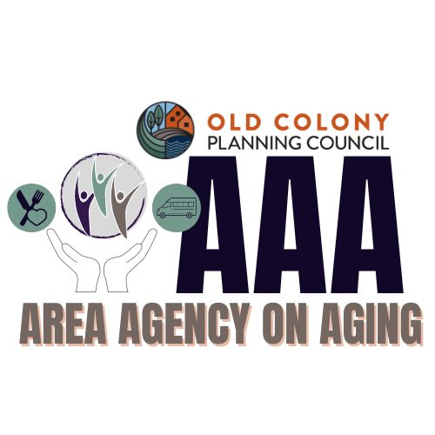

2026-2029 OCPC AAA Area Plan Draft

TABLE OF CONTENTS -TO BE ADJUSTED

ITEM PAGE NUMBER
Cover 1

Table of Contents 2

OCPC-AAA Service Region Map 3

Executive Summary – Outlining OCPC Area Plan Service Priorities 4-6

Old Colony Area Plan - Introduction 7

Needs Assessment Process 8

Focus Area Coordination 9-12
OAA Core Programs
ACL Focus Areas
Exec Office of Age & Independence Goals & Values

Sources of Comparative Data
Exec Office of Age & Independence-OCPC Needs Assessment NA OCPC-Polco: Community Assessment Survey for Older Adults NA

OCPC – Area Plan Core Programs 13

Participant-Directed/Person-Centered Planning and Elder Justice 14

Looking Forward 15

Old Colony Elder Services (OCPC – Feedback) 15-20

Attachments Page (NA = Not yet available) NA

Attachments
Attachment A: Area Plan on Aging Assurances and Affirmation NA
Attachment B: AAA Informational Requirements NA
Attachment C: AAA Organizational Chart NA
Attachment D: AAA Corporate Board of Directors – Form 1 NA
Attachment E: AAA Advisory Council Members – Form 2 NA
Attachment F: AAA Focal Points Document – Form 3 NA
Attachment G: AAA Title III-B Funded Services – Form 4a NA
Attachment H: AAA Title III-C, D, E and OMB Funded Services – Form 4b NA
Attachment I: AAA Title III-E Family Caregiver Breakout – Form 5 NA
Attachment J: Old Colony 2024 Regional Needs Assessment - Survey Links NA

Old Colony Planning Council
Area Agency on Aging
www.ocpcrpa.org
70 School Street 508-583-1833
Brockton, MA 02301 FAX: 508-559-8768
TTY: 508-583-1833

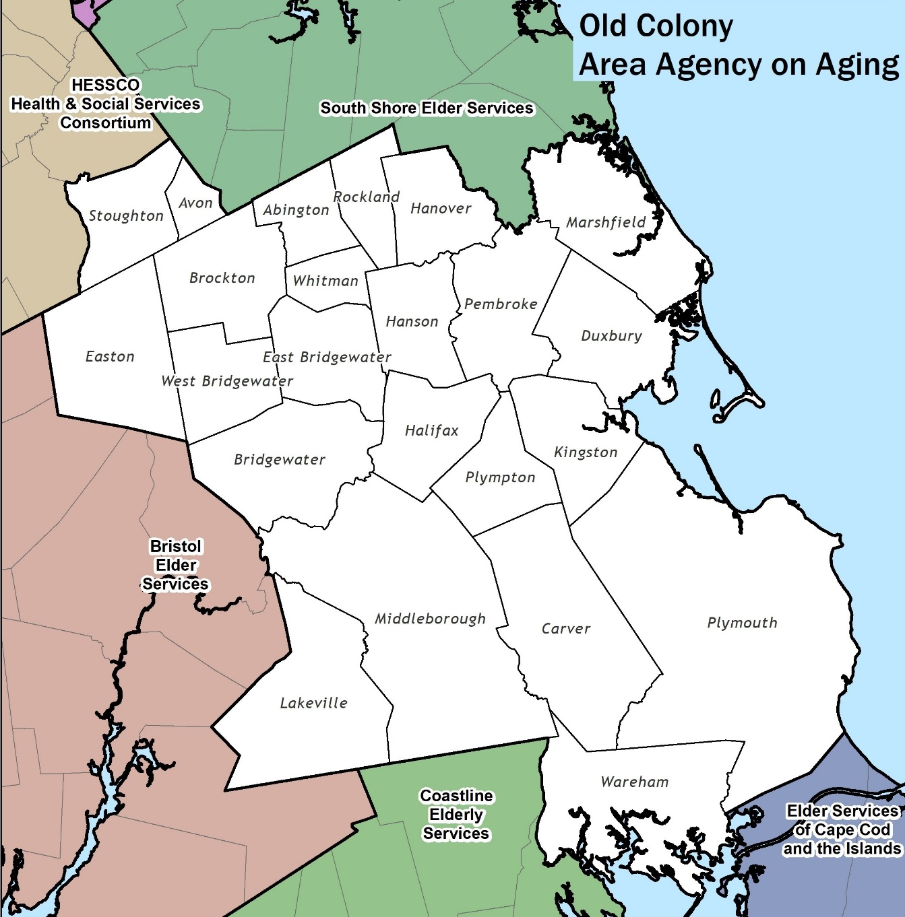

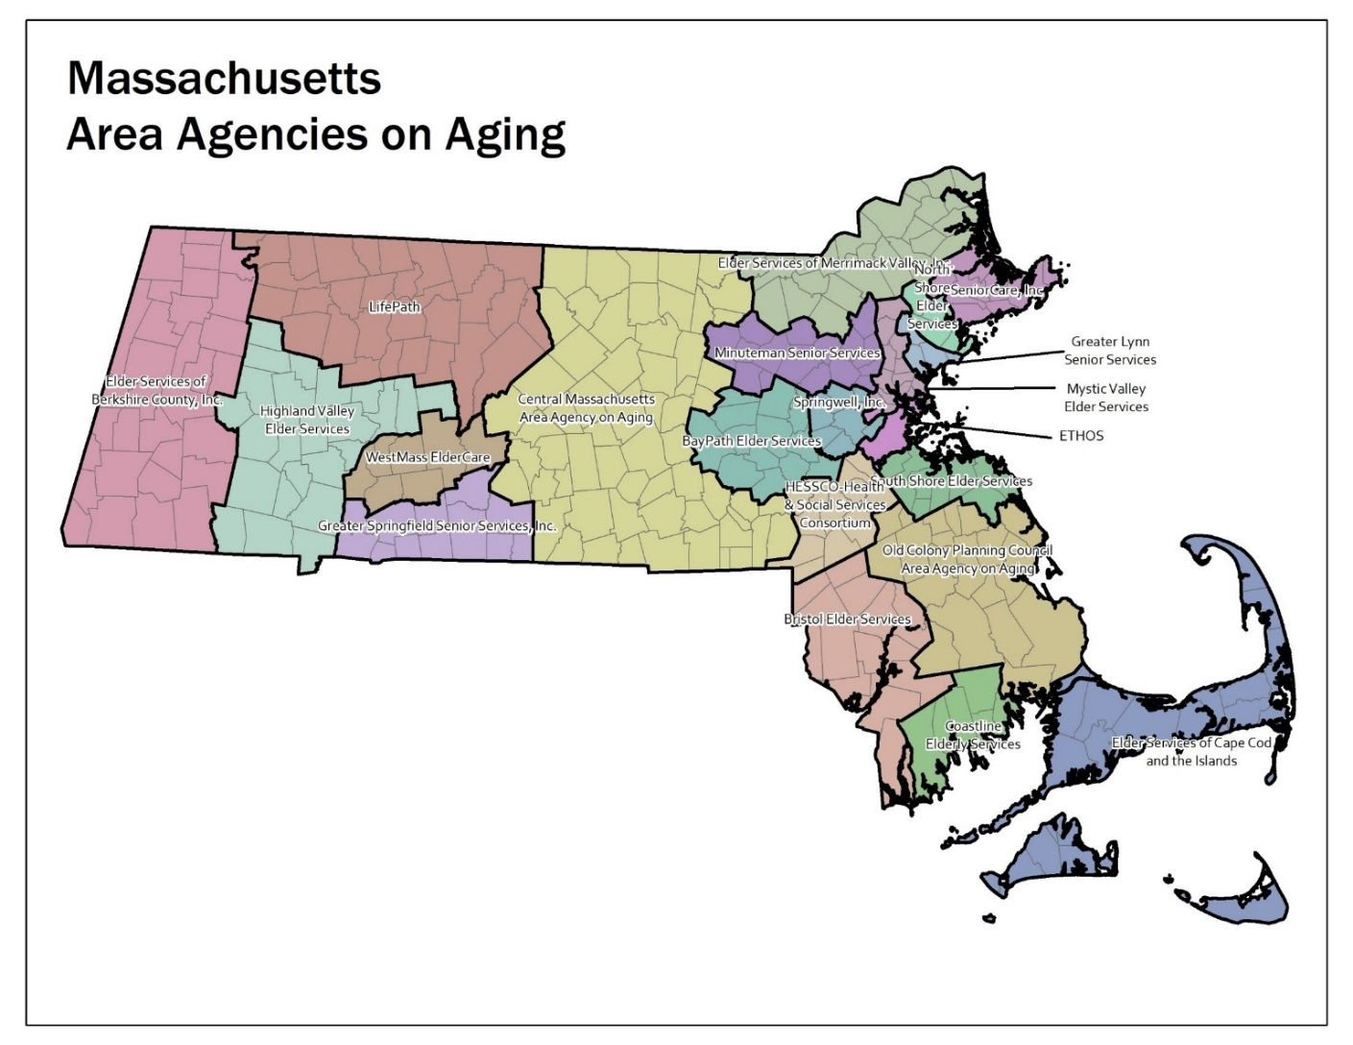

OCPC Area Plan on Aging - Executive Summary
Introduction:

The Old Colony Planning Council-Area Agency on Aging (OCPC-AAA) is the designated entity responsible for administering Older Americans Act (OAA) funding in a 23-community region in Southeastern Massachusetts. We are partners with the Massachusetts Executive Office of Age and Independence (EOAI-AGE), the U.S. Administration on Aging within the Administration for Community Living (ACL), and numerous public and private organizations and individuals that comprise the elder service network.

Our mission and purpose are driven by the vision of EOAI and ACL: “To develop a comprehensive, coordinated and cost-effective system of home and community-based services that help elderly individuals maintain their health and independence in their homes and communities…and to ensure that elders in Massachusetts have the supports necessary to maintain their wellbeing and dignity.”

Area Plan on Aging - Executive Summary - Continued

OCPC-AAA Focus Area Coordination
In keeping with Older Americans Act (OAA) target populations and core programs, Administration for Community Living (ACL) directed intra-State focus areas, and Massachusetts Executive Office of Elder Affairs (Elder Affairs) goals and as well as both recent State and Regional Needs Assessment results the Old Colony Planning Council Area Agency on Aging (OCPC-AAA) has established the following: Service Priorities for the 2026 – 2029 Area Plan on Aging:

- In-Home Support for Maintaining Independence
- Access to Services: including
  - Affordable Healthcare services
  - Affordable Housing & maintenance services
  - Legal Services
- Transportation Access and Availability
- Staying Active/Wellness Promotion – Physical & Behavioral Health*
- Long Term Services & Supports – such as Nutrition and other assistance
- Leisure Recreation, and Socialization to prevent loneliness and isolation
* (New to the top grouping)

While focus areas of service are often ongoing and similar-to those identified in the past, they also reflect the nature of ever-evolving needs, such as the need for socialization, which became even more apparent, when it was severely limited during the Covid pandemic or Staying Active for Physical and Behavioral Health, which rose to be a top priority for the first time.

From the State 2024-2025 Needs Assessment Survey, the following Old Colony Area Needs of Older Adults Ranked were reported by Priority:

- In-Home Support for Maintaining Independence:
- Affordable Housing:
- Affordable Health Care & Access to Health Care
- Transportation Access & Availability
- Staying Active / Wellness Promotion
- Long Term Services & Supports
- Housing Accessibility and Maintenance
- Nutrition Support
- Legal Services
- Mental & Behavioral Health Support

Executive Summary - Area Plan Goals and Objectives:

These service areas are identified as priorities for the region, based on the building blocks of State and Regional Older Adult and Caregiver Needs Assessment Survey data. Further input was received based on feedback from our board and advisory council members, agency providers, and the public.

To view the Results of the Old Colony region’s ‘Community Assessment Survey for Older-Adults,’ please go to: https://oldcolonyplanning.org/AAA-surveys/

Federal Focus Areas:
In addition to the Title III funded service goals, the OCPC-AAA also works as a partner with various organizations in seeking to address the focus areas established by the ACL. The OCPC-AAA seeks to address the needs of target elders in relation to OAA core programs, ACL discretionary grants, participant-directed/person-centered planning, and elder justice. We do so by requiring responding agencies to specify their plans for providing identified services to target group elders in the region. This Area Plan describes our efforts to address the established focus areas with Title III funded programs and services or indirectly with administrative support to other agencies and programs working on one or more of these focus areas.

Older Americans Act Target Populations - Integrating AAA and Statewide goals with ACL Focus Areas provides that Older Americans Act core programs target the following populations to assist older individuals with the greatest economic and social needs:
- Living Alone (Isolated) Elders
- Low Income Elders
- Minority Elder Populations
- Native American Populations (where germane)
- Rural Elder Populations (where germane)
- Socially Isolated Populations (i.e., geographic in nature; LGBTQ+; limited English proficient elders; separations from friends and family/COVID-19 related; and other socially isolated populations)

ACL Focus Areas - To meet the needs of OAA target populations, the Administration for Community Living established the following Focus Areas and associated pillars (in italics):
- Older Americas Act Core Programs – Supporting families and caregivers.
- Participant-Directed/Person-Centered Planning – Connecting people to resources.
- Elder Justice – Protecting rights and preventing abuse

2026-2029 Area Plan on Aging

Introduction: The Old Colony Planning Council is the designated Area Agency on Aging (OCPC-AAA) for the 23-community region in Southeast Massachusetts known as Region IV-A. The OCPC-AAA is a working partner with the Massachusetts Executive Office of Elder Affairs (EOEA), and the federal Administration on Community Living (ACL). Through our role in this partnership, we seek to promote and advance the mission and vision of the ACL and EOEA:

“To develop a comprehensive, coordinated and cost-effective system of home and community-based services that helps elderly individuals maintain their health and independence in their homes and communities” (ACL)

“To ensure that elders in Massachusetts have the supports necessary to maintain their wellbeing and dignity” (EOEA) These two brief statements describe the purpose, role, and focus of the OCPC-AAA.

The OCPC-AAA is one small part of an extensive network of government and private agencies, organizations and individuals that comprise the elder service network. This is a complex network of different programs and services, administered under different rules, guidelines, and eligibility criteria. Despite the complexity of the network, the above stated mission and vision provide a simple, straight-forward path for the efforts and focus of the network.

With this 2026-2029 Area Plan on Aging, we seek to outline our role and function in the Massachusetts elder service network and provide a framework for achieving the goals of the mission and vision statement. This Plan presents a detailed explanation of our most recent older adult needs assessment process, the goals, and partnerships for addressing the focus areas of the ACL, the OCPC-AAA Area Plan goals, and objectives for the next four years, and a summary of the quality management measures used to monitor program and agency performance.

Needs Assessment Process:
The OCPC-AAA is responsible for administering Older Americans Act (OAA) funding in Greater Plymouth County. As part of this responsibility, we seek to maintain an ongoing understanding of the needs and issues facing older people from throughout the region. We accomplish this in a variety of ways, such as including the emphasis and guidance of the ACL (Administration for Community Living), our State Unit on Aging, community partners, and most importantly, the views, perspectives and needs of older adults and caregivers from the region.

Our most essential method for gathering information for the 2026-2029 Old Colony Area Plan on Aging was to directly survey older adults through needs

assessment surveys conducted in the region in the fall and early winter of 2024 using:

- A State provided Older Adult Needs Assessment survey document, and,

- The Old Colony Community Assessment Survey for Older Adults (CASOA)

A complete report of the December 2024 Old Colony Community Assessment Survey for Older Adults (CASOA) project is available on the OCPC web site at:

https://oldcolonyplanning.org/aaa-surveys/

Other great comparative resources to review include:

The Massachusetts Healthy Aging Data Report: The report was just updated this month and can be explored in full here: Explore the Report - Massachusetts Healthy Aging Collaborative

This is a phenomenal resource, which offers additional insight into health, demographics, and aging-related indicators within our region’s Program and Service Area (PSA), as well as across the state. You can select each municipality and view a detailed community profile, including the total number of adults age 65 and older at: Community Profiles - Massachusetts Healthy Aging Collaborative

Another interesting, all-be-it out of the box, resources to help as an economic needs-identifier is the UMass Boston – School of Gerontology’s ‘Elder Index, ‘which is a dynamic tool used to find both local and national comparative data for regional older adult costs-of living, for example as shown below – A Plymouth County, MA couple who owns their home and happens to be in good health would need to earn $54,480 per year, which is 124% of the national average of $43,776, in order to meet the Elder Index threshold for being “Economically Secure.”

OCPC-AAA Focus Area Coordination
In keeping with Older Americans Act (OAA) target populations and core programs, Administration for Community Living (ACL) directed intra-State focus areas, and Massachusetts Executive Office of Elder Affairs (Elder Affairs) goals and as well as both recent State and Regional Needs Assessment results the Old Colony Planning Council Area Agency on Aging (OCPC-AAA) has established the following: Service Priorities for the 2026 – 2029 Area Plan on Aging:

- In-Home Support for Maintaining Independence
- Access to Services: including
  - Affordable Healthcare services
  - Affordable Housing & maintenance services
  - Legal Services
- Transportation Access and Availability
- Staying Active/Wellness Promotion – physical and mental*
- Long Term Services & Supports – wherever one’s home happens to be
- Leisure Recreation, and Socialization to prevent loneliness and isolation
* (New to the top group)

While focus areas of service are often similar-to those identified in the past, they also reflect the nature of ongoing but also ever-evolving needs, such as the need for socialization, which became even more apparent, when it was severely limited during the Covid pandemic and Staying Active/Wellness, which rose to be a top priority for the first time.

These service areas are identified as priorities for the region, based on the building blocks of feedback and input from provider agencies, and both State and Regional Older Adult and Caregiver Needs Assessment data:

ACL Focus Areas:
In addition to the Title III funded service goals, the OCPC-AAA also works as a partner with various non-profit local organizations seeking to address the focus areas established by the ACL. Specifically, the OCPC-AAA seeks to address the needs of target elders in relation to OAA core programs, ACL discretionary grants, participant-directed/person-centered planning, and elder justice. We do so by requiring responding agencies to specify their plans for providing identified services to target group elders in the region. This Area Plan provides a detailed explanation of our efforts to address the established focus areas; either directly with Title III funded programs and services, and/or indirectly with administrative support to other agencies and programs working on these focus areas.

Area Plan Goals and Objectives:

Top Ten Old Colony Area Needs Ranked by Older Adults, via the Massachusetts State 2024-2025 Needs Assessment:
      - In-Home Support for Maintaining Independence:
      - Affordable Housing:
      - Affordable Health Care & Access to Health Care
      - Transportation Access & Availability
      - Staying Active / Wellness Promotion
      - Long Term Services & Supports
      - Housing Accessibility and Maintenance
      - Nutrition Support
      - Legal Services
      - Mental & Behavioral Health Support

“Older Adults Burdened by High Costs of Housing and Care

﻿A recent blog post by the Joint Center for Housing Studies of Harvard University details the increasing burdens on older adults in the form of rising costs of housing as well as increased need for Long-Term Care (LTC) as they age. The Dual Burden of Housing and Care for Older Adults illustrates that only a little more than one-half of older adults are able to afford their cost of living (including housing) and one LTC visit per week, with that amount going down as the number of weekly visits required goes up. Demographics as well as home ownership or renter status also affect the proportion of older adults who can financially meet all of their needs.”

– Courtesy of USAging – May 2025

Greatest Economic Needs and Greatest Social Needs

The following reported needs are refined by Income representing both similarities, and divergences for those with the ‘Greatest Economic and Social Needs.’

Top 10 Massachusetts Reported Needs by Income
Need |<$20,000| ≥$20,000
----------------------------------------|----------|----------
1. Access to Services | 65.1% | 40.1%
2. Affordable Health Care | 58.6% | 46.7%
3. Access to Health Care | 55.6% | 44.5%
4. Affordable Housing | 48.3% | 29.2%
5. Housing Accessibility & Maintenance | 40.4% | 36.6%
6. In-Home Support for Independence | 62.3% | 60.6%
7. Long-Term Services & Supports | 42.3% | 38.7%
8. Assistance Managing Other Expenses | 37.5% | 25.4%
9. Legal Services | 37.8% | 29.8%
10. Mental & Behavioral Health Support | 37.2% | 29.8%

The OCPC-AAA places an emphasis on meeting the needs of “Target Group” older adults in the region, defining target groups as older adults who are low-income, minority, have limited English-speaking ability, disabled elders, and older people suffering from different forms of dementia, and their caregivers.

Our request for proposal process establishes minimum standards for addressing specific target group service provision requirements, and outlines goals for responding agencies in meeting the service requirements for the region. Proposals that do not meet this standard are not considered for funding.

Quality Management:
All Title III funded programs are required to maintain a level of performance and service that is monitored on an ongoing basis by the OCPC-AAA. Monitoring is accomplished by regular contact with grantee agencies, review and analysis of monthly program performance reports and funding requisition requests, and annual site visits. With this system, we monitor and track program performance in relation to the agency proposal and OCPC-AAA’s expectations for performance.

Emergency Planning:
The OCPC Area Agency on Aging is required to have an emergency plan in place by September 30, 2025, in order to comply with the 2024, update of Older Americans Act regulations. However, we also need to document the various aspects of the emergency plan by the early July 2025 Area Plan submission deadline. We are working to flesh out the mandatory disaster components, including a Continuity of Operations Plan, or COOP as it’s sometimes called and a plan to submit it for board approval, most likely in August or September.

Older Americans Act Core Programs:
The majority-of Title III funding that is administered by the OCPC-AAA goes to programs designed or intended to address the needs of “target population” groups. For example, 65% of standard Title III-B funding ($234,000) is applied to the categories of In-home Health and Supportive Services, Legal Services, and Supportive Services to Target Populations. Programs funded under these categories have specific target population goals (low-income, minority, economically and socially isolated), and specific unit of service provision requirements. The majority of service provision from these service categories is to elders in the identified target groups. The OCPC-AAA currently provides limited funding ($15,000) to one minority-owned and operated agency (Cape Verdiana De Brockton) for the specific purpose of outreach and assistance to minority elders in Brockton and surrounding communities. Also, the OCPC-AAA provides approximately $7,000 in Title III-B funding for the purpose of subsidizing the cost of Social Day Program attendance for low-income elders (low-income, isolated). Additionally, the OCPC-AAA provides funding to support the Dorn-Davies Senior Center, a private, non-profit agency that is housed in one of the public housing high-rise facilities in Brockton. This program serves target population elders (low-income, minority, socially and economically isolated) from Brockton and surrounding communities.

Additionally, the OCPC-AAA provides funding for emergency assistance and service to disabled elders. In FFY 2024, the OCPC-AAA provided approximately $131,000 in standard Title III-B funding for these two service categories. It is noted that in the category of emergency assistance, most of the funding (90%) was used for critical financial assistance to ensure basic survival (heating oil, food, medication). The emergency assistance program is for elders who are in an emergency situation that cannot be addressed through any other sources. One of the newer services covered by the OCPC funded emergency assistance program includes finding alternative transportation, such as rides through Lyft, via our regional partner Old Colony Elder Services (OCES). It is our contention that the elders served through this program all fall into one of the “target population” categories.

The OCPC-AAA believes that the current service priorities for the region reflect some of the most critical, unmet or undermet needs of the “target population” elders in the region. It is our hope and expectation that existing programs will continue to strive to meet the needs of the target groups, with the understanding that any increase in Title III- funding will include an increase in service provision, where possible.

Healthy Living - Title IIID - The 2026-2029 OCPC Area Plan priorities reveal establishment of Medication Management/Healthy Living as a formal category of Evidence-based Disease and Disability Prevention Program (DDPP) priorities for the region. The establishment of this priority is based on ongoing need and demand for such service and activity in the region. During FFY 2020, the OCPC-AAA provided 100% of our standard III-D allocation ($28,693) for the purpose of funding medication management/Healthy Living. Unfortunately, during most of FFY 2020 due to Covid-19, senior center, and other closures, which prevented some Medication Management/Healthy Living programs from being able to run.

The OCPC-AAA views medication management/Healthy Living as a critically key component of the community-based supportive service system in our region. Feedback from clients and providers continually highlights the importance and necessity of this type of assistance for helping to keep some of the most at-risk elders living in their own homes in as safe and reasonable a manner as can be provided. While the OCPC-AAA has established the DDPP category of Medication Management/Healthy Living as a priority in the region, we also acknowledge the value and importance of other types of DDPP (Healthy Eating, Matter of Balance, Chronic Disease Self-Management). Although our Title III funding priorities are focused on medication management/Healthy Living, we are open to consider proposals from the local ASAP (Old Colony Elder Services) for the provision of service related to Health Eating, Matter of Balance, and Chronic Disease Self-Management.

- Participant-Directed/Person-Centered Planning:
As an organization dedicated to advocating for the needs and rights of older persons, the OCPC-AAA wholeheartedly supports the concept of participant-directed/person-centered planning and service/care decision making (PDPC). We believe that all decisions regarding community-based care and support, to the extent possible, should be made by the older person. It is our expectation that all Title III funded programs in the OCPC-AAA region will continue to give elder participants final decision-making authority in terms of whether or not to receive service, the type and amount of service, the specific details of the service plan, etc. That said, not all community-based programs and services lend themselves well to PDPC. For example, limited funding often limits the amount of service available. Also, eligibility criteria for different programs and services will often limit who can receive service, and the extent of service that can be provided. Nevertheless, the OCPC-AAA supports the concept of allowing older persons the latitude to choose what is best for them.

- Elder Justice:

As an Area Agency on Aging, the OCPC-AAA views elder justice issues as paramount to the work of the aging network. Too often, the frailest, most vulnerable older people in our society are harmed and/or exploited by others. The OCPC-AAA supports the efforts of all the different components of the network of elder justice providers (Adult Protective Services, law enforcement, LTC Ombudsman, legal assistance, etc.) to address such issues. While the OCPC-AAA does not provide Title III funding for all these different components, we wholeheartedly support their efforts and are always willing to work in partnership to eliminate abuse, neglect, and exploitation.

The OCPC-AAA currently administers the Long-Term Care Ombudsman (LTCO) program for our region. Funding for the Ombudsman program changed during FFY 2024 as well when the OCPC-AAA supplemented its allocation for Ombudsman services with ARPA act funding provided during Covid-19. The OCPC LTCO believes strongly in the purpose and mission of the program, and most importantly the impact that the work has on the lives of the residents. The program empowers residents by providing advocacy, support, guidance, and problem resolution. More importantly, the program helps to provide residents with peace of mind and a sense that they remain important and valued members of the community.

Protective Services: As previously noted, the OCPC-AAA does not provide funding for the Adult Protective Services (APS) program in our region, which is handled directly by our Local Service Access Point partner, Old Colony Elder Services. However, OCPCs Long-Term Care Ombudsman Program maintains ongoing referral relationships with Adult Protective Services, local law enforcement, the Attorney General’s office, and others.

Looking forward - In recognition of a history of strong commitment to Elder Justice in the Old Colony region the OCPC-AAA was honored to be identified as one of three Regional State sites to oversee the expansion of the State Assisted Living Facility (ALF) Ombudsman program. There will be 1 FTE with the plan to recruit and train volunteers. Utilizing approximately $96,000 in budgeted funding the program, similarly to LTC/Ombudsman, will provide advocacy, support and empowerment to all Assisted Living residents and their families and ensure their rights as valued members of our communities. The program will encompass 64 assisted living facilities in the areas served by four other ASAP’s that will include Cape Cod Elder Services, Coastline, Bristol Elders and HESSCO.

The OCPC-AAA currently provides $125,000 in Title III-B for Legal Services in our region. This amount represents 30% of all non-Covid-19 related Title III-B funding available to the region. This high percentage of funding for legal assistance is, in part, driven by State requirements, but is also a reflection of the importance of this type of assistance for a region like ours that has a large concentration of low-income and minority elders. The Legal Services program provided legal assistance to over 150 unduplicated older adults each year. Of those older adults served, 22% were minority, 19% were low-income minority, and 62% of all clients served were low-income. The main categories for legal assistance were in the areas of housing (46% of all cases), public benefits (14% of all cases), and health and consumer issues including Bankruptcy (5% of all cases). We anticipate similar if not higher service provision levels for the upcoming fiscal year (2026). It is clear that legal issues addressed and resolved by the legal assistance program would not have been resolved favorably for the respective older adults without the assistance provided by the program. It is also clear that the formal avenue to justice for older adults provided through the program is an absolute necessity for our region. We continue to view the Legal Assistance program as one of our most important and impactful Title III funded programs in the region.

As part of the regional response to the ACL established focus areas, the OCPC-AAA asked our older adult service network partner Old Colony Elder Services (the regional Aging Services Access Point) to provide a summary of their activities and efforts related to the issues identified, including the influences of Covid-19 and other newer factors. Their responses are provided here:

Old Colony Elder Services-Feedback on the MA State Plan on Aging, 2026-2029
Title III/Person -Centered Care Planning Focus Area:

- The Family Caregiver Support Program:
- Music & Memory (M&M)– This will continue to be offered as this programming reaches caregivers in a creative way, OCES has one staff member from Healthy Living (HL) completing caregiver assessments as part of the M&M protocol. M&M is non-threatening, and it increases referrals to FCSP. M&M is an intervention that can be used universally – there are no cultural or language barriers.
- NEW/Rebranded Building Better Caregivers – This rebranded evidence-based class will continue to be offered as it reaches additional caregivers and provides significant support to caregivers of loved ones with dementia, helping to keep older adults in the community.
- Note: When COVID-19 hit OCES converted in-person FCSP Programming into a virtual program. OCES currently has one caregiver support group that is offered via zoom.

- The Nutrition Program:
- Kennedy meal site- Update: The Kennedy Drive community Room/kitchen was closed, first during COVID and then for a remodel. It is now open, and Community Dining meals/boxed lunches and coffee hour will be offered 3 days a week starting April 2025; future plan is for 5 days a week. After Covid the site was re-opened for Grab & Go meals to support older adults living alone, low-income older adults, minority older adults and socially isolated populations. Ideally, OCES will continue to offer the Grab & Go meals now that the Community Dining site is reopened, and as an additional option to reach additional older adults. Providing more opportunities to get meals into the community helps fight malnutrition.
- Expanding Meal Sites are being rolled out at housing units.
- Updates on Culturally-focused initiatives – The Haitian meal site was on hold due to COVID-19,but Community Dining Caribbean meals are now being served at Belair Housing two days a week. Caribbean HDMs are also offered in Brockton from all HDM sites
- Nutrition Education – Virtual Nutrition education presentations are scheduled throughout our catchment area, regardless of whether they are OCES meal sites. Printed Nutritional education material is distributed with Home Delivered Meals. Individual in-home consultations are conducted when needed. Nutrition Education at meal sites and other Agencies/Businesses are in-person.
- Community Dining sites were offering Grab & Go meals in place of in-person dining. However, Community Dining hot meals and boxed lunches/grab and go will now both be used at Community Dining.
- Adjusting to new requirements: AGE is now requiring all ASAPs to provide the basic 4 types of medically tailored meals so we will need to supplement the self-catered sites with these types of meals to meet that requirement. We have been/currently offering the 4 basic medically tailored meals at all other OCES meal sites.
- If adequate funding were to be available, we would like to target more of the cultures we serve to offer culturally sensitive/appropriate meals. We have done this very successfully with a 2x/week Caribbean Community Dining meal and Caribbean HDM in Brockton, but we would like to expand and increase the types of cultures served and offer at more housing locations to ensure accessibility to these meals. We would need access to additional funding to do this in a sustainable manner for other Brockton Community Dining sites.

- Other ambitions with more sustainable Nutrition funding include:
  - Increasing access to nutritionally fresh foods.
  - Creating a grocery program to include providing one week of shelf stable food to prepare meals; addressing social isolation created by COVID-19 and food insecurity.
  - Improve the Nutrition program through technology by purchasing a program to electronically provide route sheets for meal delivery drivers, notification of when a meal was delivered, status on when a consumer can expect their meal and provide immediate notification of consumers not at home. An example of this is ServTracker.
  - Expand employment opportunities by adding staff to the growing Nutrition program. We would need additional funds to sustain the new positions.

- The Healthy Living Programs:
- Honoring Choices (HC)- (Title IIID supports several Healthy Living expenses) - With 2 certified Honoring Choices facilitators, we will continue to offer group presentations. In FFY 21, OCES expanded internally to training Home Care CMs. HL is funded in part by Title III and HC supports Person-Centered Planning. Most trainings are currently taking place in-person, and all evidence-based trainings are now required to be in-person, but other trainings can be offered virtually.
- Going forward, a new Memory Training presentation is being offered called Bringing Health to You, as well as more fall prevention trainings are offered. This will continue with our goal to support older adults in the community, allowing them to live safely in the community longer.

- The Home Care Program:
- Home Care (HC) staff/I&R staff participated in BU CADER courses.
- I&R/Options Counselor’s (OC) and Transition staff completed ACL No Wrong Door/ PCCTP courses.
- OCs provide short-term assistance with consumer-directed decision support. We would like to expand this program to work with more hospitals to support safer discharges home.
- OCES is a member of ADRC SE SM and supports No Wrong Door and Person-Centered Counseling (PCC). ADRC supports all ages; older adults, individuals living with disabilities and their caregivers.
- OCES has SHINE certified benefits advisors.
- HC also has experience administering/delivering person centered planning through the Consumer Directed Care (CDC) delivery option and the Veteran’s Independence Plus (VIP) programs that offer individualized flexible care planning.
- Experience collecting consumer satisfaction data and incorporating feedback into practice.
- Transitions staff have successfully participated in Money Follows the Person (MFP) to promote safe transitions from skilled nursing facility care to community living with LTSS, incorporating consumers’ needs and preferences.
- HC/Transitions staff has Partnered with Patient Ping to receive real-time admission and discharge notifications to ensure services are reinstated promptly upon discharge home.
Elder Justice:

- The Protective Services Program:
- All PS staff have completed trainings provided by EOEA in the following areas: Alzheimer’s Disease and Related Dementias (ADRD); Introduction to Massachusetts Elder Protective Services; Massachusetts Elder Protective Services Investigation Training; Massachusetts Elder Protective Services Legal Issues; and Massachusetts Elder Protective Services Risk Assessment. PS Staff will continue to complete these required trainings as they become available from EOEA.
- PS staff have responded to the COVID-19 pandemic by adjusting how they conduct in person visits. Staff bring extra/additional PPE to provide for the consumers when they visit. PS staff has also been conducting virtual visits with consumers when appropriate and accessible to the Consumer. PS staff will continue to offer virtual visits to consumers as an alternative way to maintain contact.
- PS staff have recently partnered with Public Guardianship Services (PGS) and are able to utilize them in certain cases where the consumer needed a guardian or conservator. PS staff will continue with this partnership moving forward to ensure consumers who are elevated risk have the appropriate representative to maintain their care and wellbeing.
- PS staff will continue to work with PCSPC Plymouth County Suicide Prevention coalition to provide trainings on suicide prevention.
- OCES’s Protective Services training has been recorded on video and disseminated from agency providers and within OCES. This has been helpful to get more individuals trained since it can be shared via email as opposed to before when staff had to be present for live-in person training. In addition, this training has been translated into many other languages to meet our service areas’ linguistic needs.
- OCES is a founding member of The Brockton Area Hoarding Task Force (GBAH) which meets regularly to share community resources and educational events. This collaboration assists PS staff with effective strategies to engage with consumers with hoarding concerns from a Person-centered planning perspective while using a harm reduction model. The GBAH also utilizes the interdisciplinary model to have other agencies’ representatives brainstorm solutions and offer referrals and guidance. The Buried in Treasures (BIT) support group has been successfully held virtually via zoom due to COVID-19. Our Consumer Advocate Program assists with being a member of the task force and works closely with PS and HC to assist with these difficult hoarding cases. We will continue with professional outreach for the GBAH on the topic of hoarding.
- OCES PS promotes elder justice issues by sponsoring two events in the greater Brockton and Plymouth areas to recognize World Elder Abuse Awareness Day and bring awareness to the communities. This has also helped enhance OCES and PS relationship with local law enforcements for collaboration, trainings on Protective Services and Elder Abuse, mandated reporting, and consultation. We have done a mass email campaign for our consumers that receive HDM’s to assist with educating them on the signs and symptoms of elder abuse. Participants used an online forum to post pictures of themselves wearing purple and holding signs that displayed what they do to assist older adults or bring awareness to the issue of elder abuse.
- OCES will continue to recognize WEAAD awareness to build awareness in the community.

- The Nutrition Program:
- MAMOW Driver Training video– This is a Nutrition Program initiative that relates to “Elder Justice” and has been rolled out to all volunteers and employee drivers and is part of on-going Nutrition Program Driver Training. It addresses all procedures including the safety check and reporting issues/problems to Meal Site Managers (MSM).
- Meals on Wheels – Continuing and expanding MOW contributes to the focus on elder safety by providing for regular contact with older adults.

Ways we would like to expand programming in Title III/Person -Centered Care Planning if we had additional Funding:
The Home Care Program: If we had additional funding, we would expand the program to offer:
- Additional financial supports for individual’s w/ disabilities under age 60
- We would expand our abilities to meet the unmet needs of housing and funding to preserve housing.
- Additional assistance with the extreme costs associated with hoarding situations and preservation of housing.
- Reduce the cost of transportation and Expand transportation resources.
- Expand resources to address socially isolated older adults, including limited English proficient older adults.
- Support aging in place resources/services with increase in access to LTSS services or social supports identified by consumer that are not funded through ASAP contracts.
- Increase dementia friendly communities.
- Access to affordable health care and medications
- Additional assistance with the extreme costs associated with the preparation and fumigation of Bedbug treatment and assistance with replacement furniture and household items.
- Additional funding for in-home mental health and substance abuse professionals.

Old Colony Elder Services - Ways to expand Elder Justice programming:
The Protective Services Program:
If we had additional funding, we have identified ongoing needs in the following areas that we would like to develop:
- Emergency shelters for older adults.
- Additional funding/financial assistance associated with the high costs it takes to resolve housing issues as-a result of hoarding and/or bed bug/pest infestation.
- Develop a partnership with patient advocates or geriatric care managers to assist consumers who need an advocate to help them navigate the complexities of multiple medical diagnoses and the varying information that is provided by their different specialist doctors.
- Develop & distribute domestic violence resources/supports specifically for older adults.
- Develop and partner with others on substance abuse centers that are specific to meet older adults’ needs.
- Expand resources to address loneliness/socially isolated older adults, including limited English proficient older adults.
- Expand and partner with others on mental health trainings for staff and community.

